

**Fitness Care**

**Software Design Document**

– Hanoi, February 2023–

**Table of Contents**

I. Overview 9

1. Code Packages/Namespaces 9

2. Database Design 10

1. User 13

2. Role 13

3. Service 13

4. Customer 14

5. TechnicalStaff 14

6. Timeslot 14

7. Schedule 14

8. Product 15

9. Material 15

10. CategoryProduct 15

11. Image 16

12. Product_Image 16

13. Blog 16

14. CategoryBlog 16

15. Feedback 16

16. User update 17

17. Product update 17

18. Service update 18

19. Order 19

20. Order Detail 19

21. Status order 19

22. Cart 20

23. Registration 20

24. Status_Registration 20

**II. Code Designs 21**

1. Public/Homepage 21

a. Screen Design 21

b. Class Diagram 21

c. Class Specifications 22

d. Sequence Diagram(s) 22

e. Database queries 23

2. Common/Login 24

a. Screen Design 24

b. Class Diagram 24

c. Class Specifications 25

d. Sequence Diagram(s) 25

e. Database queries 25

3. Common/Register 26

a. Screen Design 26

b. Class Diagram 27

c. Class Specifications 27

d. Sequence Diagram(s) 28

e. Database queries 28

4. Common/UserProfile 29

a. Screen Design 29

b. Class Diagram 29

c. Class Specifications 30

d. Sequence Diagram(s) 30

e. Database queries 31

5. Common/Reset Password 32

a. Screen Design 32

b. Class Diagram 32

c. Class Specifications 32

d. Sequence Diagram(s) 33

e. Database queries 33

6. Common/Logout 33

d. Sequence Diagram(s) 33

7. Public / Product List 34

a. Screen Design 34

b. Class Diagram 34

c. Class Specifications 35

d. Sequence Diagram(s) 35

e. Database queries 36

8. Public/ProductDetail 36

a. Screen Design 37

b. Class Diagram 37

c. Class Specifications 37

d. Sequence Diagram(s) 38

e. Database queries 38

9. Cart management/View All product in cart 39

a. Screen Design 39

b. Class Diagram 39

c. Class Specifications 40

d. Sequence Diagram(s) 40

e. Database queries 40

10. Cart management/Cart checkout 41

a. Screen Design 41

b. Class Diagram 41

c. Class Specifications 42

d. Sequence Diagram(s) 42

e. Database queries 42

11. Public / Service List 43

a. Screen Design 43

b. Class Diagram 43

c. Class Specifications 44

d. Sequence Diagram(s) 44

e. Database queries 45

12. Public/Service Detail 45

a. Screen Design 46

b. Class Diagram 46

c. Class Specifications 46

d. Sequence Diagram(s) 47

e. Database queries 47

13. Service Management / Register Service 47

a. Screen Design 48

b. Class Diagram 48

c. Class Specifications 48

d. Sequence Diagram(s) 49

e. Database queries 49

14. Material Management / View list Material 52

a. Screen Design 52

b. Class Diagram 52

c. Class Specifications 52

d. Sequence Diagram(s) 53

e. Database queries 53

15. Material Management / Add Material 53

a. Screen Design 53

b. Class Diagram 54

c. Class Specifications 54

d. Sequence Diagram(s) 54

e. Database queries 55

16. Material Management / Update Material 56

a. Screen Design 56

b. Class Diagram 56

c. Class Specifications 56

d. Sequence Diagram(s) 57

e. Database queries 57

17. Material Management / Delete Material 58

a. Screen Design 58

b. Class Diagram 58

c. Class Specifications 58

d. Sequence Diagram(s) 59

e. Database queries 59

18. Order Management/ApprovalOrder 60

a. Screen Design 60

b. Class Diagram 60

c. Class Specifications 61

d. Sequence Diagram(s) 62

e. Database queries 62

19. Order Management/Order Details 63

a. Screen Design 63

b. Class Diagram 63

c. Class Specifications 63

d. Sequence Diagram(s) 64

e. Database queries 64

20. Service Management/View registered service 65

a. Screen Design 65

b. Class Diagram 65

c. Class Specifications 65

d. Sequence Diagram(s) 66

e. Database queries 66

21. Blog Management/Blog List 67

a. Screen Design 67

b. Class Diagram 67

c. Class Specifications 68

d. Sequence Diagram(s) 68

e. Database queries 69

22. Blog Management/Blog Details 70

a. Screen Design 70

b. Class Diagram 70

c. Class Specifications 71

d. Sequence Diagram(s) 71

e. Database queries 71

23. Blog Management/Update Blog 72

a. Screen Design 72

b. Class Diagram 72

c. Class Specifications 73

d. Sequence Diagram(s) 73

e. Database queries 73

24. Blog Management/Add Blog 74

a. Screen Design 74

b. Class Diagram 74

c. Class Specifications 75

d. Sequence Diagram(s) 75

e. Database queries 75

25. Public/Blog List 76

a. Screen Design 76

b. Class Diagram 76

c. Class Specifications 77

d. Sequence Diagram(s) 77

e. Database queries 77

26. Public/Blog Details 78

a. Screen Design 78

b. Class Diagram 78

c. Class Specifications 79

d. Sequence Diagram(s) 79

e. Database queries 80

27. Product Management/View Product list 80

a. Screen Design 80

b. Class Diagram 81

c. Class Specifications 81

d. Sequence Diagram(s) 81

e. Database queries 82

28. Product Management/Add Product 82

a. Screen Design 82

b. Class Diagram 83

c. Class Specifications 83

d. Sequence Diagram(s) 83

e. Database queries 84

29. Product Management/Edit Product 84

a. Screen Design 84

b. Class Diagram 84

c. Class Specifications 85

d. Sequence Diagram(s) 85

e. Database queries 86

30. Product Management/Delete Product 86

a. Screen Design 86

b. Class Diagram 87

c. Class Specifications 87

d. Sequence Diagram(s) 87

e. Database queries 88

# I. Overview

## 1. Code Packages/Namespaces

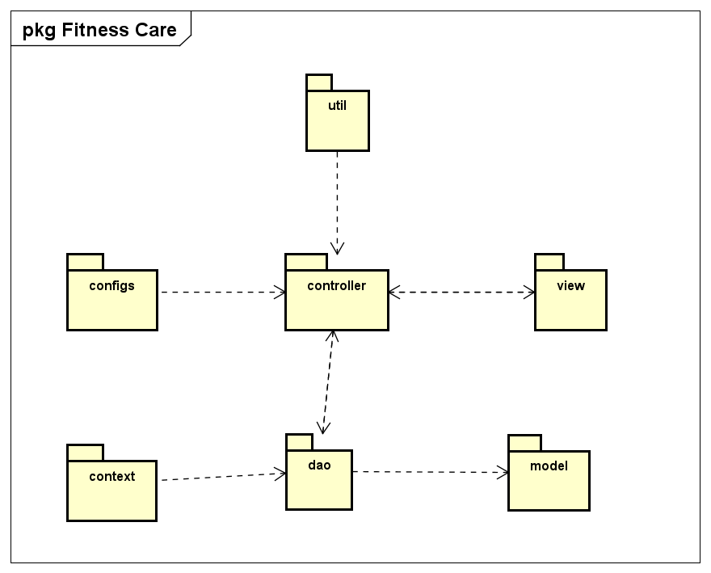

***Package descriptions & package class naming conventions***

|  |  |  |
| --- | --- | --- |
| ***No*** | ***Package*** | ***Description*** |
| *01* | *controller* | *Description: controller classes which receive HTTP request and response HTTP response to clients*  *Class Naming Convention: LoginController* |
| *02* | *dao* | *Description: This component is used to get data directly FROM the database*  *Class Naming Convention: UserDAO* |
| *03* | *model* | *Description: This component includes interfaces used to receive data retrieved FROM the database and classes used to receive data*  *Class Naming Convention: User* |
| *04* | *util* | *Description: Provide helping methods for using in the system*  *Class Naming Convention: DateTimeHelper* |
| *05* | *configs* | *Description: This component helps define configuration* |
| *06* | *view* | *Description: This component display front-end* |
| *07* | *context* | *This component helps connect database* |

## 2. Database Design

**2.1 Database Schema**

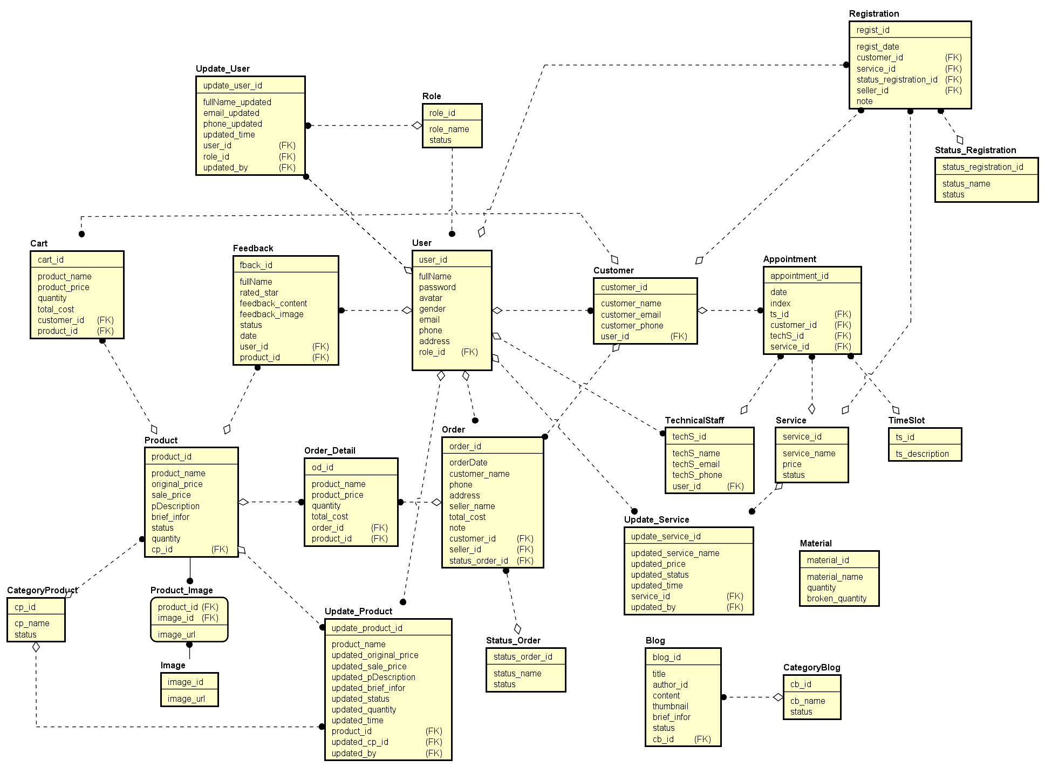

***Table descriptions & package class naming conventions are as below***

|  |  |  |
| --- | --- | --- |
| **No** | **Table** | **Description** |
| *01* | *User* | *User contains information of user including user_id, email, password, full_ name, phone, avatar, gender, address, status, role_id*  *- Primary keys: user_id*  *- Foreign keys: role_id* |
| *02* | *Role* | *Role contains information of role including role_id, role_name, status*   * *Primary keys: role_id* |
| *03* | *Service* | *Service contains information of Service including service_id, service_name, price, status*   * *Primary keys: service_id* |
| *04* | *Customer* | *Customer contains information of Customer including customer_id, customer_name, customer_phone, customer_email, user_id*   * *Primary keys: customer_id* * *Foreign keys: user_id* |
| *05* | *Timeslot* | *Timeslot contains information of Timeslot in day including ts_id, ts_description*   * *Primary keys: ts_id* |
| *06* | *TechnicalStaff* | *TechnicalStaff contains information of TechnicalStaff including techS_id, techS_name, techS_phone, techS_email, user_id*   * *Primary keys: techS_id* * *Foreign keys: user_id* |
| *07* | *Schedule* | *Schedule contains information of an appointment between technical staff and customer including schedule_id, date, ts_id, customer_id, techS_id,service_id, index*   * *Primary keys: schedule_id* * *Foreign keys: ts_id, customer_id, techS_id, service_id* |
| *08* | *Product* | *Product contains information of Product including product_id, product_name, original_price, sale_price, pDescription, brief_infor, status , quantity, cp_id*   * *Primary keys: product_id* * *Foreign keys: cp_id* |
| *10* | *Material* | *Material contains information of Material including material_id, material_name, quantity, broken quantity*   * *Primary keys: material_id* |
| *09* | *CategoryProduct* | *CategoryProduct contains information of CategoryProduct including cp_id, cp_name , status*   * *Primary keys: cp_id* |
| *11* | *Image* | *Image contains images used for the website including image_id, image_url, product_id*   * *Primary keys: image_id* * *Foreign keys: product_id* |
| *12* | *Product_Image* | *Product_Image Contains images related to the respective product including product_id, image_id, image_url*   * *Primary keys: product_id, image_id* * *Foreign keys: product_id, image_id* |
| *13* | *Blog* | *Blog contains articles related to the website including blog_id, title, author_id,content ,thumbnail, brief_infor,cb_id,status*   * *Primary keys: blog_id* * *Foreign keys: cb_id* |
| *14* | *CategoryBlog* | *CategoryBlog contains categories of blogs including cb_id, cb_name, status*   * *Primary keys: cb_id* |
| *15* | *Feedback* | *CategoryBlog contains feedback customer about product, service including fback_id, fullName, rated_star, feedback_content, feedback_image, status, product_id, user_id, date*   * *Primary keys: fback_id* * *Foreign keys: user_id, product_id* |
| *16* | *User update* | *User update contains a user's update history including update_user_id, user_id,role_id, fullName_updated, email_updated, phone_updated, updated_time, updated_by*   * *Primary keys: update_user_id* * *Foreign keys: role_id, user_id, updated_by* |
| *17* | *Product update* | *Product update contains a product’s update history including update_product_id, product_id, product_name, updated_original_price, updated_sale_price, updated_pDescription, updated_brief_infor, updated_status, updated_quantity, updated_cp_id, updated time, updated_by*   * *Primary keys: update_product_id* * *Foreign keys: product_id, updated_cp_id, updated_by* |
| *18* | *Service update* | *Service update contains a service’s update history including updated_service_id, service_id,updated_service_name, updated_price, updated_status,*  *updated_time, updated_by*   * *Primary keys: updated_service_id* * *Foreign keys: service_id,updated_by* |
| *19* | *Order* | *Order contains information of an order including order_id, orderDate, custormer_id,customer_name, phone, address, seller_id, seller_name, total_cost, status_order, note*   * *Primary keys: order_id* * *Foreign keys: custormer_id,seller_id* |
| *20* | *Order_Detail* | *Order_Detail contains detail information of an order including od_id, order_id, product_id,product_name, product_price, quantity, total_cost*   * *Primary keys: od_id* * *Foreign keys: order_id,product_id* |
| *21* | *Status_Order* | *Status_Order contains status of an order(processing/done/failed)*  *including status_order_id, status_name, status*   * *Primary keys: status_order_id* |
| *22* | *Cart* | *Cart contains cart’s information added by the customer including cart_id, product_id, product_name, product_price, quantity, total_cost, customer_id*   * *Primary keys: cart_id* * *Foreign keys: product_id,customer_id* |
| *23* | Registration | Contains information about a customer's service registration including regist_id, regist_date, customer_id,service_id, status_regist_id, seller_id, note   * Primary key: regist_id * Foreign key: service_id, seller_id, customer_id |
| *24* | Status_Registration | contains information about the status of a service registration (success/failure) including status_regist_id, status_name, status   * Primary key: status_regist_id |

**2.2 Database table**

## 1. User

|  |  |  |  |  |  |  |  |
| --- | --- | --- | --- | --- | --- | --- | --- |
| **#** | **Field name** | **Type** | **Size** | **Unique** | **Not Null** | **PK/FK** | **Notes** |
| 1 | user_id | int |  | x | x | PK |  |
| 2 | fullName | nvarchar | 50 |  | x |  |  |
| 3 | password | varchar | 50 |  | x |  |  |
| 4 | avatar | varchar | MAX |  |  |  |  |
| 5 | gender | bit |  |  | x |  |  |
| 6 | email | varchar | 50 | x | x |  |  |
| 7 | phone | varchar | 50 | x | x |  |  |
| 8 | address | nvarchar | 255 |  | x |  |  |
| 9 | status | bit |  |  | x |  |  |
| 10 | role_id | int |  |  | x | FK |  |

## 2. Role

|  |  |  |  |  |  |  |  |
| --- | --- | --- | --- | --- | --- | --- | --- |
| **#** | **Field name** | **Type** | **Size** | **Unique** | **Not Null** | **PK/FK** | **Notes** |
| 1 | role_id | int |  | x | x | PK |  |
| 2 | role_name | nvarchar | 50 |  | x |  |  |
| 3 | status | bit |  |  | x |  |  |

## 3. Service

|  |  |  |  |  |  |  |  |
| --- | --- | --- | --- | --- | --- | --- | --- |
| **#** | **Field name** | **Type** | **Size** | **Unique** | **Not Null** | **PK/FK** | **Notes** |
| 1 | service_id | int |  | x | x | PK |  |
| 2 | service_name | nvarchar | 100 |  | x |  |  |
| 3 | price | money |  |  | x |  |  |
| 4 | status | bit |  |  | x |  |  |

## 

## 4. Customer

|  |  |  |  |  |  |  |  |
| --- | --- | --- | --- | --- | --- | --- | --- |
| **#** | **Field name** | **Type** | **Size** | **Unique** | **Not Null** | **PK/FK** | **Notes** |
| 1 | customer_id | int |  | x | x | PK |  |
| 2 | customer_name | nvarchar | 50 |  | x |  |  |
| 3 | customer_email | varchar | 50 | x | x |  |  |
| 4 | customer_phone | varchar | 50 | x | x |  |  |
| 5 | user_id | int |  |  | x | FK |  |

## 

## 5. TechnicalStaff

|  |  |  |  |  |  |  |  |
| --- | --- | --- | --- | --- | --- | --- | --- |
| **#** | **Field name** | **Type** | **Size** | **Unique** | **Not Null** | **PK/FK** | **Notes** |
| 1 | techS_id | int |  | x | x | PK |  |
| 2 | techS_name | nvarchar | 50 |  | x |  |  |
| 3 | techS_email | varchar | 50 | x | x |  |  |
| 4 | techS_phone | varchar | 50 | x | x |  |  |
| 5 | user_id | int |  |  | x | FK |  |

## 

## 6. Timeslot

|  |  |  |  |  |  |  |  |
| --- | --- | --- | --- | --- | --- | --- | --- |
| **#** | **Field name** | **Type** | **Size** | **Unique** | **Not Null** | **PK/FK** | **Notes** |
| 1 | ts_id | int |  | x | x | PK |  |
| 2 | ts_description | varchar | 50 |  | x |  |  |

## 

## 7. Schedule

|  |  |  |  |  |  |  |  |
| --- | --- | --- | --- | --- | --- | --- | --- |
| **#** | **Field name** | **Type** | **Size** | **Unique** | **Not Null** | **PK/FK** | **Notes** |
| 1 | schedule_id | int |  | x | x | PK |  |
| 2 | ts_id | int |  |  | x | FK |  |
| 3 | customer_id | int |  |  | x | FK |  |
| 4 | techS_id | int |  |  | x | FK |  |
| 5 | service_id | int |  |  | x | FK |  |
| 6 | date | date |  |  | x |  |  |
| 7 | index | int |  |  | x |  |  |

## 

## 8. Product

|  |  |  |  |  |  |  |  |
| --- | --- | --- | --- | --- | --- | --- | --- |
| **#** | **Field name** | **Type** | **Size** | **Unique** | **Not Null** | **PK/FK** | **Notes** |
| 1 | product_id | int |  | x | x | PK |  |
| 2 | product_name | nvarchar | 100 |  | x |  |  |
| 3 | original_price | money |  |  | x |  |  |
| 4 | sale_price | money |  |  | x |  |  |
| 5 | pDescription | nvarchar | MAX |  | x |  |  |
| 6 | brief_info | nvarchar | MAX |  | x |  |  |
| 7 | quantity | int |  |  | x |  |  |
| 8 | status | bit |  |  | x |  |  |
| 9 | cp_id | int |  |  | x | FK |  |

## 

## 9. Material

|  |  |  |  |  |  |  |  |
| --- | --- | --- | --- | --- | --- | --- | --- |
| **#** | **Field name** | **Type** | **Size** | **Unique** | **Not Null** | **PK/FK** | **Notes** |
| 1 | material_id | int |  | x | x | PK |  |
| 2 | material_name | nvarchar | 100 |  | x |  |  |
| 3 | quantity | int |  |  | x |  |  |
| 4 | broken quantity | int |  |  | x |  |  |

## 

## 10. CategoryProduct

|  |  |  |  |  |  |  |  |
| --- | --- | --- | --- | --- | --- | --- | --- |
| **#** | **Field name** | **Type** | **Size** | **Unique** | **Not Null** | **PK/FK** | **Notes** |
| 1 | cp_id | int |  | x | x | PK |  |
| 2 | cp_name | nvarchar | 100 |  | x |  |  |
| 3 | status | bit |  |  | x |  |  |

## 

## 11. Image

|  |  |  |  |  |  |  |  |
| --- | --- | --- | --- | --- | --- | --- | --- |
| **#** | **Field name** | **Type** | **Size** | **Unique** | **Not Null** | **PK/FK** | **Notes** |
| 1 | image_id | int |  | x | x | PK |  |
| 2 | image_url | varchar | MAX |  | x |  |  |

## 

## 12. Product_Image

|  |  |  |  |  |  |  |  |
| --- | --- | --- | --- | --- | --- | --- | --- |
| **#** | **Field name** | **Type** | **Size** | **Unique** | **Not Null** | **PK/FK** | **Notes** |
| 1 | image_id | int |  | x | x | both |  |
| 2 | product_id | int |  | x | x | both |  |
| 3 | image_url | varchar | MAX |  | x |  |  |

## 

## 13. Blog

|  |  |  |  |  |  |  |  |
| --- | --- | --- | --- | --- | --- | --- | --- |
| **#** | **Field name** | **Type** | **Size** | **Unique** | **Not Null** | **PK/FK** | **Notes** |
| 1 | blog_id | int |  | x | x | PK |  |
| 2 | title | nvarchar | MAX |  | x |  |  |
| 3 | author_id | int |  |  | x | FK |  |
| 4 | content | nvarchar | MAX |  | x |  |  |
| 5 | thumbnail | nvarchar | MAX |  | x |  |  |
| 6 | brief_infor | nvarchar | MAX |  | x |  |  |
| 7 | cb_id | int |  |  | x | FK |  |
| 8 | status | bit |  |  | x |  |  |

## 

## 14. CategoryBlog

|  |  |  |  |  |  |  |  |
| --- | --- | --- | --- | --- | --- | --- | --- |
| **#** | **Field name** | **Type** | **Size** | **Unique** | **Not Null** | **PK/FK** | **Notes** |
| 1 | cb_id | int |  | x | x | PK |  |
| 2 | cb_name | nvarchar | MAX |  | x |  |  |
| 3 | status | bit |  |  | x |  |  |

# 

## 15. Feedback

|  |  |  |  |  |  |  |  |
| --- | --- | --- | --- | --- | --- | --- | --- |
| **#** | **Field name** | **Type** | **Size** | **Unique** | **Not Null** | **PK/FK** | **Notes** |
| 1 | fback_id | int |  | x | x | PK |  |
| 2 | fullName | nvarchar | 50 |  |  |  |  |
| 3 | rated_star | int |  |  |  |  |  |
| 4 | feedback_content | nvarchar | MAX |  | x |  |  |
| 6 | feedback_image | nvarchar | MAX |  |  |  |  |
| 7 | product_id | int |  |  | x | FK |  |
| 8 | user_id | int |  |  | x | FK |  |
| 9 | date | date |  |  | x |  |  |

# 

## 16. User update

|  |  |  |  |  |  |  |  |
| --- | --- | --- | --- | --- | --- | --- | --- |
| **#** | **Field name** | **Type** | **Size** | **Unique** | **Not Null** | **PK/FK** | **Notes** |
| 1 | update_user_id | int |  | x | x | PK |  |
| 2 | user_id | int |  |  | x |  |  |
| 3 | role_id | int |  |  | x |  |  |
| 4 | fullName_updated | nvarchar | 50 |  | x |  |  |
| 5 | email_updated | varchar | 50 |  | x |  |  |
| 6 | phone_updated | varchar | 50 |  | x |  |  |
| 7 | updated_time | datetime |  |  | x |  |  |
| 8 | updated_by | int |  |  | x | FK |  |

# 

## 17. Product update

|  |  |  |  |  |  |  |  |
| --- | --- | --- | --- | --- | --- | --- | --- |
| **#** | **Field name** | **Type** | **Size** | **Unique** | **Not Null** | **PK/FK** | **Notes** |
| 1 | update_product_id | int |  | x | x | PK |  |
| 2 | product_id | int |  |  | x | FK |  |
| 3 | product_name | nvarchar | 100 |  | x |  |  |
| 4 | original_price_updated | money |  |  | x |  |  |
| 5 | sale_price_updated | money |  |  | x |  |  |
| 6 | pDescription_updated | nvarchar | (MAX) |  |  |  |  |
| 7 | brief_info_updated | nvarchar | MAX |  | x |  |  |
| 8 | status_updated | bit |  |  | x |  |  |
| 9 | quantity_uupdated | int |  |  | x |  |  |
| 10 | updated time | datetime |  |  | x |  |  |
| 11 | updated_by | int |  |  | x | FK |  |

# 

## 18. Service update

|  |  |  |  |  |  |  |  |
| --- | --- | --- | --- | --- | --- | --- | --- |
| **#** | **Field name** | **Type** | **Size** | **Unique** | **Not Null** | **PK/FK** | **Notes** |
| 1 | updated_service_id | int |  | x | x | PK |  |
| 2 | service_id | int |  |  | x | FK |  |
| 3 | service_name_updated | nvarchar | 100 |  | x |  |  |
| 4 | price_updated | money |  |  | x |  |  |
| 5 | status_updated | bit |  |  | x |  |  |
| 6 | updated_time | datetime |  |  | x |  |  |
| 7 | updated_by | int |  |  | x | FK |  |

# 

## 19. Order

|  |  |  |  |  |  |  |  |
| --- | --- | --- | --- | --- | --- | --- | --- |
| **#** | **Field name** | **Type** | **Size** | **Unique** | **Not Null** | **PK/FK** | **Notes** |
| 1 | order_id | int |  | x | x | PK |  |
| 2 | orderDate | date |  |  | x |  |  |
| 3 | custormer_id | int |  |  | x | FK |  |
| 4 | customer_name | nvarchar | 50 |  | x |  |  |
| 5 | phone | varchar | 50 |  | x |  |  |
| 6 | address | nvarchar | 255 |  | x |  |  |
| 7 | seller_id | int |  |  | x | FK |  |
| 8 | total_cost | money |  |  | x |  |  |
| 9 | status_order_id | int |  |  | x | FK |  |
| 10 | note | nvarchar | 255 |  |  |  |  |

# 

## 20. Order Detail

|  |  |  |  |  |  |  |  |
| --- | --- | --- | --- | --- | --- | --- | --- |
| **#** | **Field name** | **Type** | **Size** | **Unique** | **Not Null** | **PK/FK** | **Notes** |
| 1 | order_id | int |  | x | x | PK |  |
| 2 | orderDate | date |  |  | x |  |  |
| 3 | custormer_id | int |  |  | x | FK |  |
| 4 | customer_name | nvarchar | 50 |  | x |  |  |
| 5 | phone | varchar | 50 |  | x |  |  |
| 6 | address | nvarchar | 255 |  | x |  |  |
| 7 | seller_id | int |  |  | x | FK |  |
| 8 | seller_name | nvarchar | 50 |  | x |  |  |
| 9 | total_cost | money |  |  | x |  |  |
| 10 | note | nvarchar | 255 |  |  |  |  |

# 

## 21. Status order

|  |  |  |  |  |  |  |  |
| --- | --- | --- | --- | --- | --- | --- | --- |
| **#** | **Field name** | **Type** | **Size** | **Unique** | **Not Null** | **PK/FK** | **Notes** |
| 1 | status_order_id | int |  | x | x | PK |  |
| 2 | status_name | nvarchar | 50 |  | x |  |  |
| 3 | status | bit |  |  | x |  |  |

# 

## 22. Cart

|  |  |  |  |  |  |  |  |
| --- | --- | --- | --- | --- | --- | --- | --- |
| **#** | **Field name** | **Type** | **Size** | **Unique** | **Not Null** | **PK/FK** | **Notes** |
| 1 | cart_id | int |  | x | x | PK |  |
| 2 | product_id | int |  |  | x | FK |  |
| 3 | product_name | nvarchar | 50 |  | x |  |  |
| 4 | product_price | money |  |  | x |  |  |
| 5 | quantity | int |  |  | x |  |  |
| 6 | total_cost | money |  |  | x |  |  |
| 7 | customer_id | int |  |  | x | FK |  |

## 

## 23. Registration

|  |  |  |  |  |  |  |  |
| --- | --- | --- | --- | --- | --- | --- | --- |
| **#** | **Field name** | **Type** | **Size** | **Unique** | **Not Null** | **PK/FK** | **Notes** |
| 1 | regist_id | int |  | x | x | PK |  |
| 2 | regist_date | Date |  |  | x |  |  |
| 3 | customer_id | int |  |  | x | FK |  |
| 4 | service_id | int |  |  | x | FK |  |
| 5 | status_regist_id | int |  |  | x | FK |  |
| 6 | seller_id | int |  |  | x | FK |  |
| 7 | note | nvarchar | MAX |  |  |  |  |

## 

## 24. Status_Registration

|  |  |  |  |  |  |  |  |
| --- | --- | --- | --- | --- | --- | --- | --- |
| **#** | **Field name** | **Type** | **Size** | **Unique** | **Not Null** | **PK/FK** | **Notes** |
| 1 | status_regist_id | int |  | x | x | PK |  |
| 2 | status_name | nvarchar | 50 |  | x |  |  |
| 3 | status | bit |  |  | x |  |  |

# 

# II. Code Designs

## 1. Public/Homepage

### a. Screen Design

Trang chủ

Sản phẩm

Dịch vụ

Tin tức & chủ đề

Search(Icon)

Giỏ hàng(icon)

Giới thiệu chung: Nền tảng hỗ trợ trực tuyến cho các phòng tập gym, yoga,....

Thời gian hoạt động

Những dịch vụ nổi bật dưới dạng bài viết

Đội ngũ chuyên gia

Footer Map

Thông tin liên hệ

### b. Class Diagram

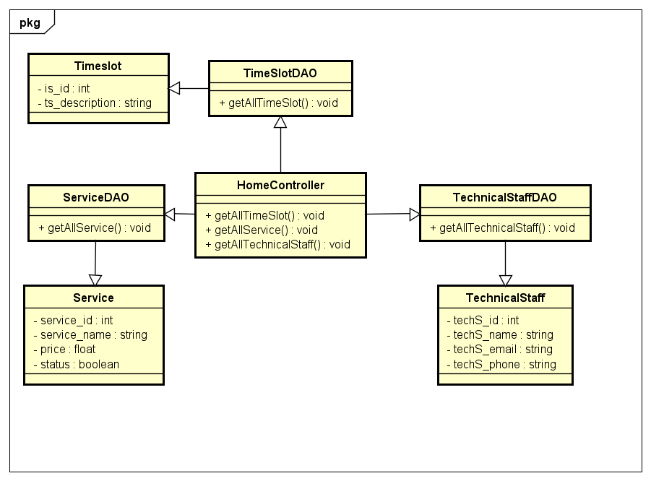

### c. Class Specifications

|  |  |  |
| --- | --- | --- |
| **No** | **Method** | **Description** |
| *01* | *getAllService()* | *get all property in Service* |
| *02* | *getAllTimeslot()* | *get all property in Timeslot* |
| *03* | *getAllTechnicalStaff()* | *get all property in TechnicalStaff* |

### 

### d. Sequence Diagram(s)

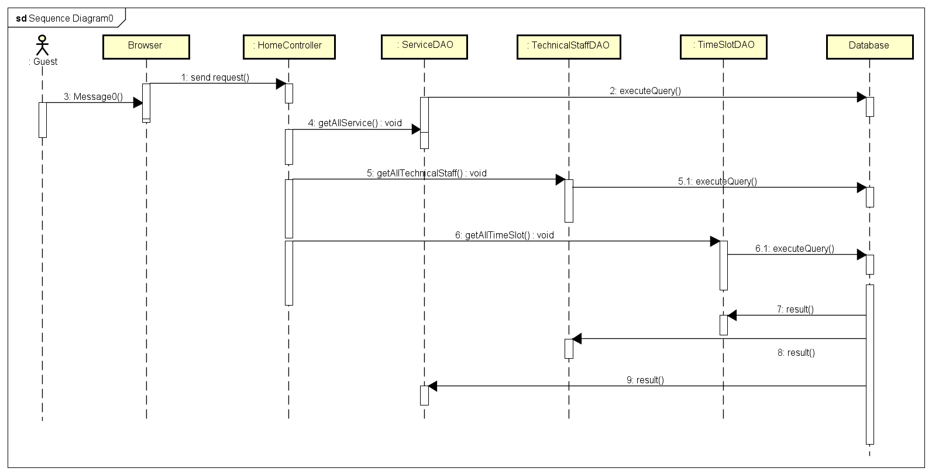

### e. Database queries

*SELECT * FROM Service*

*SELECT * FROM TechnicalStaff*

*Select * from TimeSlot*

## 2. Common/Login

### a. Screen Design

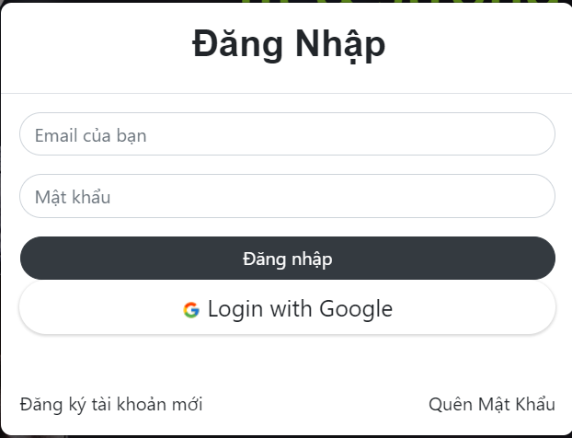

### b. Class Diagram

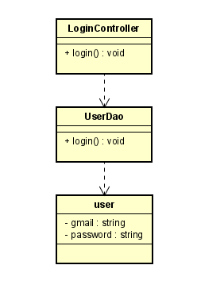

### c. Class Specifications

|  |  |  |
| --- | --- | --- |
| **No** | **Method** | **Description** |
| *01* | *login* | *using to login into the system* |
|  |  |  |

### d. Sequence Diagram(s)

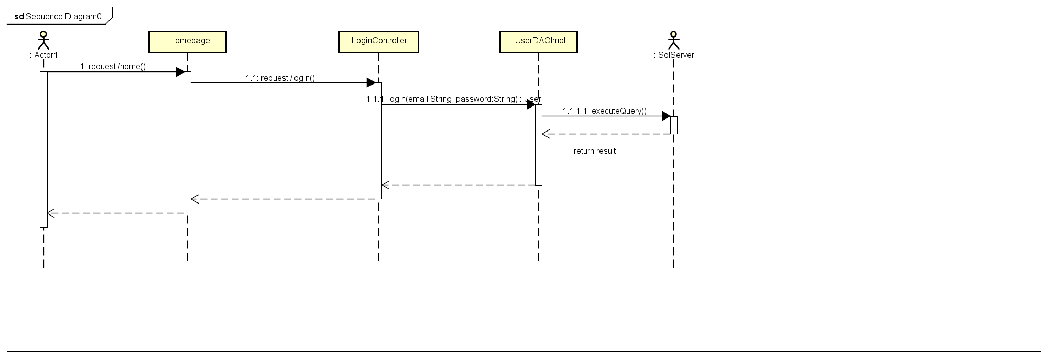

### e. Database queries

***String sql = "SELECT * FROM User where email=? and password=?"***

## 3. Common/Register

### a. Screen Design

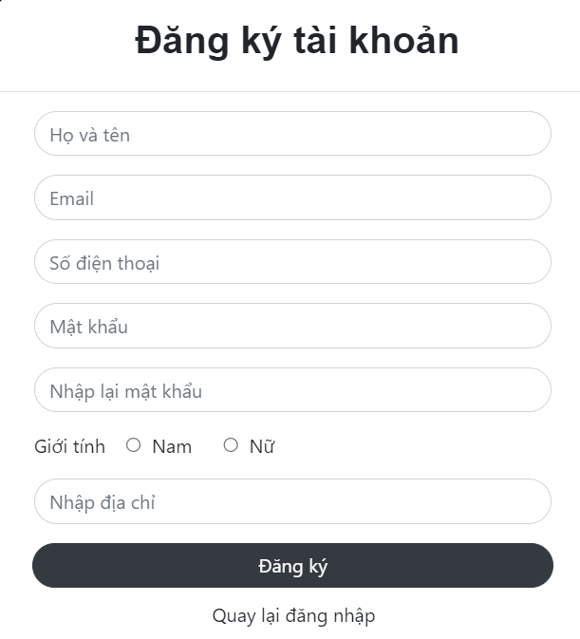

### b. Class Diagram

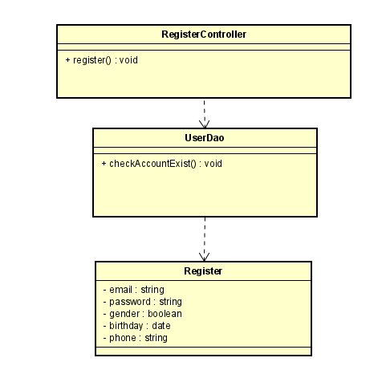

### c. Class Specifications

|  |  |  |
| --- | --- | --- |
| **No** | **Method** | **Description** |
| ***1*** | ***Register*** | ***use to create new user*** |
| ***2*** | ***checkAccountExist*** | ***use to check email exist*** |

### d. Sequence Diagram(s)

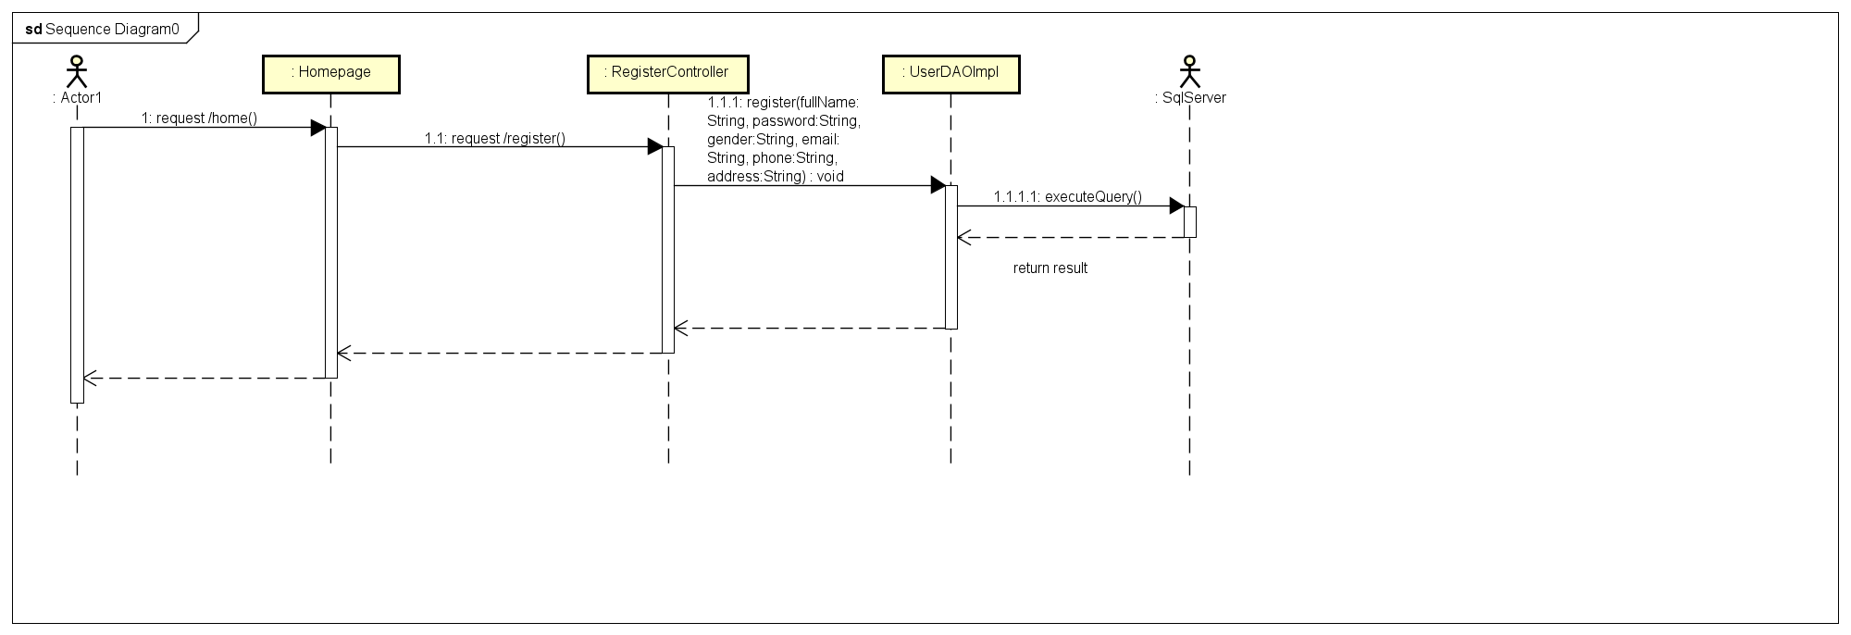

### e. Database queries

*-* ***SELECT * FROM User WHERE email =?***

*-* ***INSERT INTO User (fullName, email, phone,gender, birthday, password) VALUES (?, ?, ?, ?, ?,?)***

## 4. Common/UserProfile

### a. Screen Design

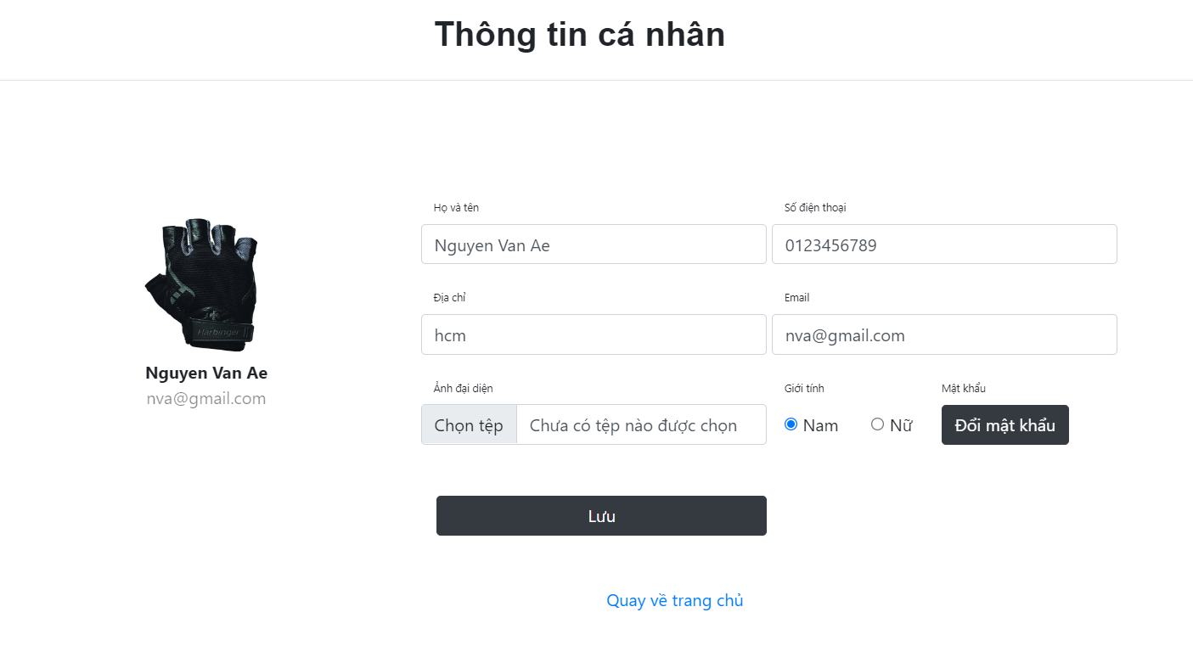

### b. Class Diagram

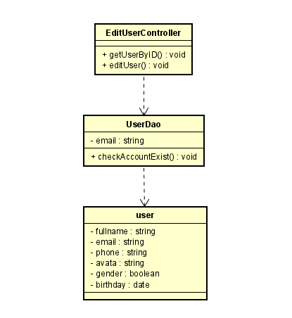

### c. Class Specifications

|  |  |  |
| --- | --- | --- |
| **No** | **Method** | **Description** |
| ***1*** | ***getUserByID()*** | ***use to find account profile by it’s id*** |
| ***2*** | ***editUser()*** | ***use to update user’s profile*** |

### d. Sequence Diagram(s)

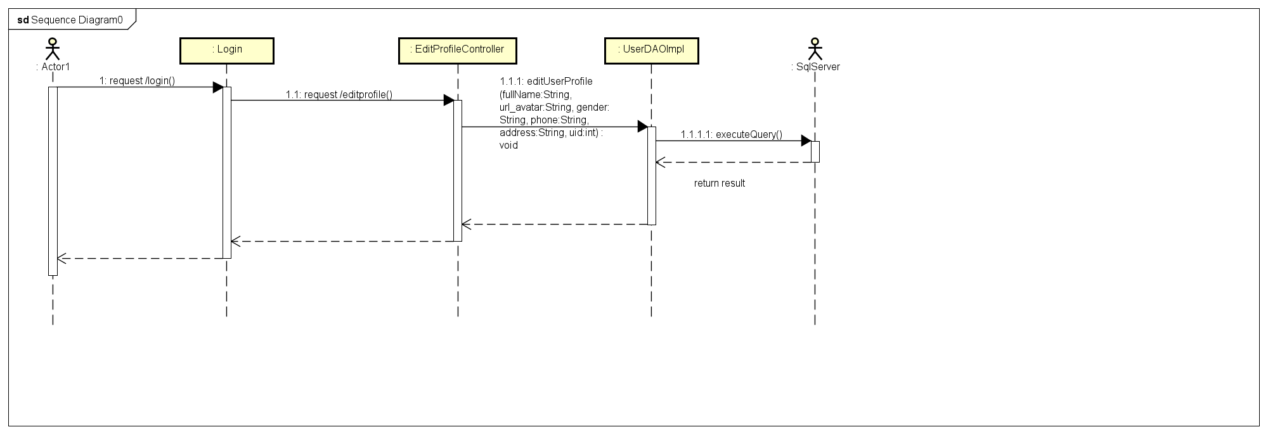

### e. Database queries

* ***Select fullName, gender, email, mobile, img FROM User***
* ***UPDATE User SET fullName = ?, gender = ?, email = ?, phone= ?, img = ?***

***WHERE id = ?***

## 5. Common/Reset Password

### a. Screen Design

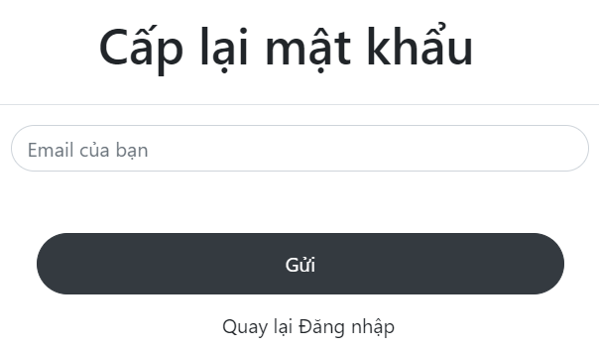

### b. Class Diagram

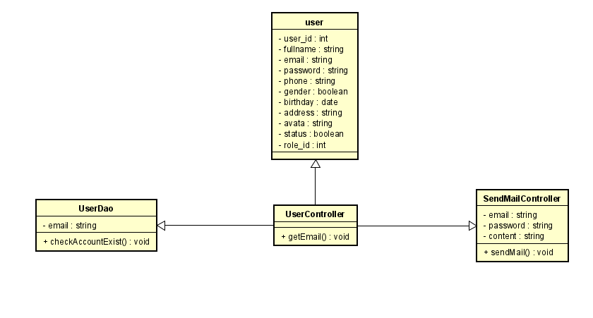

### c. Class Specifications

|  |  |  |
| --- | --- | --- |
| **No** | **Method** | **Description** |
| ***01*** | ***getEmail()*** | ***Retrieve the User's Email entered*** |
| ***02*** | ***checkAccByEmail()*** | ***Check email existence*** |
| ***03*** | ***sendMail()*** | ***Send a link that leads the user to the reset password page*** |

### d. Sequence Diagram(s)

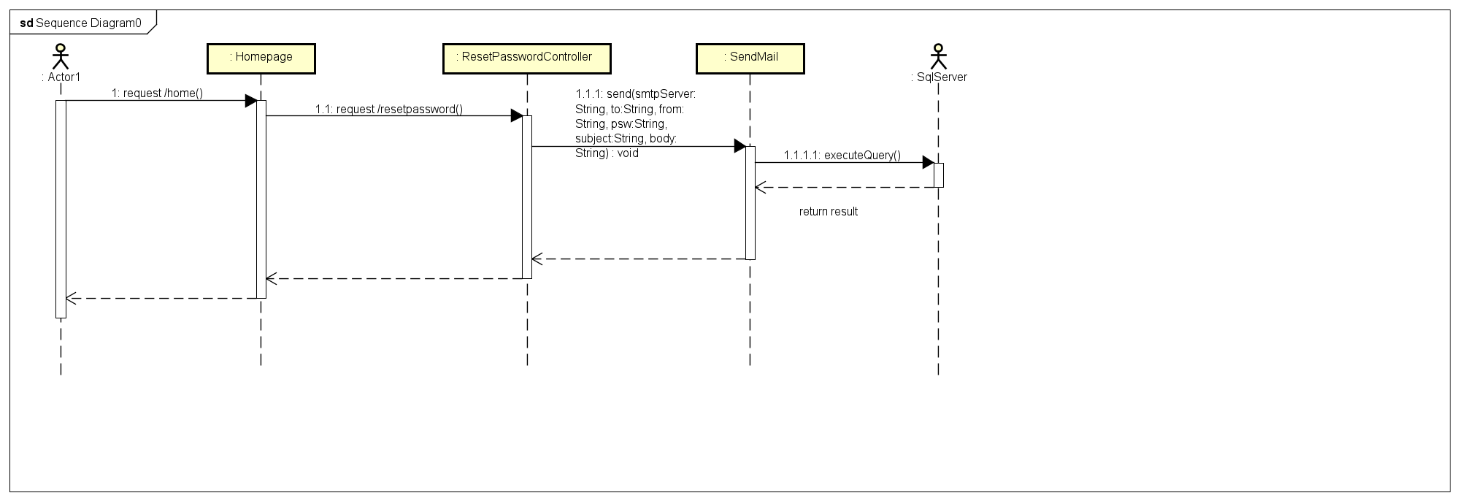

### e. Database queries

***- select * from User where email = ?***

***- update User set password = ? where user_id = ?***

## 6. Common/Logout

### d. Sequence Diagram(s)

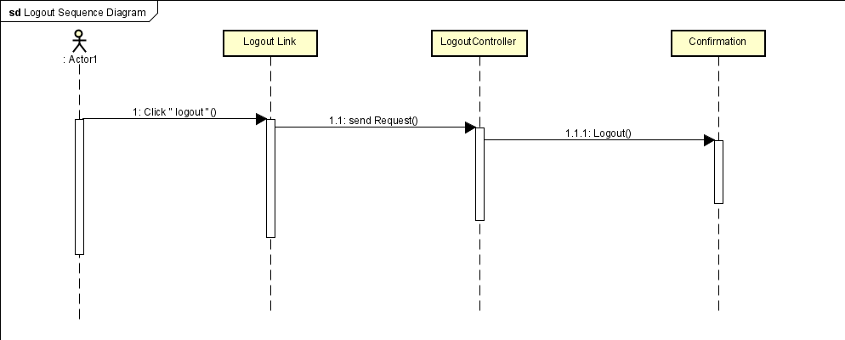

## 7. Public / Product List

### a. Screen Design

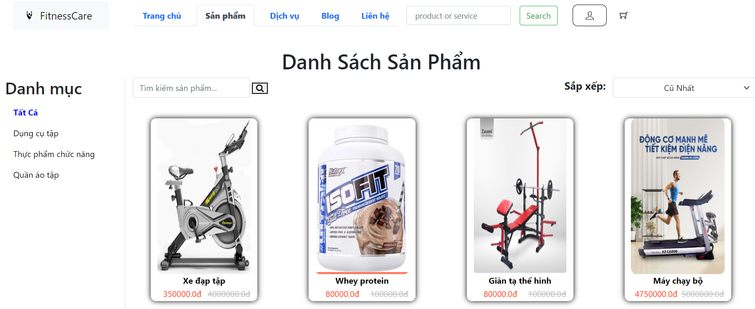

### b. Class Diagram

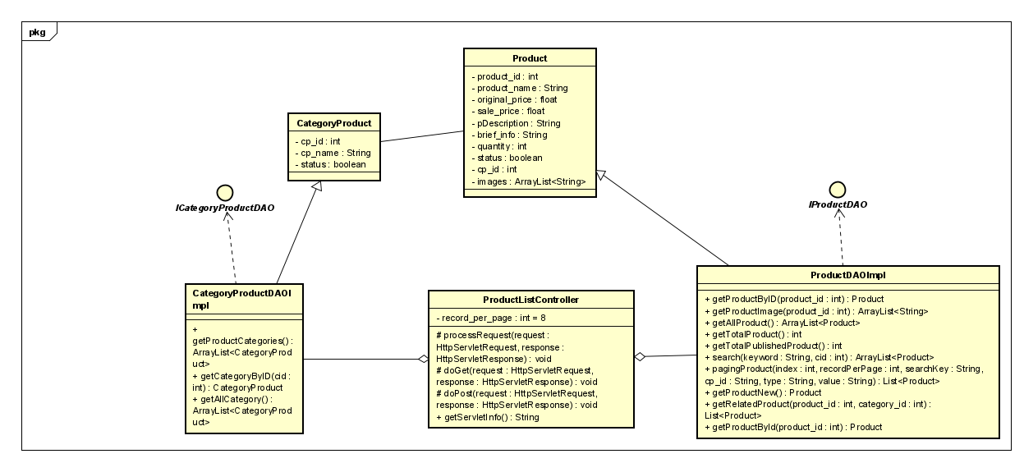

### c. Class Specifications

|  |  |  |
| --- | --- | --- |
| **No** | **Method** | **Description** |
| ***01*** | ***getAllProduct()*** | ***get all product in db*** |
| ***02*** | ***getTotalProduct()*** | ***get number of product in db*** |
| ***03*** | ***pagingProduct()*** | ***pagination for product list display*** |
| ***04*** | ***getAllCategoryProduct()*** | ***get all categoryProduct in db*** |

### d. Sequence Diagram(s)

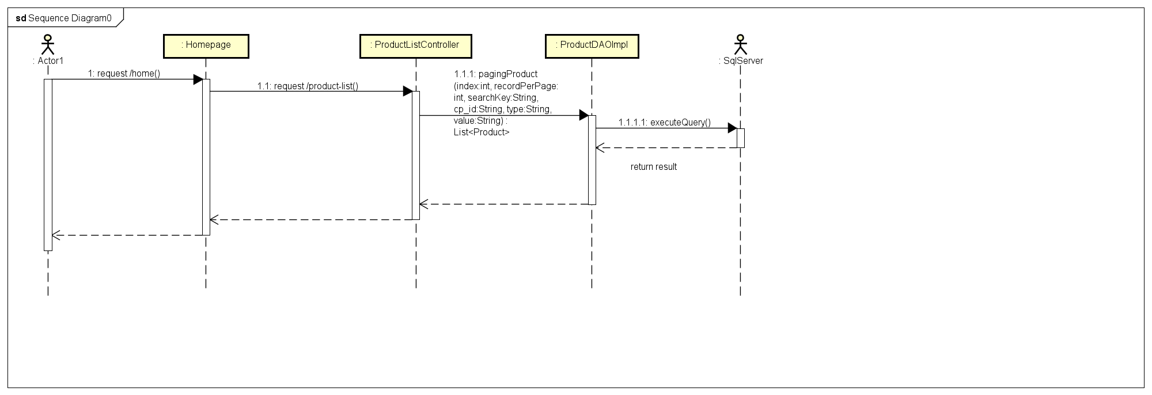

### e. Database queries

***- select * from Product = ?***

***- select * from CategoryProduct = ?***

***- select COUNT(product_id) from Product***

***- select * from Product where cp_id " + cp_id + " and product_name like '%" + searchKey + "%' "***

***+ "order by " + value + " " + type + " offset ? rows fetch next ? rows only;***

## 8. Public/ProductDetail

### a. Screen Design

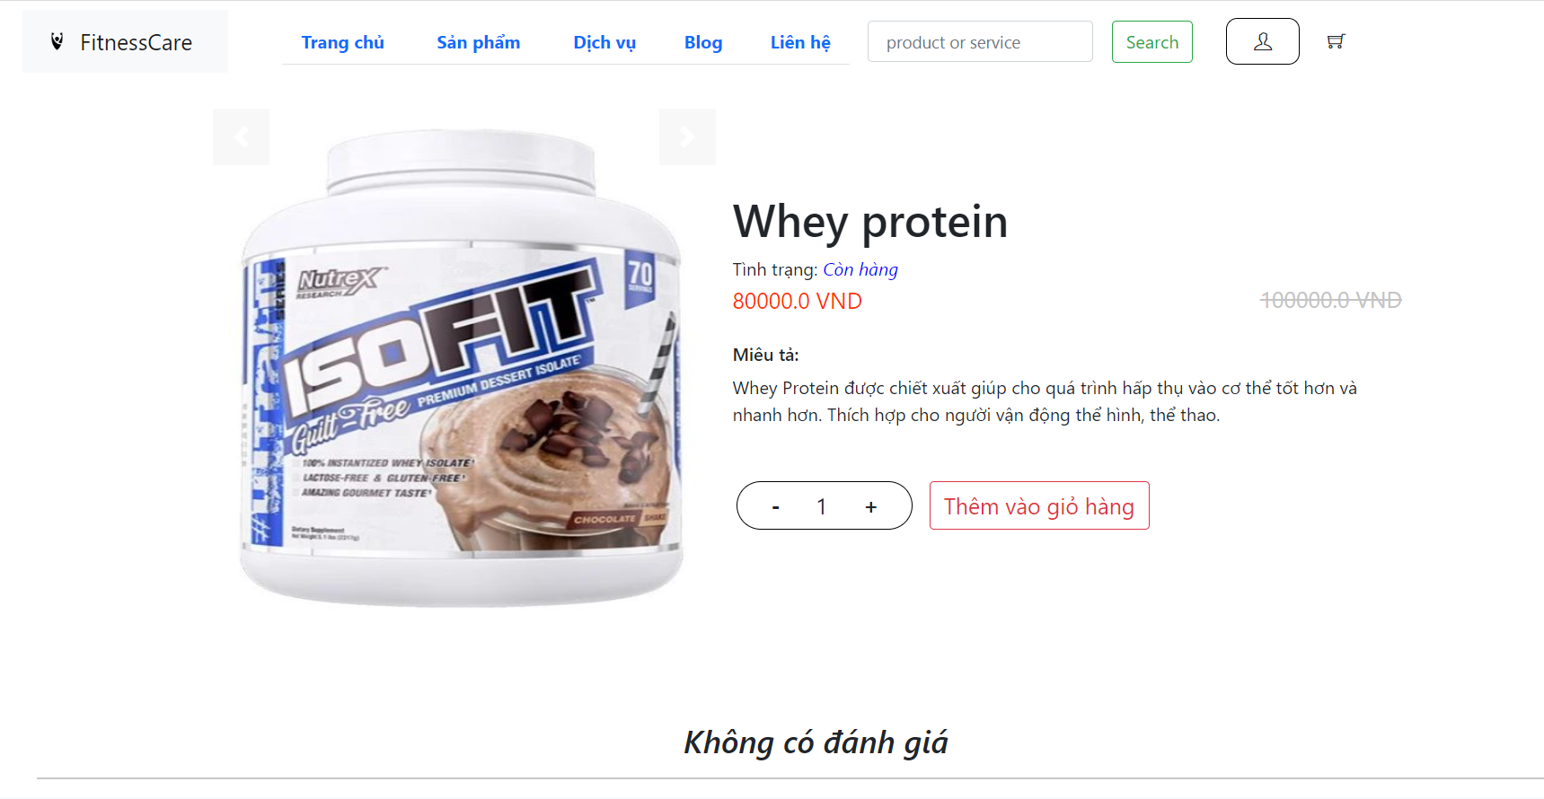

### b. Class Diagram

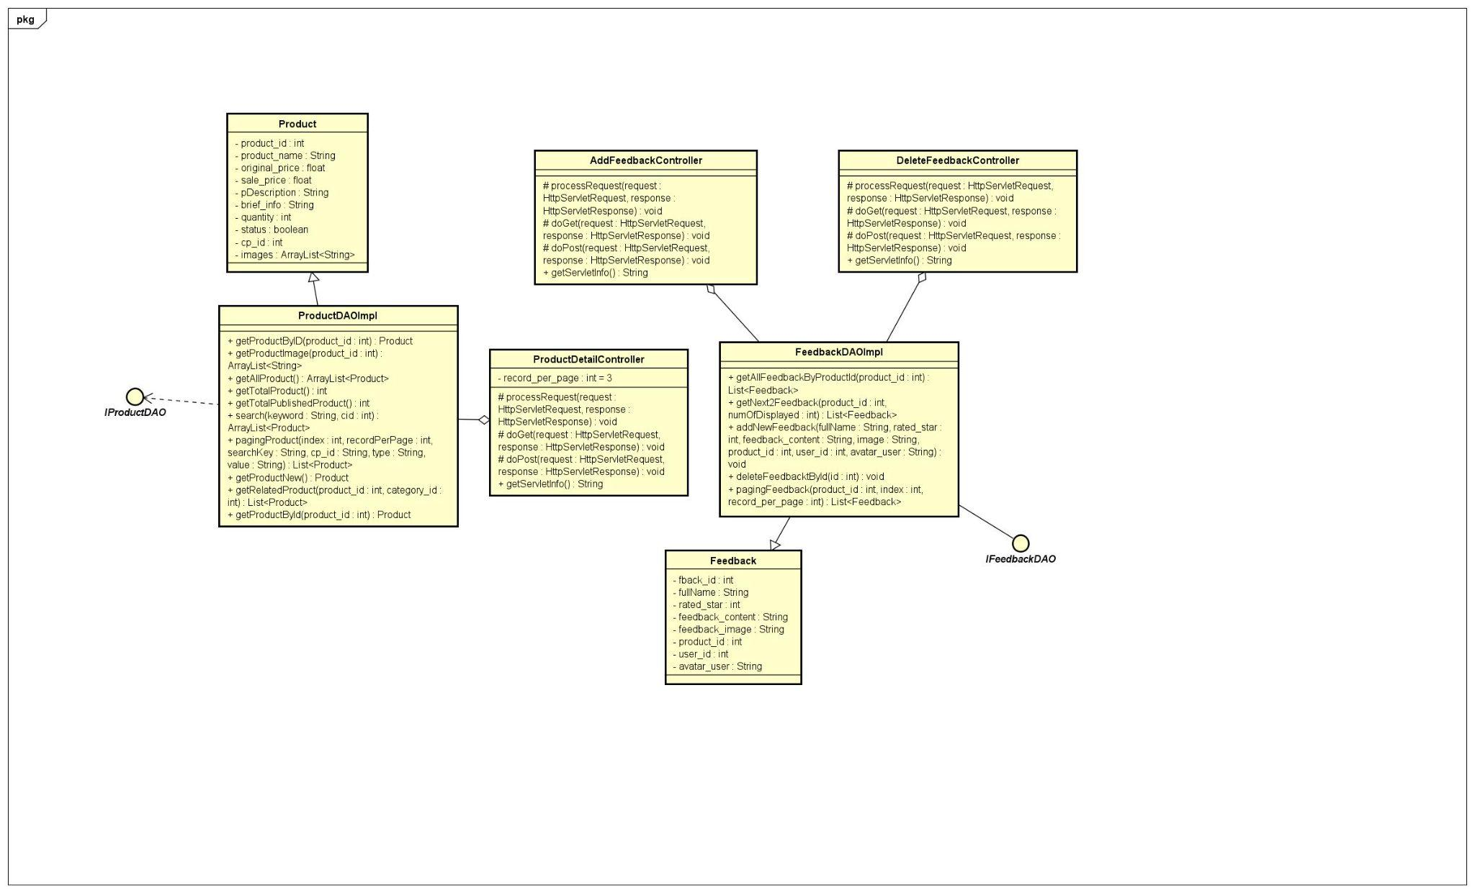

### c. Class Specifications

|  |  |  |
| --- | --- | --- |
| **No** | **Method** | **Description** |
| ***01*** | ***getProductByID()*** | ***get Product By product_id*** |
| ***02*** | ***GetAllFeedbackByProductID(pId)*** | ***get all feedback correspond a product*** |
| ***03*** | ***pagingFeedback*** | ***pagination for feedback list display*** |

### 

### d. Sequence Diagram(s)

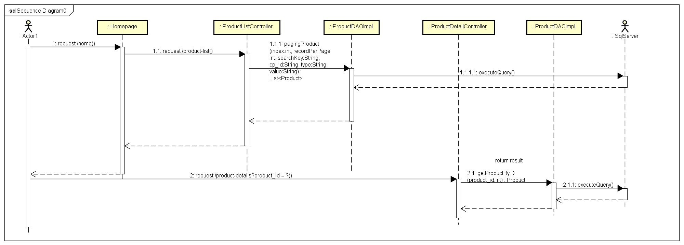

### e. Database queries

***- select * from Product where product_id = ?***

***- select * from Feedback where product_id = ?***

***- select * from Feedback where product_id = ? offset ? rows fetch next ? rows only;***

## 9. Cart management/View All product in cart

### a. Screen Design

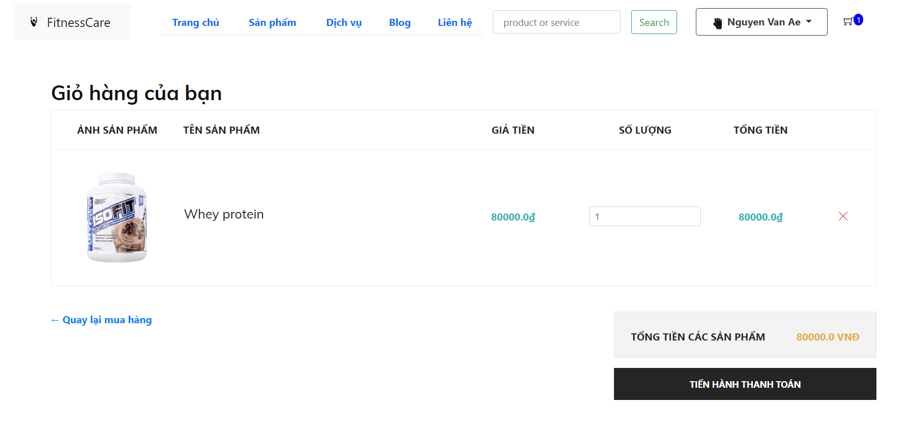

### b. Class Diagram

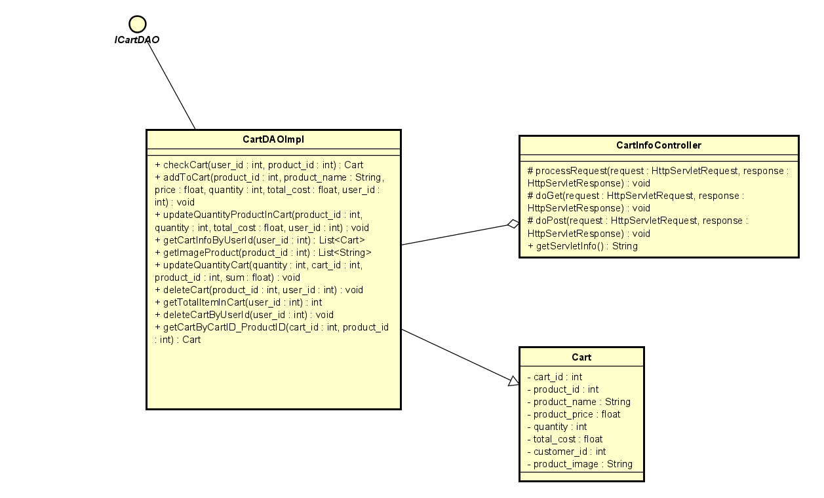

### c. Class Specifications

|  |  |  |
| --- | --- | --- |
| **No** | **Method** | **Description** |
| ***01*** | ***getCartInfoByUserId()*** |  |

### d. Sequence Diagram(s)

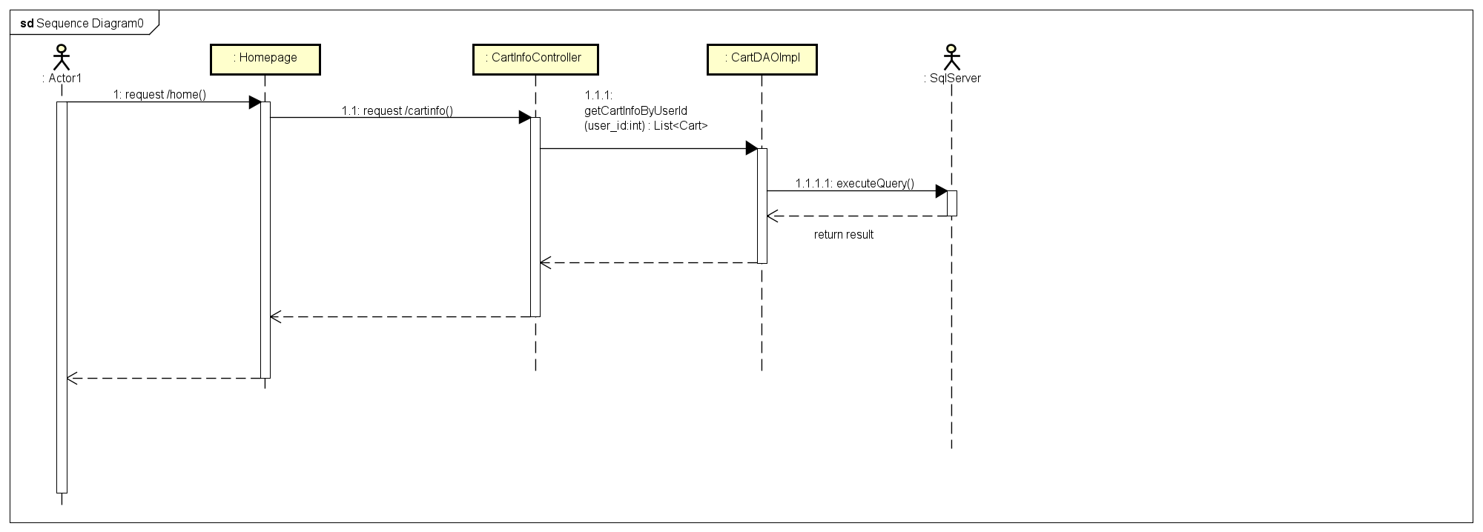

### e. Database queries

***- select * from Cart where user_id = ?***

## 10. Cart management/Cart checkout

### a. Screen Design

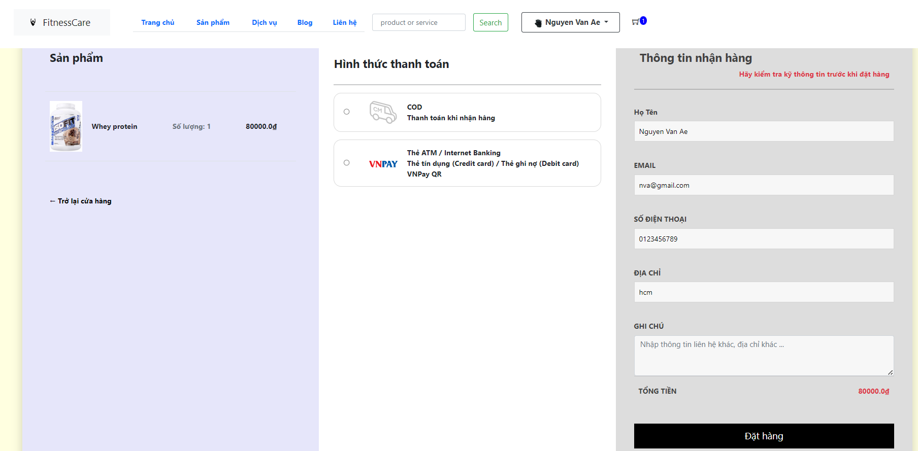

### b. Class Diagram

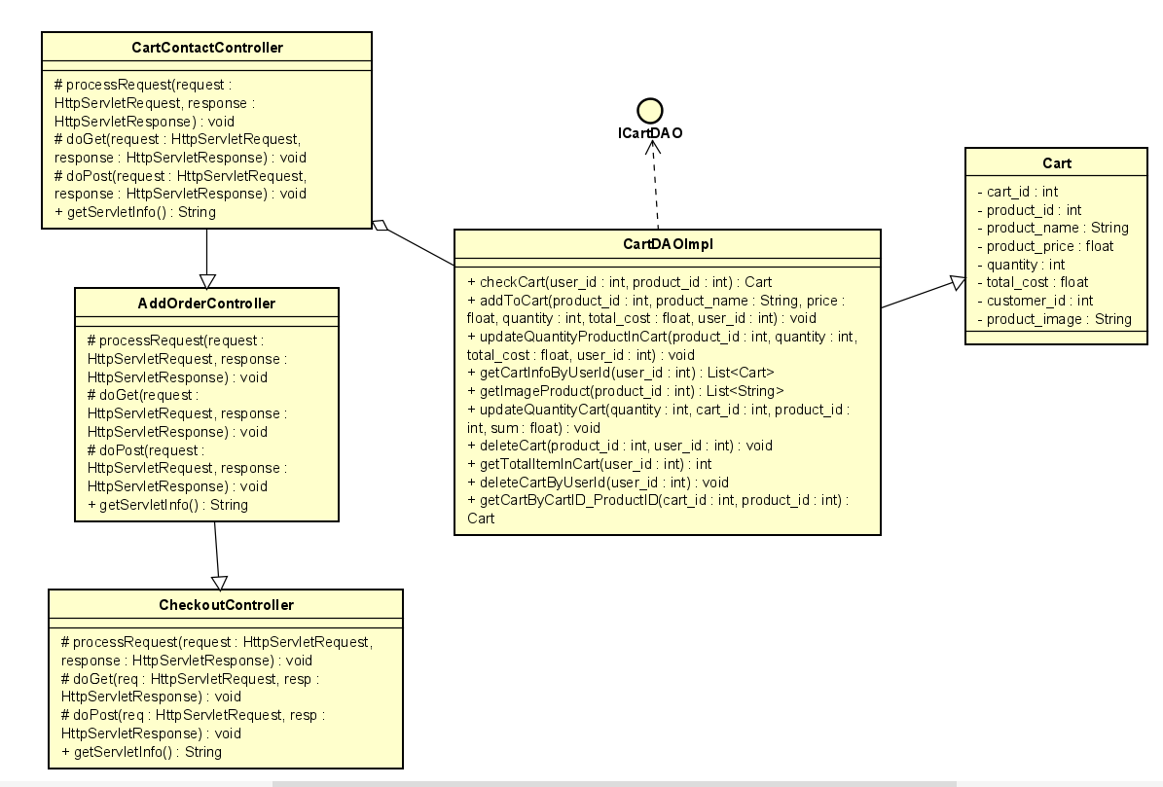

### c. Class Specifications

|  |  |  |
| --- | --- | --- |
| **No** | **Method** | **Description** |
| ***01*** | ***getCartInfoByUserId(user_id)*** | ***getCartInfo for user*** |
| ***02*** | ***createNewOrder(sum, fullname, email, phone, address, user_id, note)*** | ***Add cartinfo to Order*** |
| ***03*** | ***addCartToOrder(listCart, order_id)*** | ***Add cart info detail to Orderdetail*** |

### d. Sequence Diagram(s)

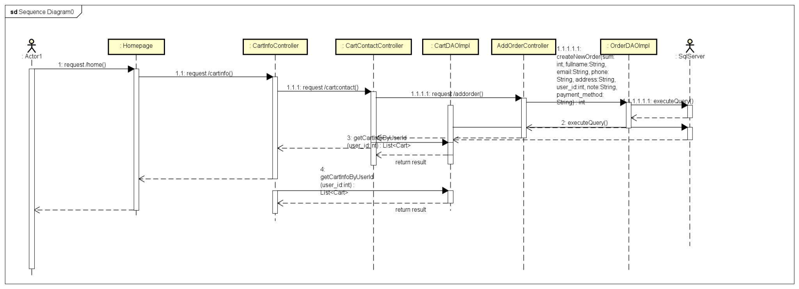

### e. Database queries

***- INSERT INTO [dbo].[Order] ([total_cost] ,[customer_name] ,[email] ,[phone] ,[address] ,[customer_id] ,[note]) VALUES (?,?,?,?,?,?,?)***

***- INSERT INTO [dbo].[OrderDetail] values (?,?,?,?,?,?)***

***- select * from Cart where user_id = ?***

## 11. Public / Service List

### a. Screen Design

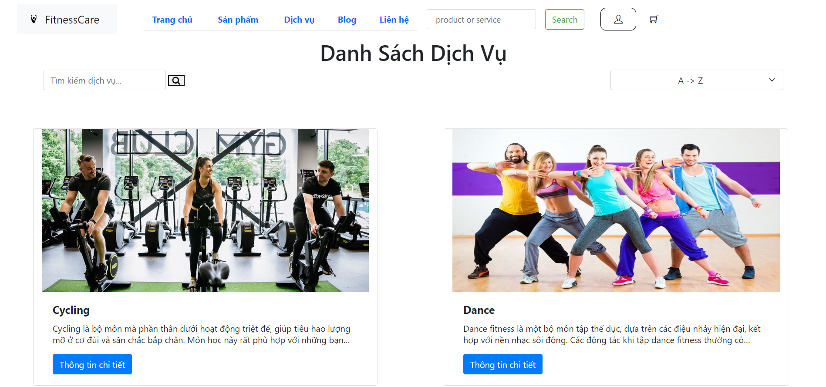

### b. Class Diagram

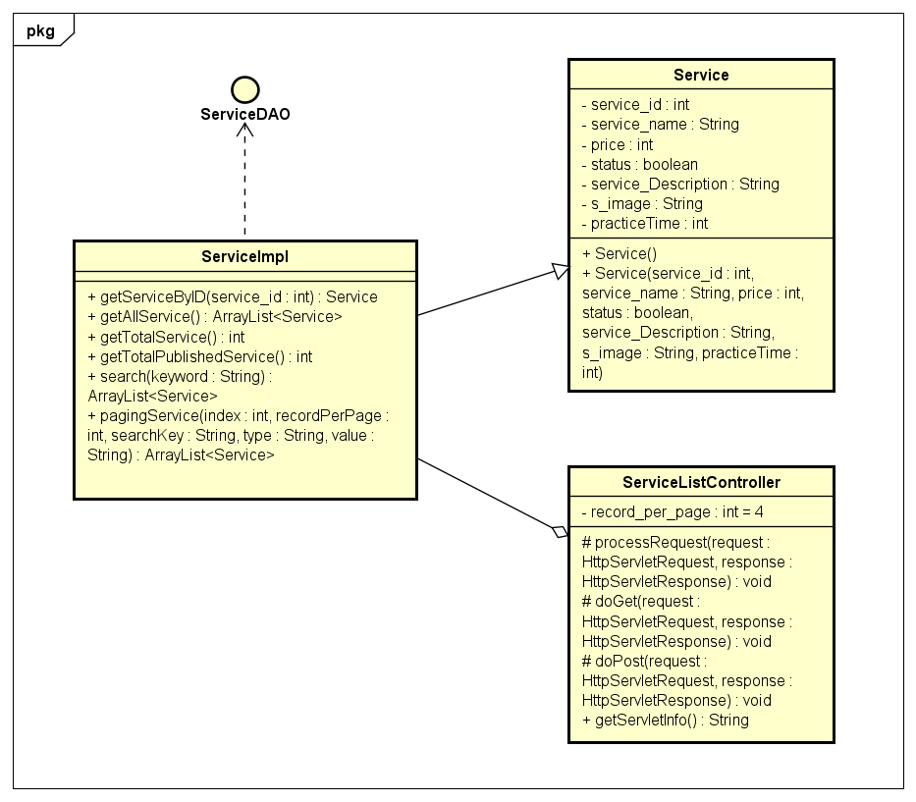

### c. Class Specifications

|  |  |  |
| --- | --- | --- |
| **No** | **Method** | **Description** |
| ***01*** | ***getAllService()*** | ***get all service in db*** |
| ***02*** | ***getTotalService()*** | ***get number of service in db*** |
| ***03*** | ***pagingService()*** | ***pagination for service list display*** |

### d. Sequence Diagram(s)

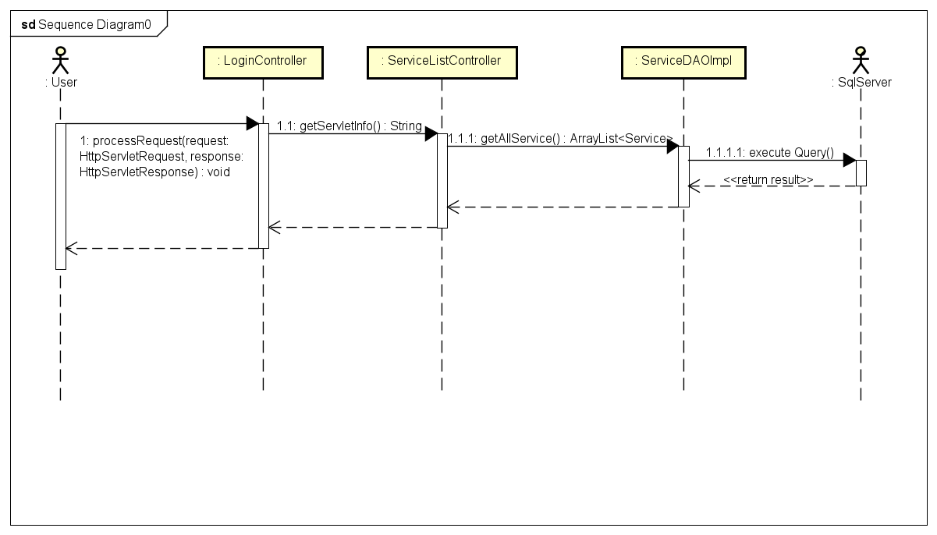

### e. Database queries

***- select * from [Service]***

***- select COUNT(service_id) from Service***

***- select * from Service where service_name like '%" + searchKey + "%' "***

***+ "order by " + value + " " + type + " offset ? rows fetch next ? rows only***

## 12. Public/Service Detail

### a. Screen Design

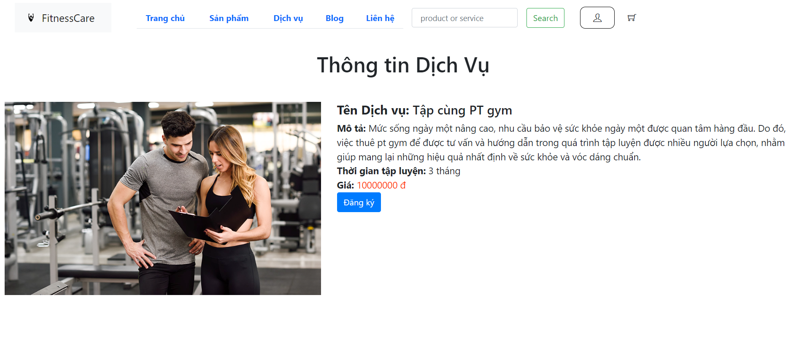

### b. Class Diagram

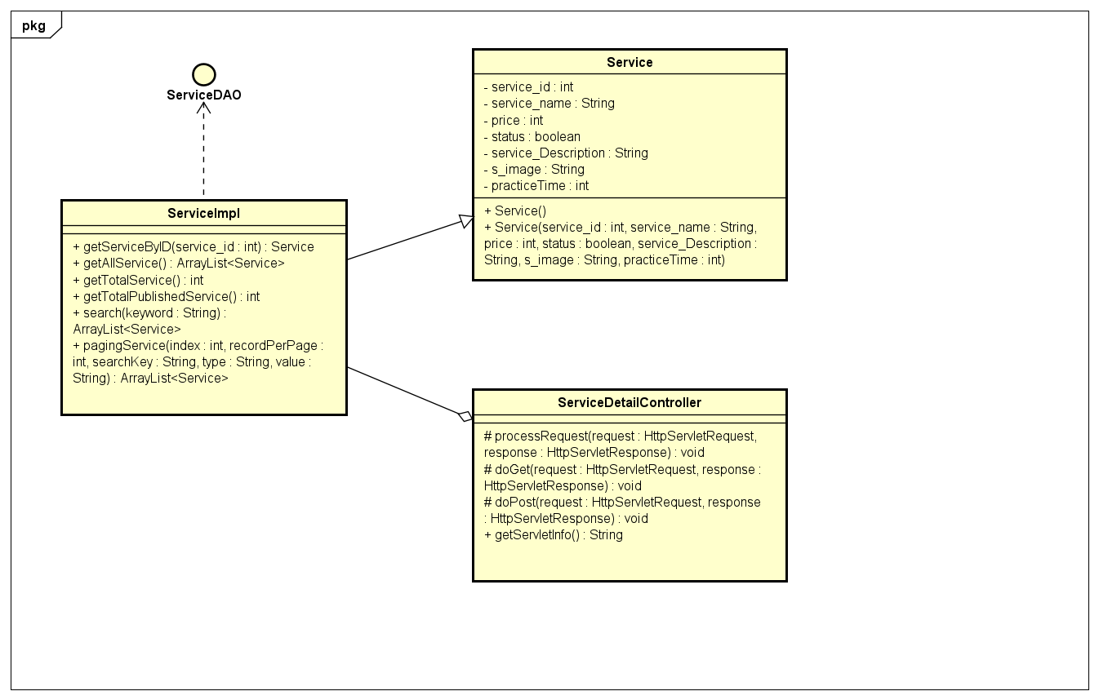

### c. Class Specifications

|  |  |  |
| --- | --- | --- |
| **No** | **Method** | **Description** |
| ***01*** | ***getServiceByID()*** | ***get Service By service_id*** |

### 

### d. Sequence Diagram(s)

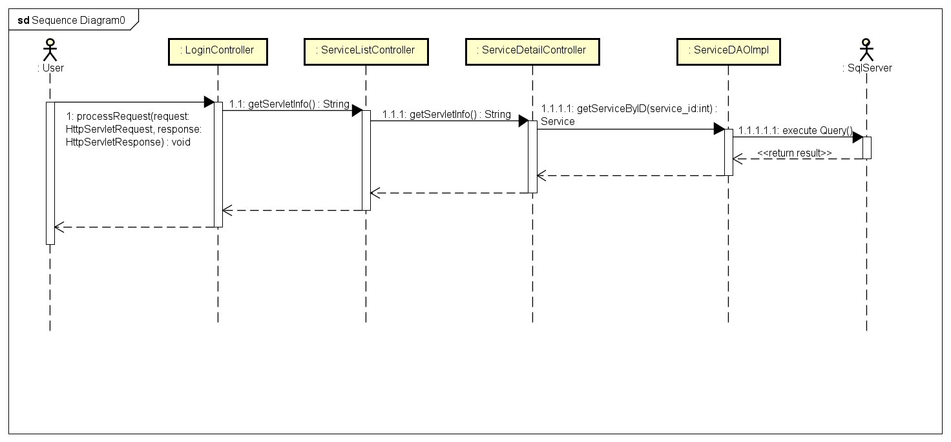

### e. Database queries

***- select * from [Service] where service_id=?***

## 13. Service Management / Register Service

### a. Screen Design

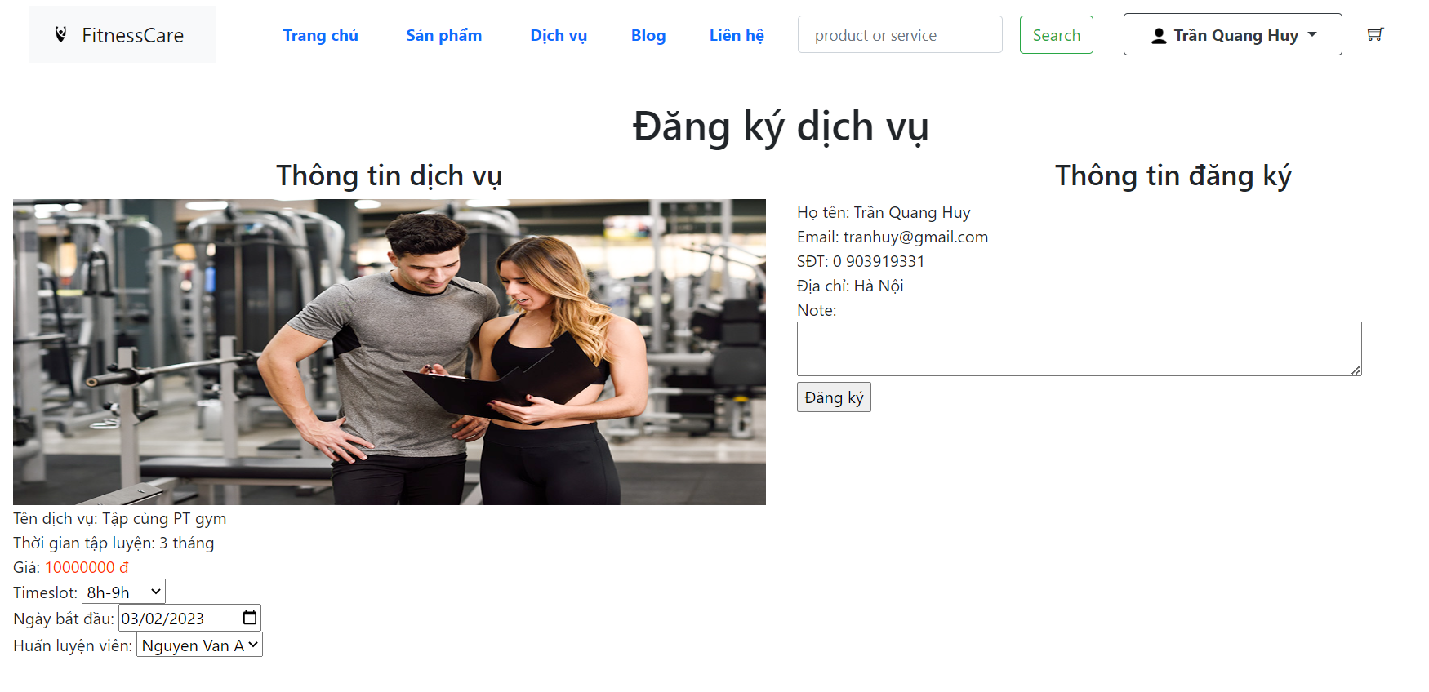

### b. Class Diagram

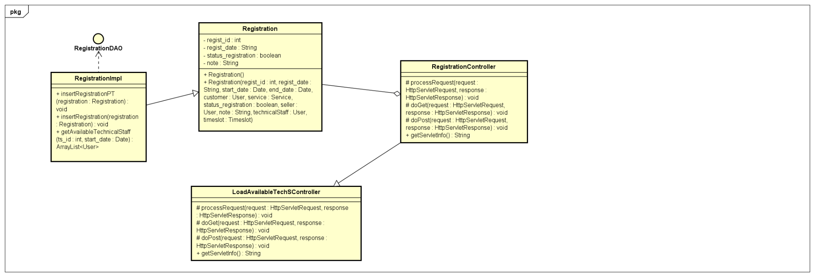

### c. Class Specifications

|  |  |  |
| --- | --- | --- |
| **No** | **Method** | **Description** |
| ***01*** | ***getServiceByID()*** | ***get Service By service_id*** |
| ***02*** | ***getAllTimeslot()*** | ***get all timeslot in db*** |
| ***03*** | ***insertRegistration()*** | ***insert information of registration service into db*** |
| ***04*** | ***insertRegistrationPT()*** | ***insert information of registration service with PT into db*** |
| ***05*** | ***getAvailableTechnicalStaff()*** | ***get all technical staff available with choice in db*** |

### 

### d. Sequence Diagram(s)

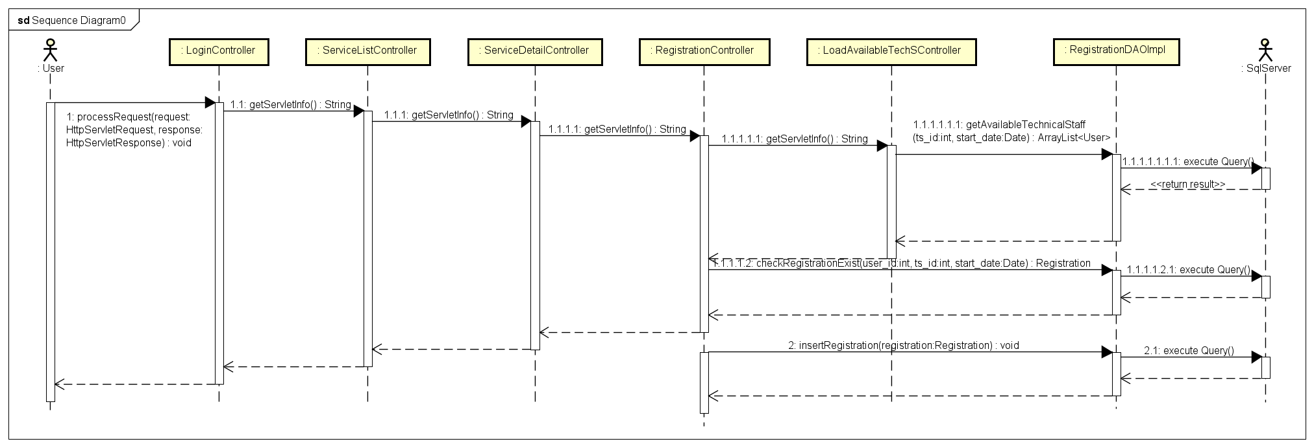

### e. Database queries

***- select * from [Service] where service_id=?***

***- SELECT * FROM [dbo].[Timeslot]***

***- INSERT INTO [dbo].[Registration]\n"***

***+ " ([customer_id]\n"***

***+ " ,[techS_id]\n"***

***+ " ,[service_id]\n"***

***+ " ,[status_regist_id]\n"***

***+ " ,[ts_id]\n"***

***+ " ,[regist_date]\n"***

***+ " ,[start_date]\n"***

***+ " ,[end_date]\n"***

***+ " ,[note])\n"***

***+ " VALUES\n"***

***+ " (?"***

***+ " ,?"***

***+ " ,?"***

***+ " ,'2'"***

***+ " ,?"***

***+ " ,GETDATE()"***

***+ " ,?"***

***+ " ,?"***

***+ " ,?)***

***- INSERT INTO [dbo].[Registration]\n"***

***+ " ([customer_id]\n"***

***+ " ,[service_id]\n"***

***+ " ,[status_regist_id]\n"***

***+ " ,[ts_id]\n"***

***+ " ,[regist_date]\n"***

***+ " ,[start_date]\n"***

***+ " ,[end_date]\n"***

***+ " ,[note])\n"***

***+ " VALUES\n"***

***+ " (?"***

***+ " ,?"***

***+ " ,'2'"***

***+ " ,?"***

***+ " ,GETDATE()"***

***+ " ,?"***

***+ " ,?"***

***+ " ,?)***

***- select user_id, fullName from [User] where role_id=3\n"***

***+ "except\n"***

***+ "select techS_id, u.fullName from Registration r join [User] u on r.techS_id=u.user_id \n"***

***+ "where status_regist_id=3 and ts_id=? and DATEDIFF(day, ?, end_date) > 0***

## 14. Material Management / View list Material

### a. Screen Design

### 

### b. Class Diagram

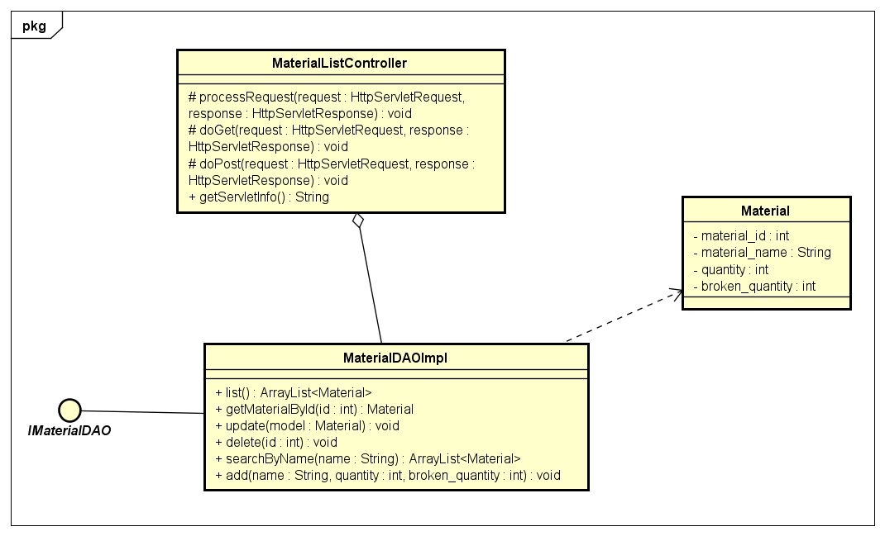

### c. Class Specifications

|  |  |  |
| --- | --- | --- |
| **No** | **Method** | **Description** |
| ***01*** | ***list()*** | ***get all material in db*** |

### 

### d. Sequence Diagram(s)

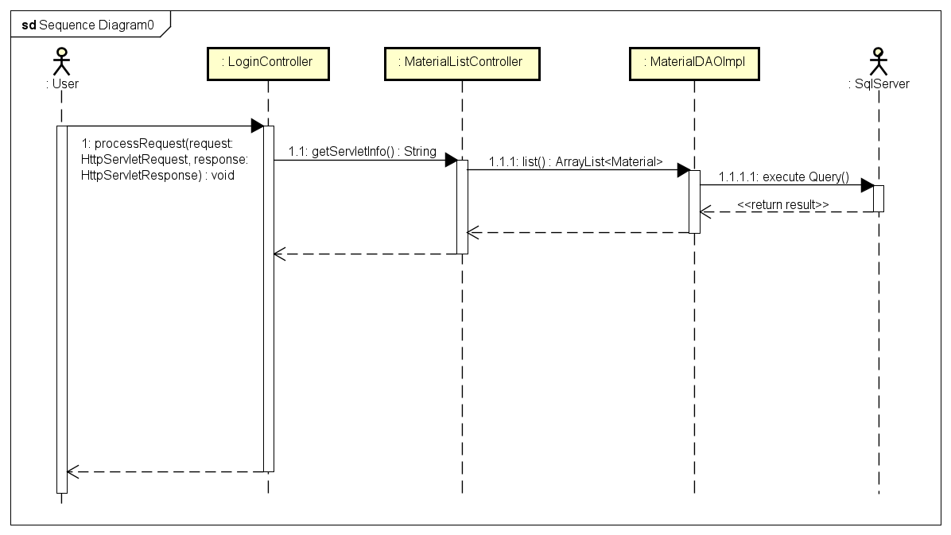

### e. Database queries

***select material_id, material_name, quantity, broken_quantity from Material***

## 15. Material Management / Add Material

### a. Screen Design

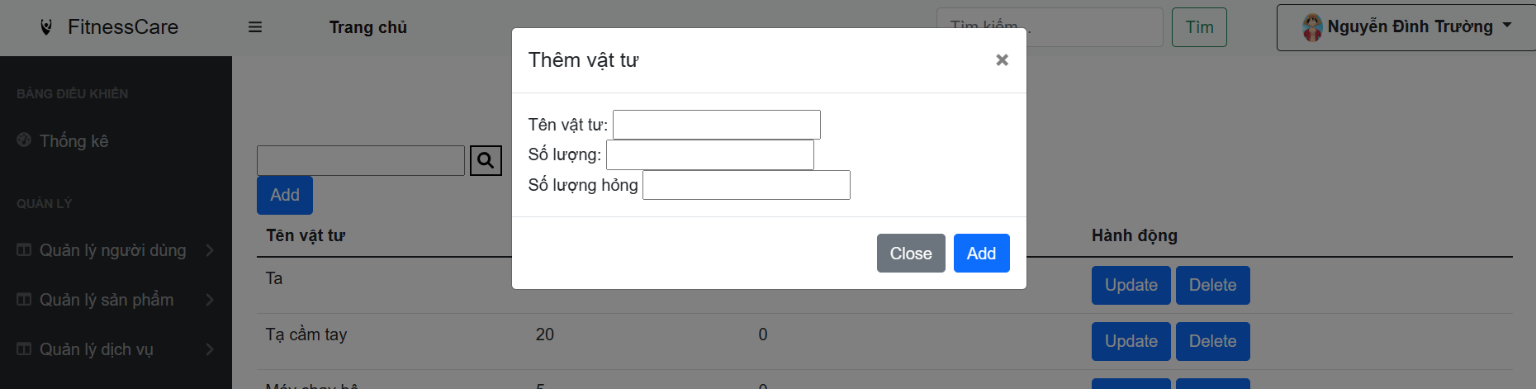

### b. Class Diagram

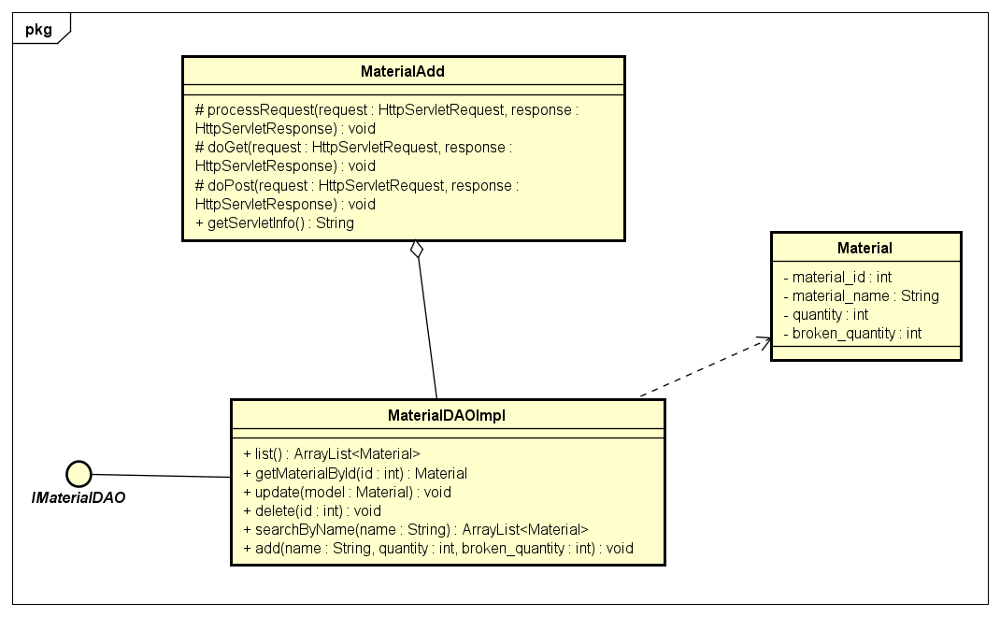

### c. Class Specifications

|  |  |  |
| --- | --- | --- |
| **No** | **Method** | **Description** |
| ***01*** | ***list()*** | ***get all material in db*** |
| ***02*** | ***add()*** | ***insert new information of material to db*** |

### 

### d. Sequence Diagram(s)

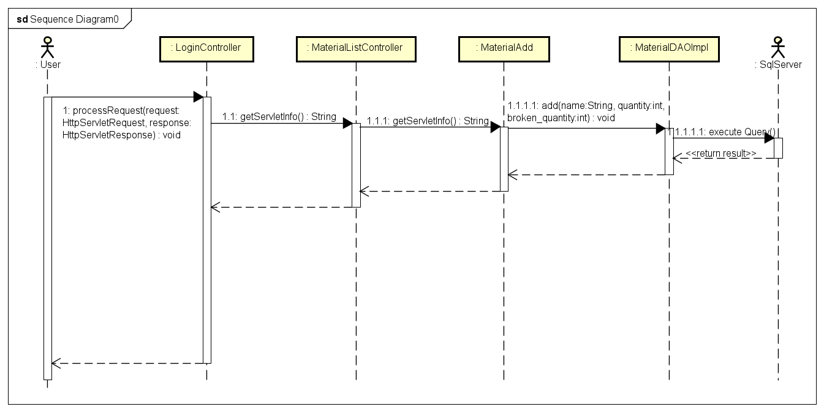

### e. Database queries

***select material_id, material_name, quantity, broken_quantity from Material***

***INSERT INTO Material values (?,?,?)***

## 16. Material Management / Update Material

### a. Screen Design

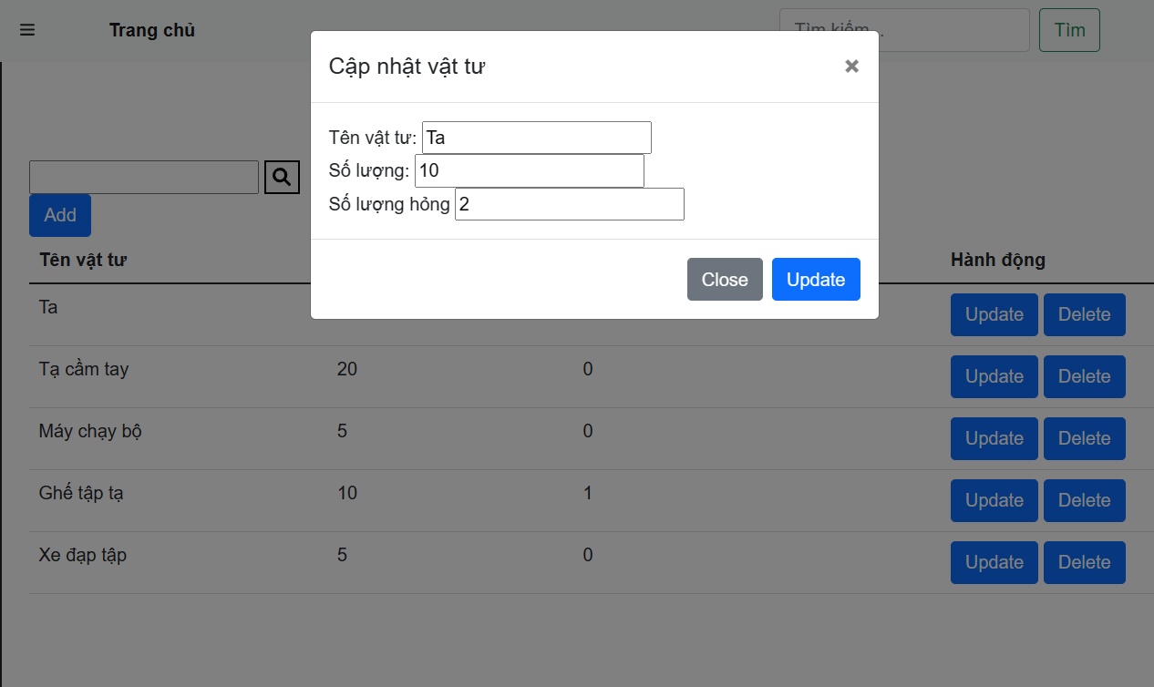

### b. Class Diagram

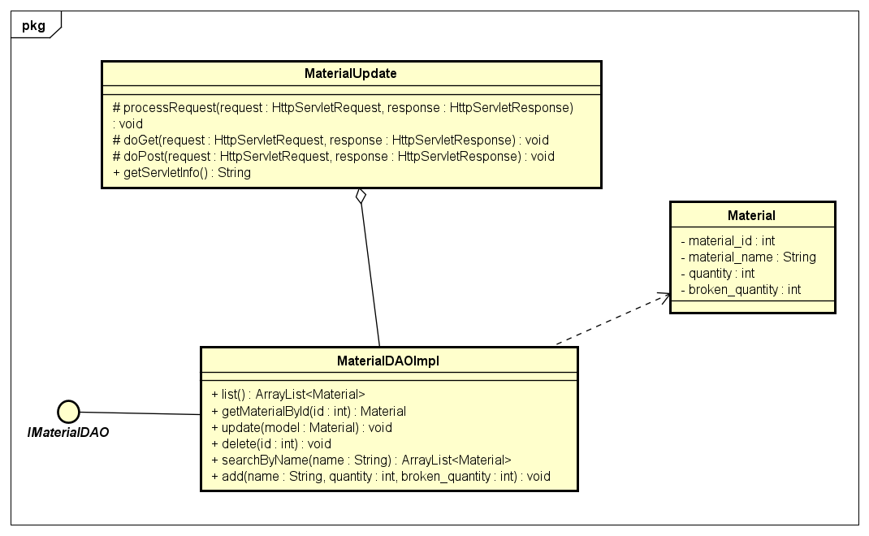

### c. Class Specifications

|  |  |  |
| --- | --- | --- |
| **No** | **Method** | **Description** |
| ***01*** | ***list()*** | ***get all material in db*** |
| ***02*** | ***update()*** | ***update information of material*** |
| ***03*** | ***getMaterialById()*** | ***get all information of material by id*** |

### 

### d. Sequence Diagram(s)

### 

### e. Database queries

***select material_id, material_name, quantity, broken_quantity from Material***

***UPDATE [Material] SET material_name = ? , quantity = ? , broken_quantity = ? WHERE material_id = ?***

## 17. Material Management / Delete Material

### a. Screen Design

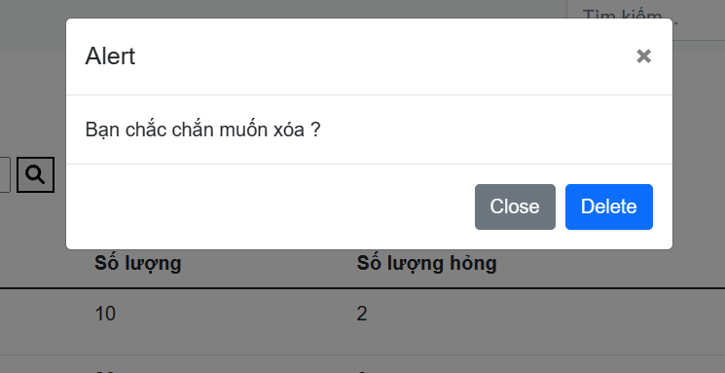

### b. Class Diagram

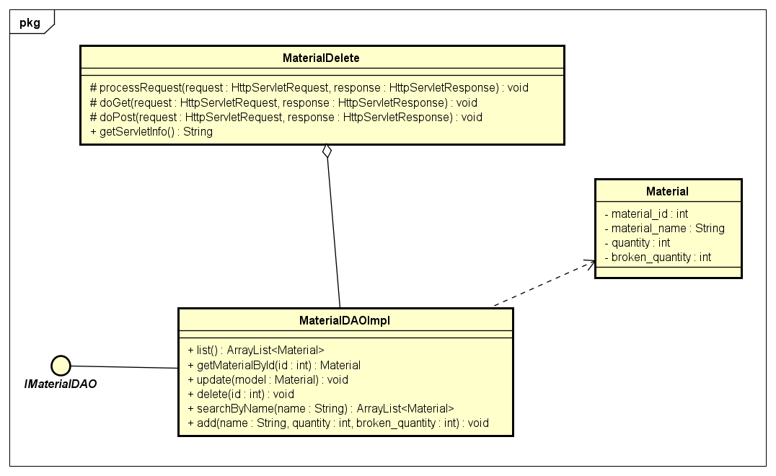

### c. Class Specifications

|  |  |  |
| --- | --- | --- |
| **No** | **Method** | **Description** |
| ***01*** | ***list()*** | ***get all material in db*** |
| ***02*** | ***delete()*** | ***delete material*** |
| ***03*** | ***getMaterialById()*** | ***get all information of material by id*** |

### 

### d. Sequence Diagram(s)

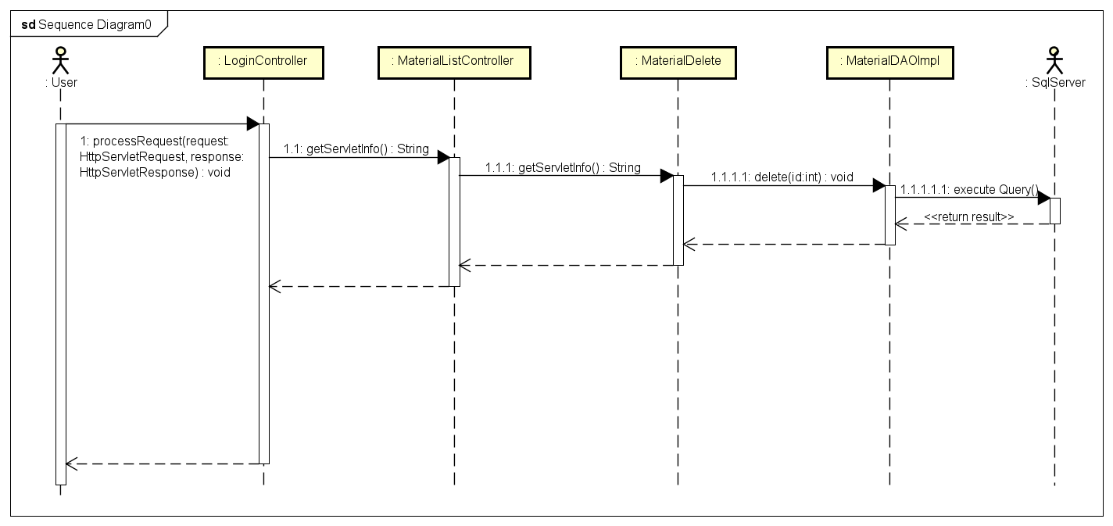

### e. Database queries

***select material_id, material_name, quantity, broken_quantity from Material***

***DELETE FROM Material WHERE material_id = ?***

## 18. Order Management/ApprovalOrder

### a. Screen Design

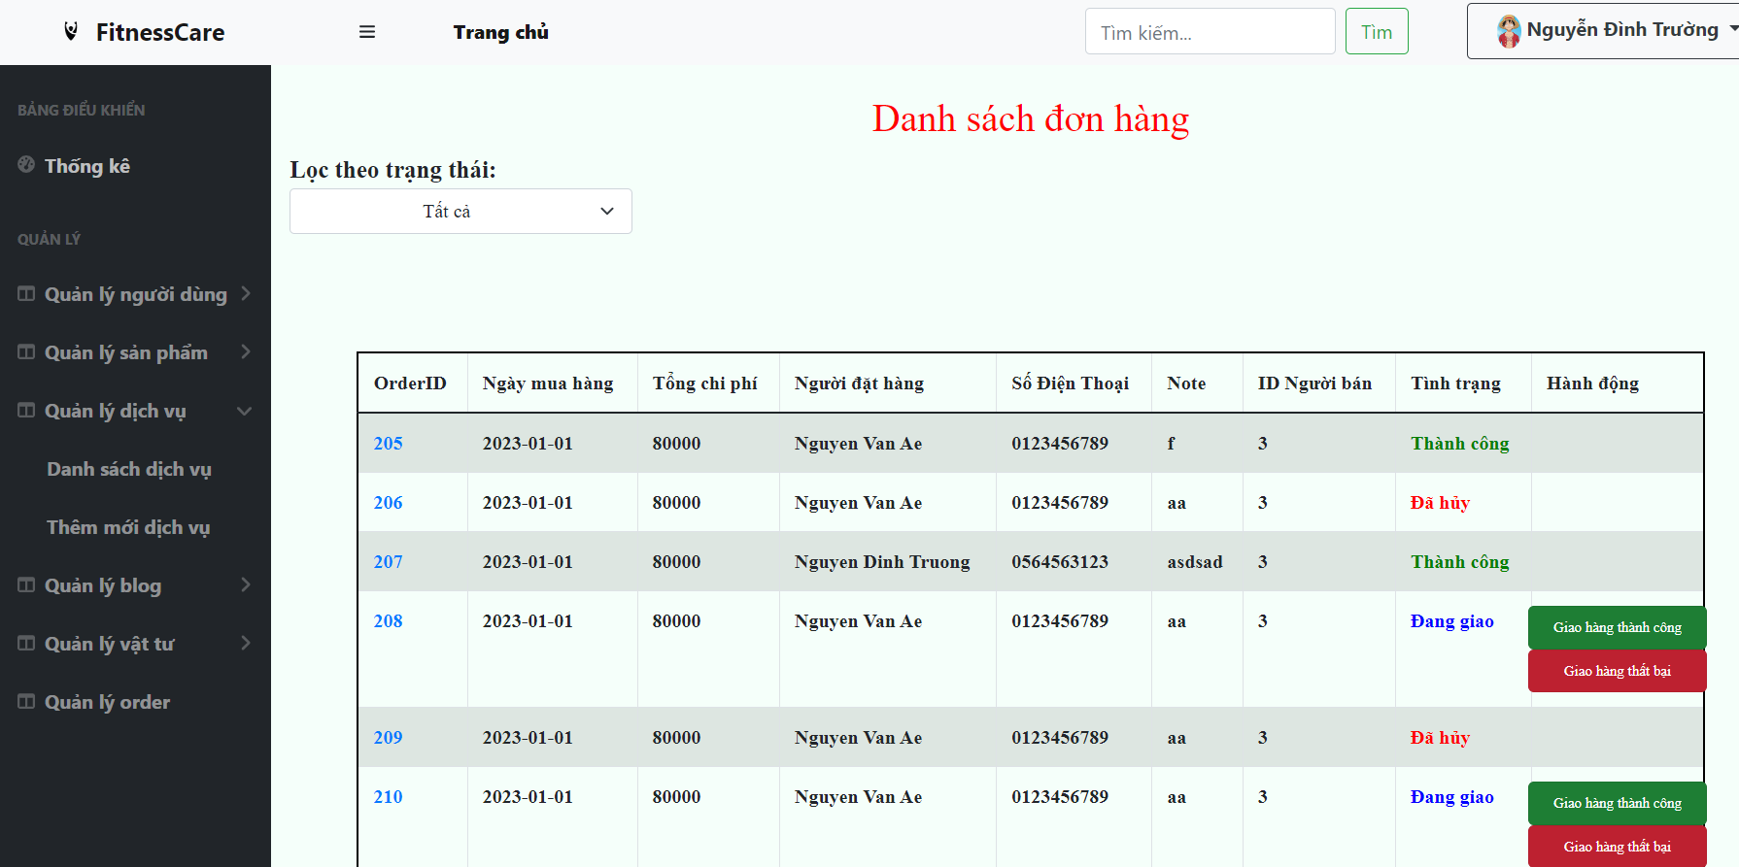

### b. Class Diagram

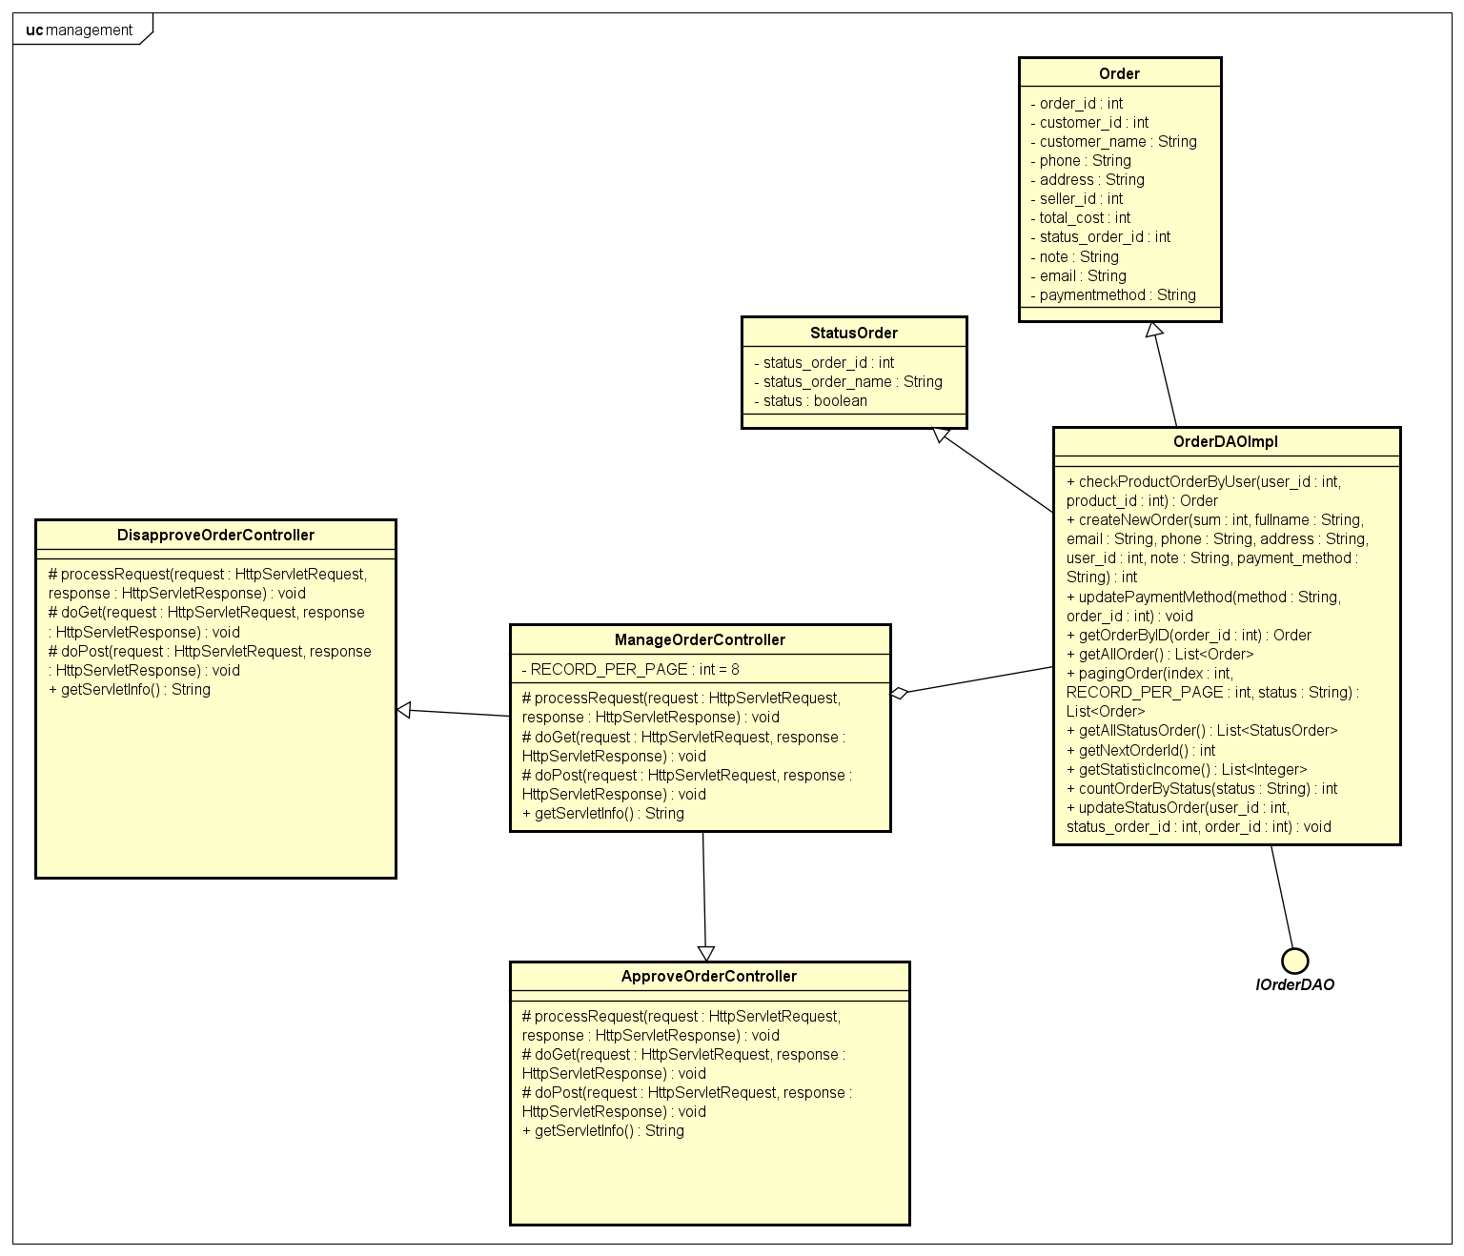

### c. Class Specifications

|  |  |  |
| --- | --- | --- |
| **No** | **Method** | **Description** |
| ***01*** | ***getAllOrder*** | ***get all Order*** |
| ***02*** | ***getAllStatusOrder*** | ***get all status of order*** |
| ***03*** | ***pagingOrder(index, RECORD_PER_PAGE, statusStr*** | ***filter and paging order*** |
| ***04*** | ***countOrderByStatus(statusStr)*** | ***count order by status*** |

### d. Sequence Diagram(s)

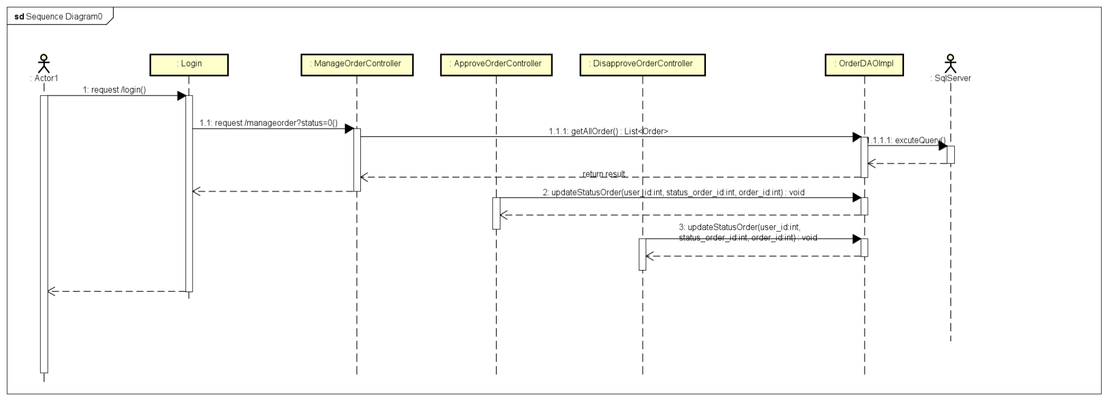

### e. Database queries

***- select * from [Order]***

***- select * from StatusOrder***

***- select * from [Order] where status_order_id " + status + " order by order_id offset ? rows fetch next ? rows only;***

***- select count(*) from [Order] where status_order_id " + status***

## 19. Order Management/Order Details

### a. Screen Design

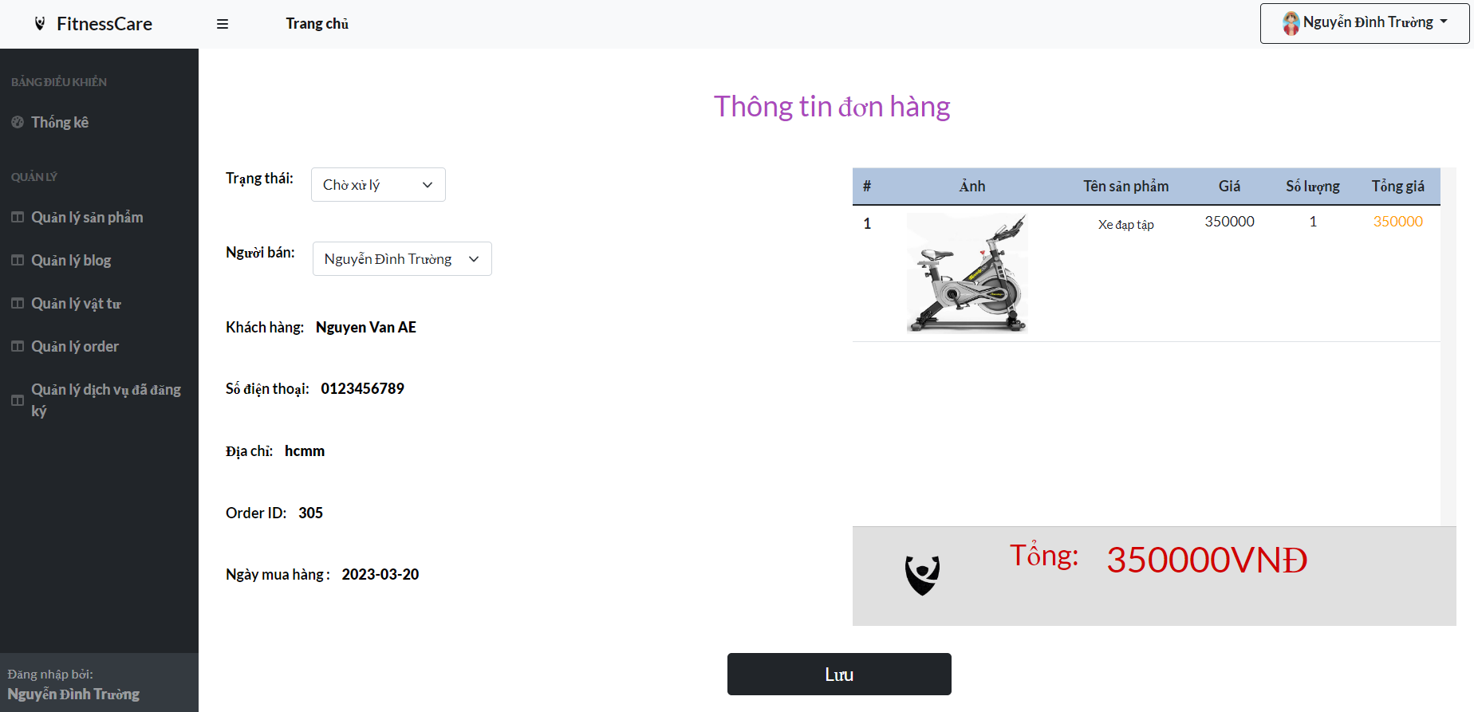

### b. Class Diagram

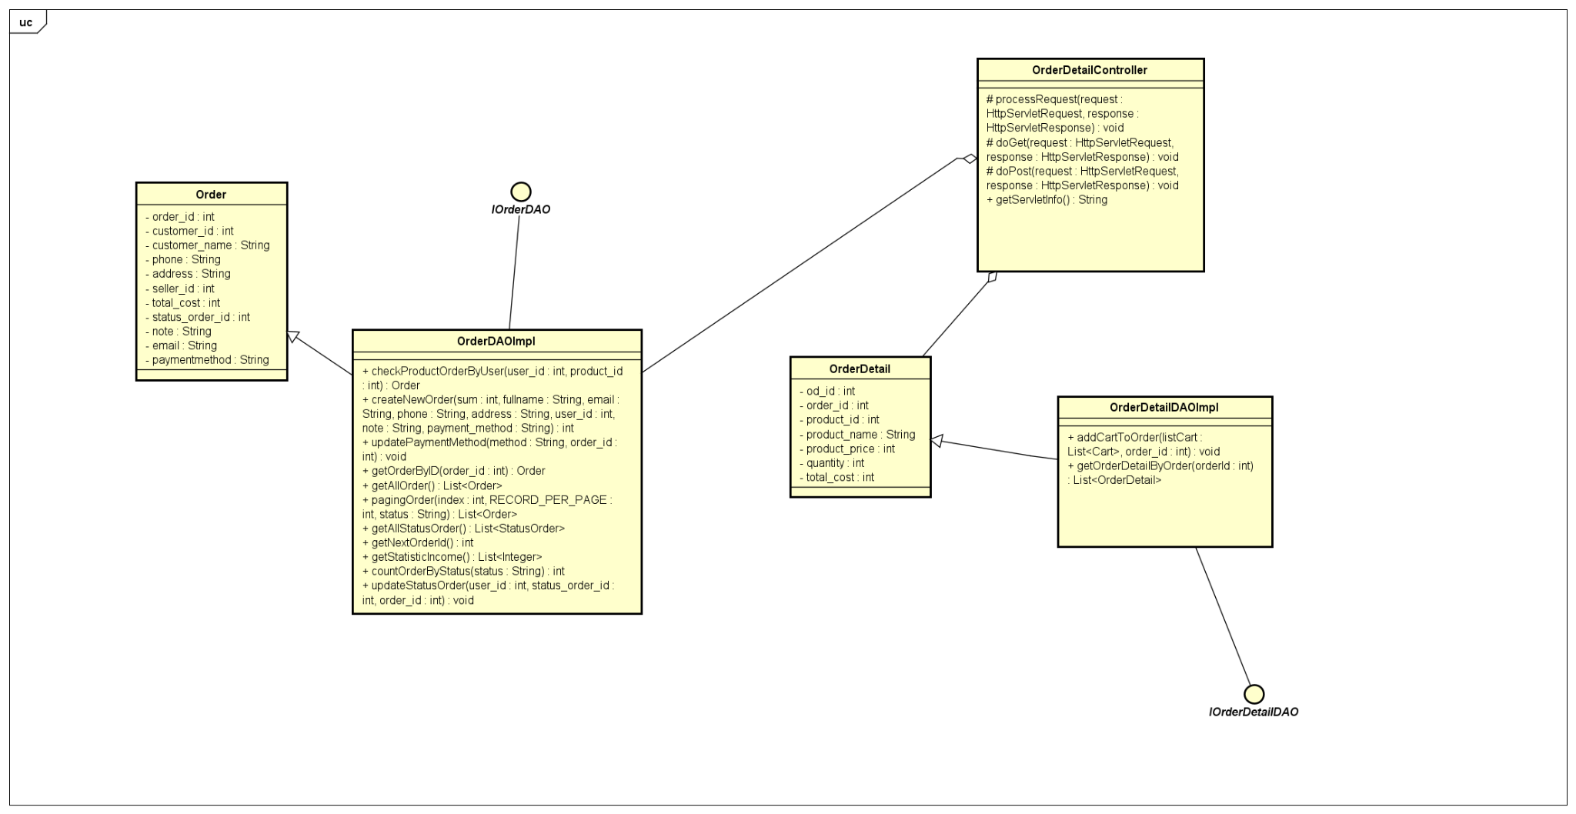

### c. Class Specifications

|  |  |  |
| --- | --- | --- |
| **No** | **Method** | **Description** |
| ***01*** | ***getOrderByID*** | ***get Order by order_id*** |
| ***02*** | ***getOrderDetailByOrder(orderId)*** | ***get Order detail by order_id*** |
| ***03*** | ***getAllProduct()*** | ***get all product*** |
| ***04*** | ***getSellers()*** | ***get all user with role admin or online staff*** |

### d. Sequence Diagram(s)

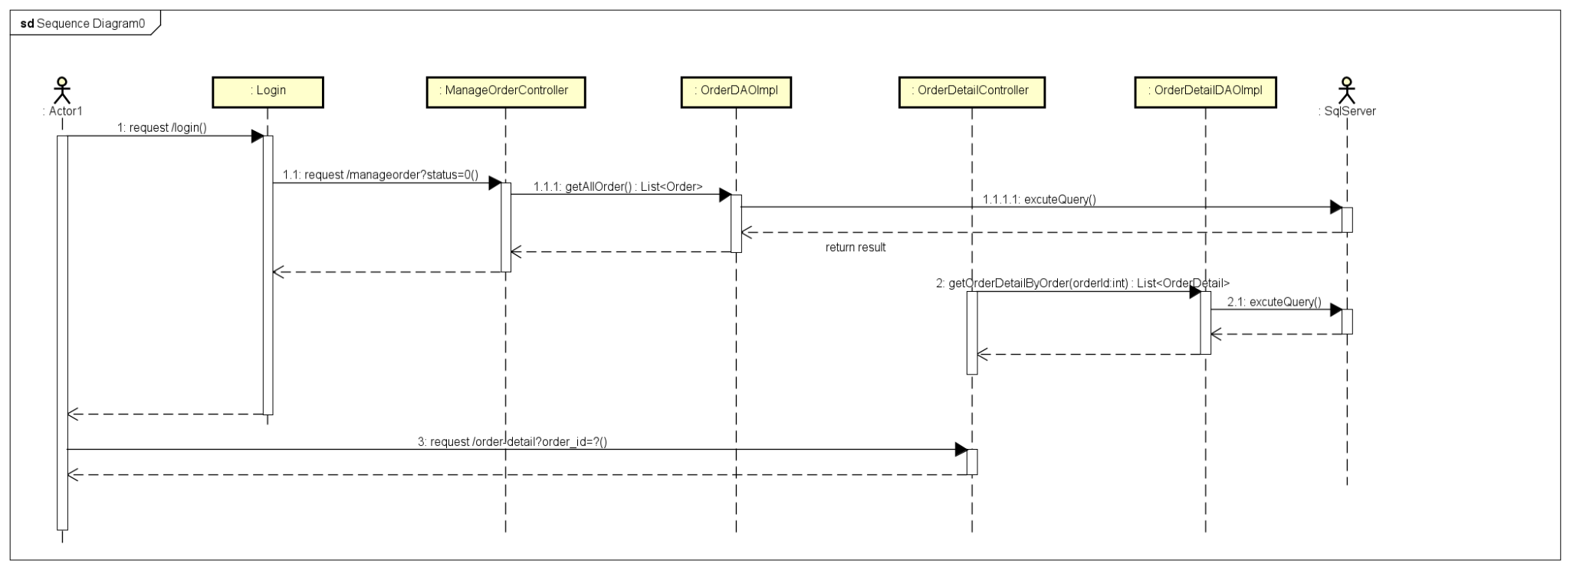

### e. Database queries

***- select * from [Order] where order_id = ?***

***- select * from OrderDetail where order_id = ?***

***- SELECT * FROM [dbo].[Product]***

***- select * from [User] where role_id = 1 or role_id = 2***

## 20. Service Management/View registered service

### a. Screen Design

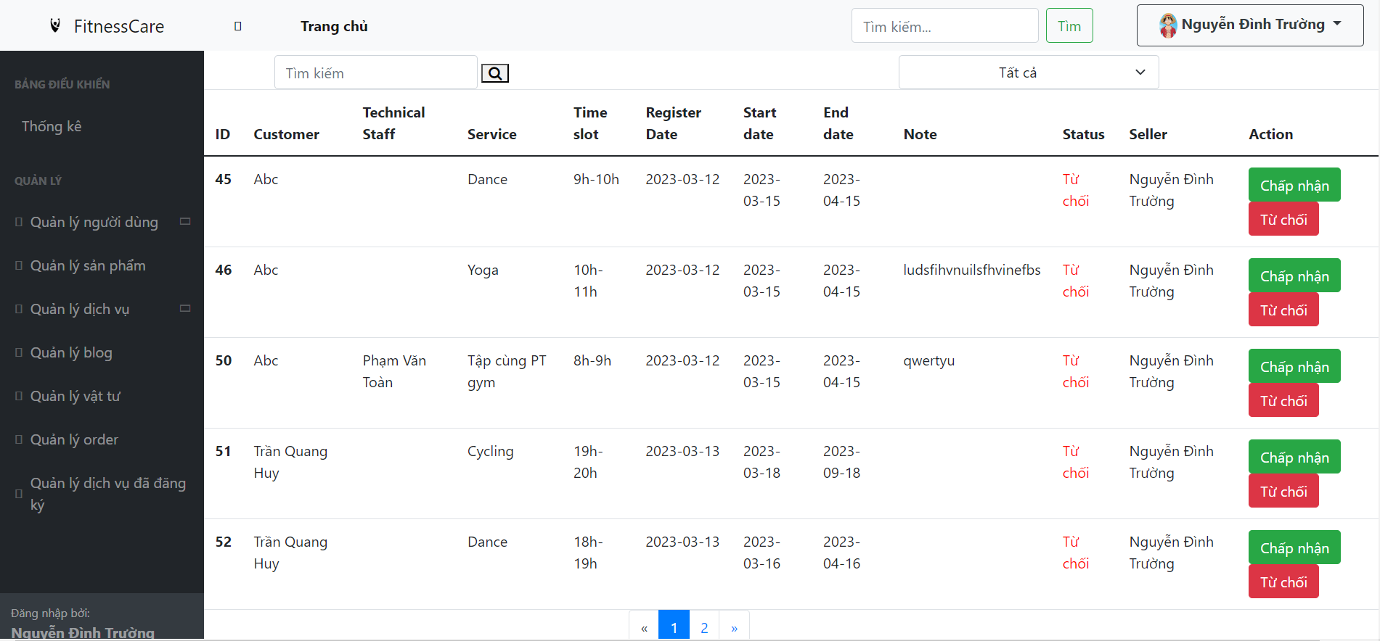

### b. Class Diagram

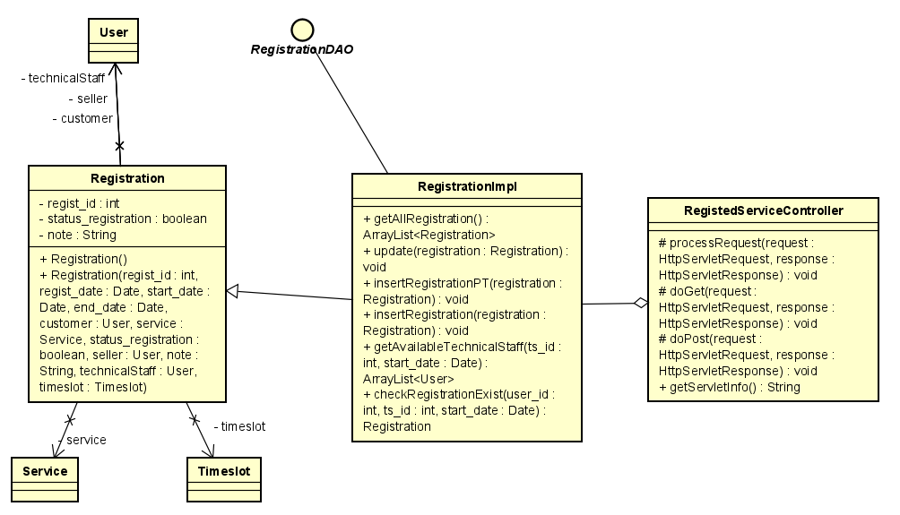

### c. Class Specifications

|  |  |  |
| --- | --- | --- |
| **No** | **Method** | **Description** |
| ***01*** | ***getAllRegistration()*** | ***get all registration*** |
| ***02*** | ***insertSchedule()*** | ***insert information of schedule have service into db*** |
| ***03*** | ***insertSchedulePT()*** | ***insert information of schedule have service with PT into db*** |

### d. Sequence Diagram(s)

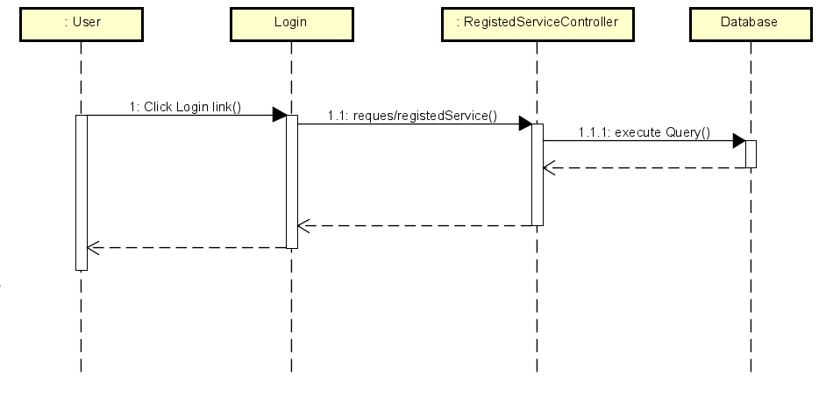

### e. Database queries

***- select regist_id,r.customer_id, u1.fullName as Customer, r.techS_id, u2.fullName as TechnicalStaff,s.service_id, s.service_name, sr.status, r.seller_id, u3.fullName as Seller, t.ts_id ,t.ts_description, regist_date, start_date, end_date, r.note***

***from Registration r join [User] u1 on r.customer_id=u1.user_id***

***left join [User] u2 on r.techS_id=u2.user_id***

***left join [User] u3 on r.seller_id=u3.user_id***

***join status_Registration sr on r.status_regist_id=sr.status_regist_id***

***join Timeslot t on t.ts_id=r.ts_id***

***join [Service] s on r.service_id=s.service_id***

***- INSERT INTO [dbo].[Schedule] ([customer_id] ,[service_id] ,[timeslot_id] ,[date])***

***VALUES (? ,? ,? ,?)***

***- INSERT INTO [dbo].[Schedule] ([customer_id] ,[techS_id] ,[service_id] ,[timeslot_id] ,[date])***

***VALUES (? ,? ,? ,? ,?)***

## 21. Blog Management/Blog List

### a. Screen Design

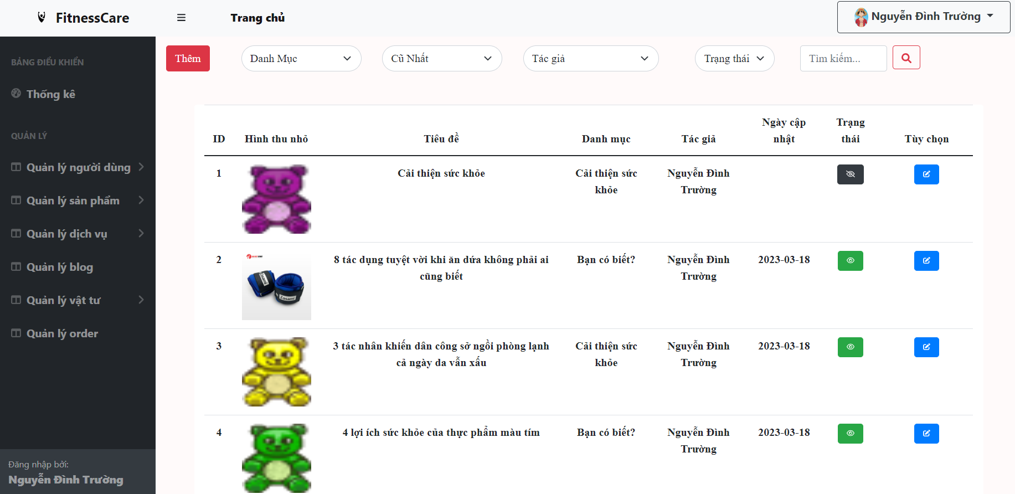

### b. Class Diagram

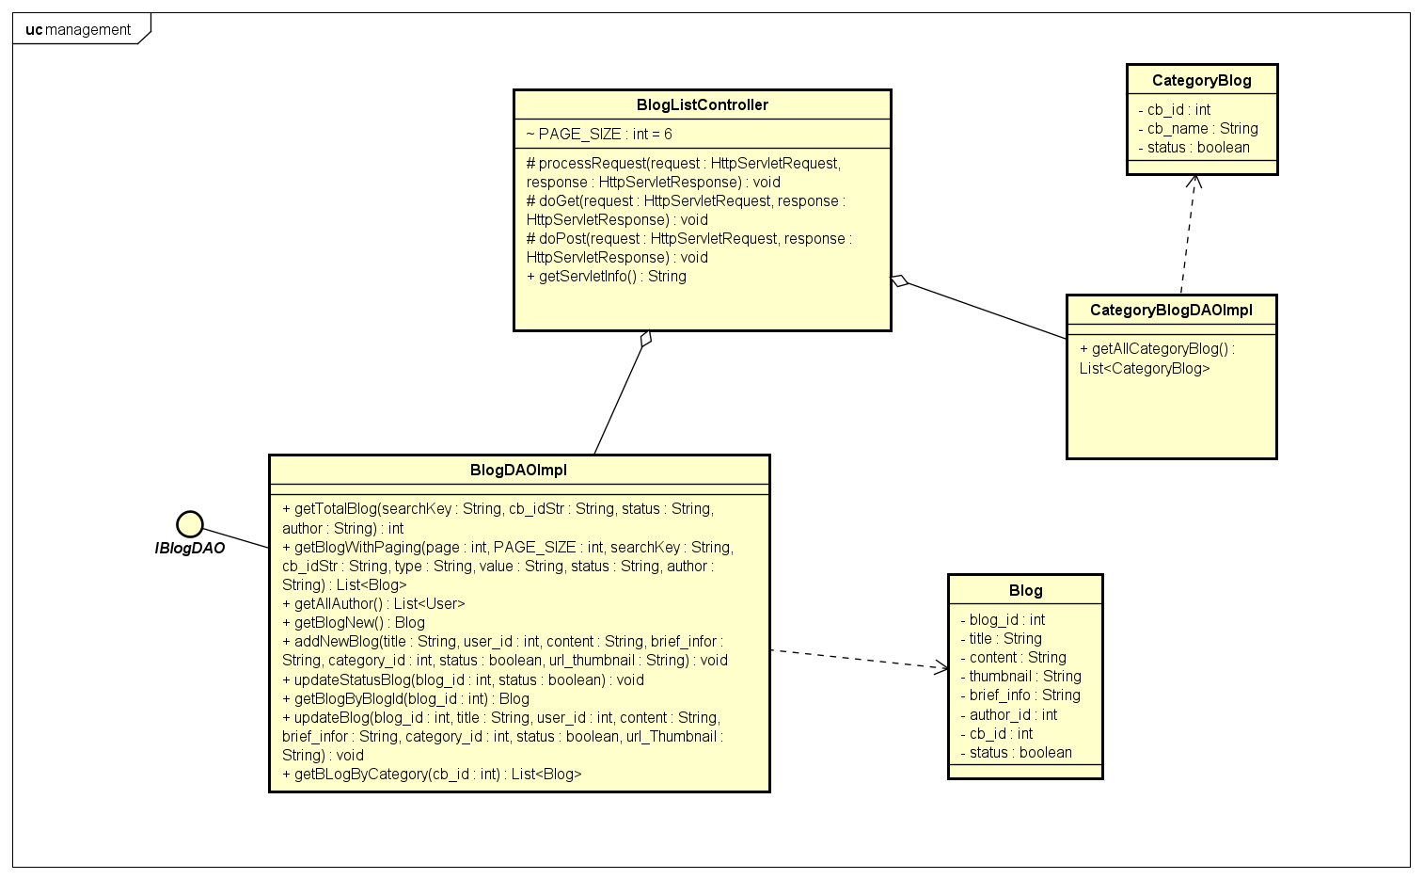

### c. Class Specifications

|  |  |  |
| --- | --- | --- |
| **No** | **Method** | **Description** |
| ***01*** | ***getTotalBlog(searchKey, cb_idStr, status, author);*** | ***get number of blog by filter*** |
| ***02*** | ***getBlogWithPaging(page, PAGE_SIZE, searchKey, cb_idStr, type, value, status, author);*** | ***Get Blogs by filter*** |
| ***03*** | ***getAllCategoryBlog();*** | ***get all category of blog*** |
| ***04*** | ***getAllAuthor();*** | ***get all user with role admin or online staff*** |

### d. Sequence Diagram(s)

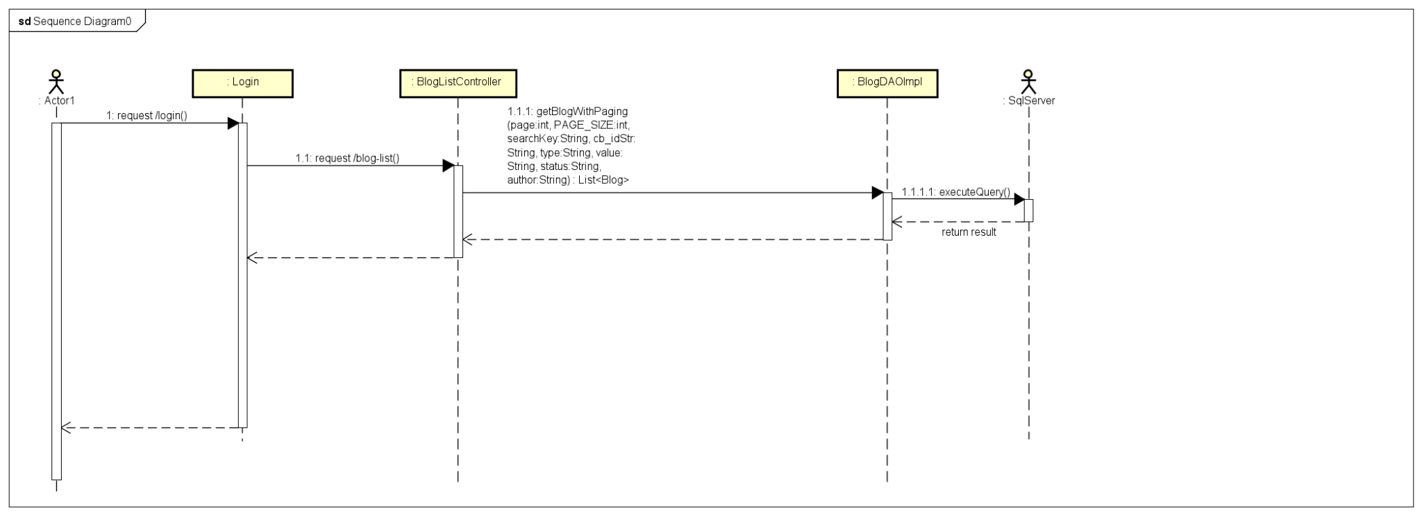

### e. Database queries

***- Select count(*) from Blog where cb_id " + cb_idStr + " and [status] " + status + " and author_id " + author + " and title like N'%" + searchKey + "%'\n***

***- select * from Blog where cb_id " + cb_idStr + " and [status] " + status + " and author_id " + author + " and [title] like N'%" + searchKey + "%' order by " + value + " " + type + " offset ? rows fetch next ? rows only;***

***- Select * from CategoryBlog where status = 1***

***- select * from [User] where role_id = 2 or role_id = 1***

## 22. Blog Management/Blog Details

## a. Screen Design

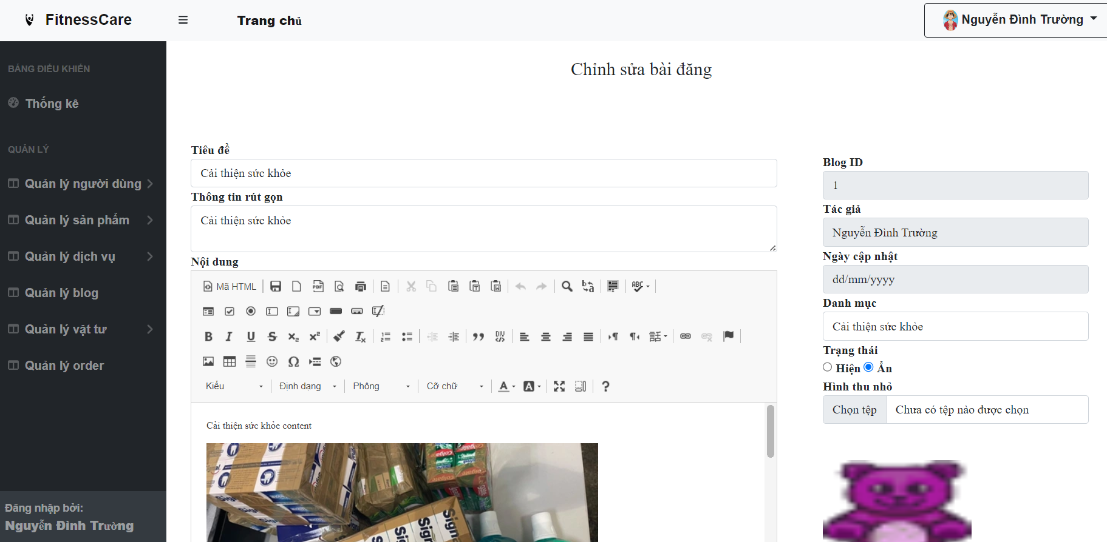

### b. Class Diagram

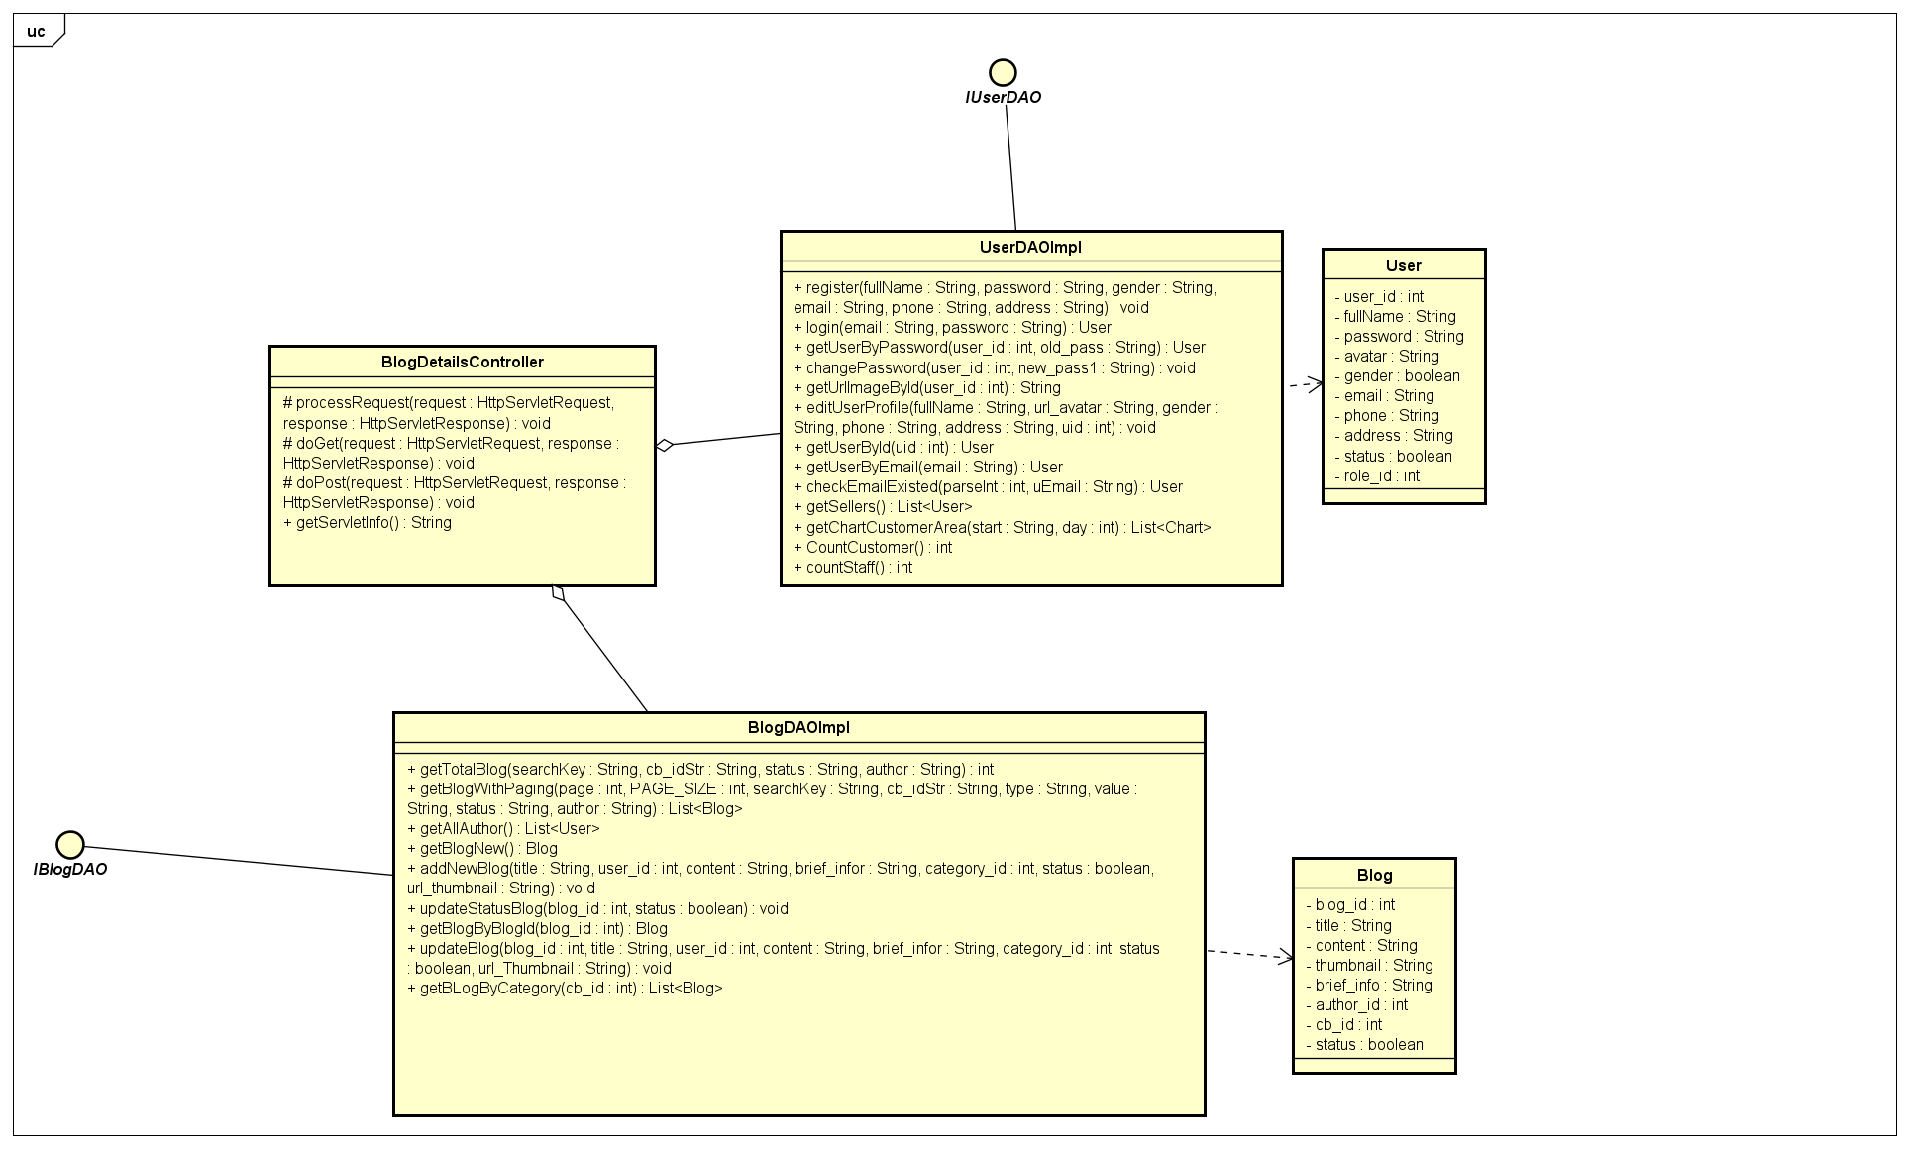

### c. Class Specifications

|  |  |  |
| --- | --- | --- |
| **No** | **Method** | **Description** |
| ***01*** | ***getBlogByBlogId(blog_id);*** | ***get blog by blog_id*** |
| ***02*** | ***getUserById(blog.getAuthor_id());*** | ***get user by Author_id*** |

### d. Sequence Diagram(s)

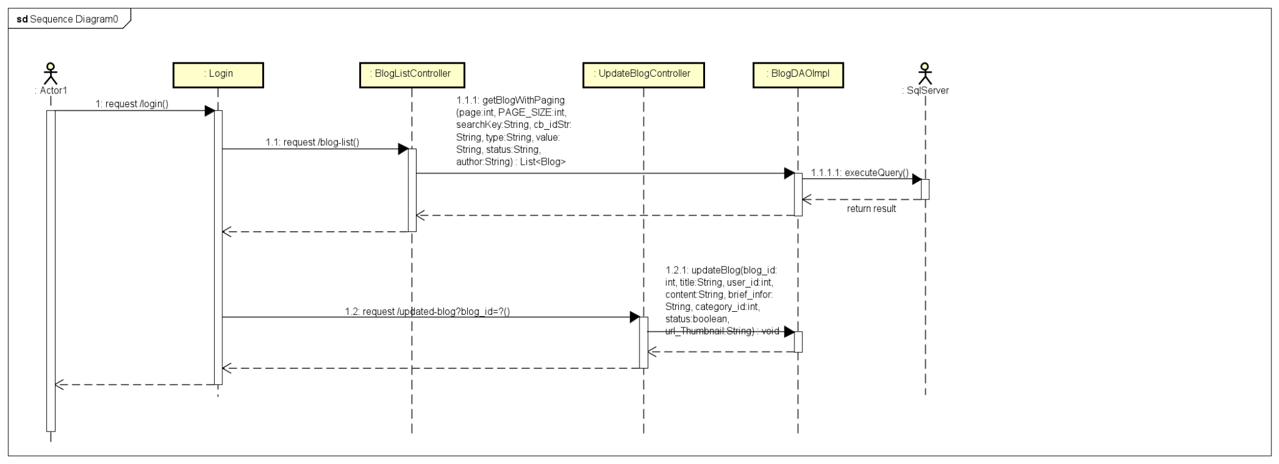

### e. Database queries

***- select * from Blog where blog_id = ?***

***- select * from [User] where user_id = ?***

## 23. Blog Management/Update Blog

## a. Screen Design



### b. Class Diagram

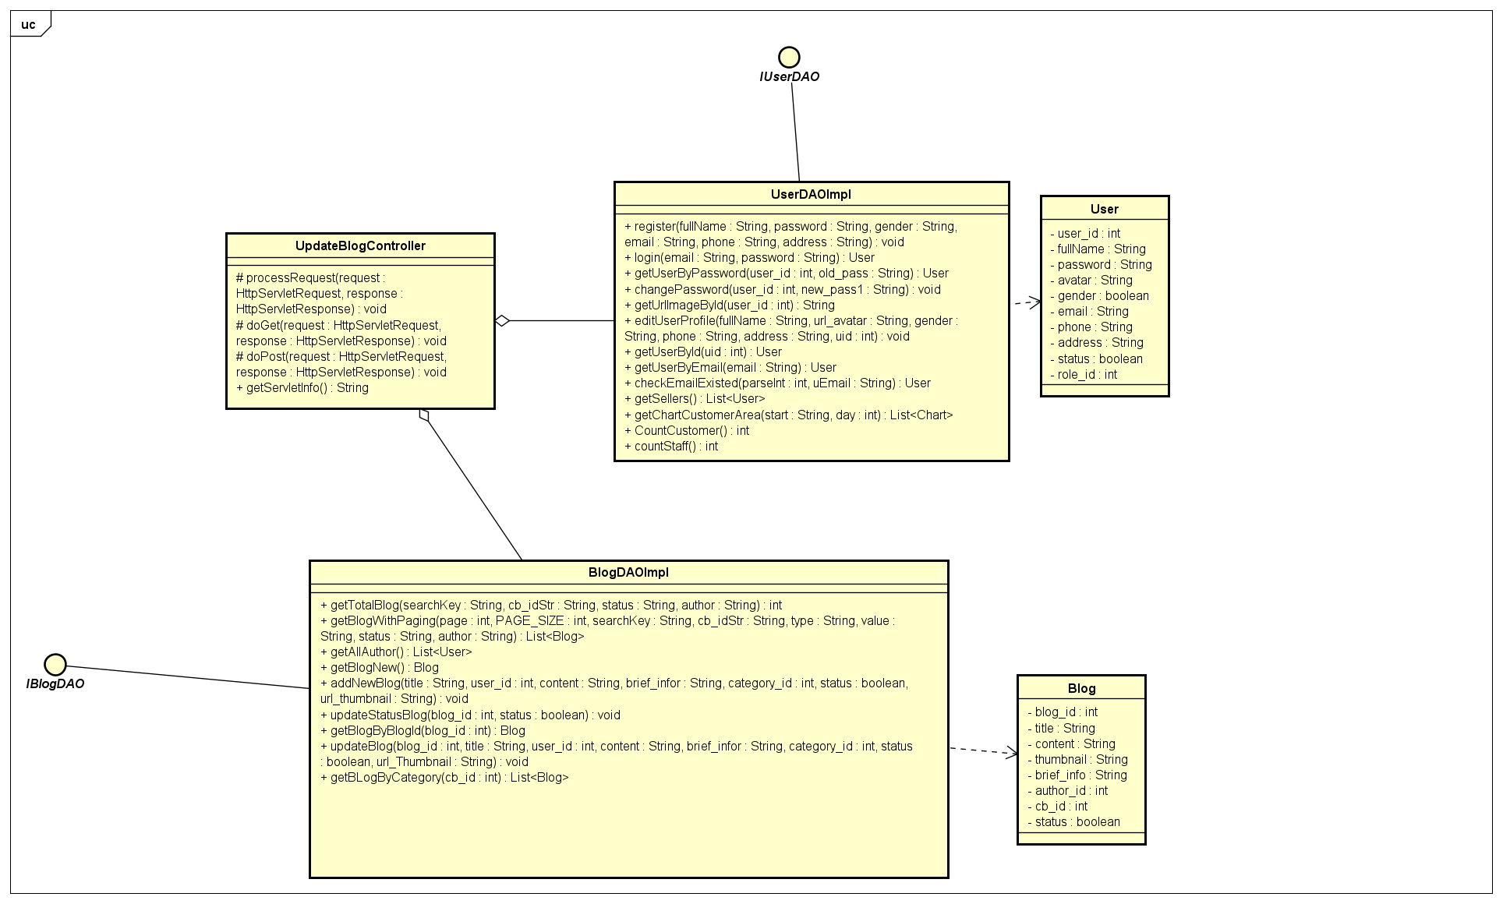

### c. Class Specifications

|  |  |  |
| --- | --- | --- |
| **No** | **Method** | **Description** |
| ***01*** | ***getBlogByBlogId(blog_id);*** | ***get blog by blog_id*** |
| ***02*** | ***updateBlog(blog_id, title, user_id, content, brief_infor, category_id, status, url_Thumbnail);*** | ***update new information for blog*** |

### d. Sequence Diagram(s)

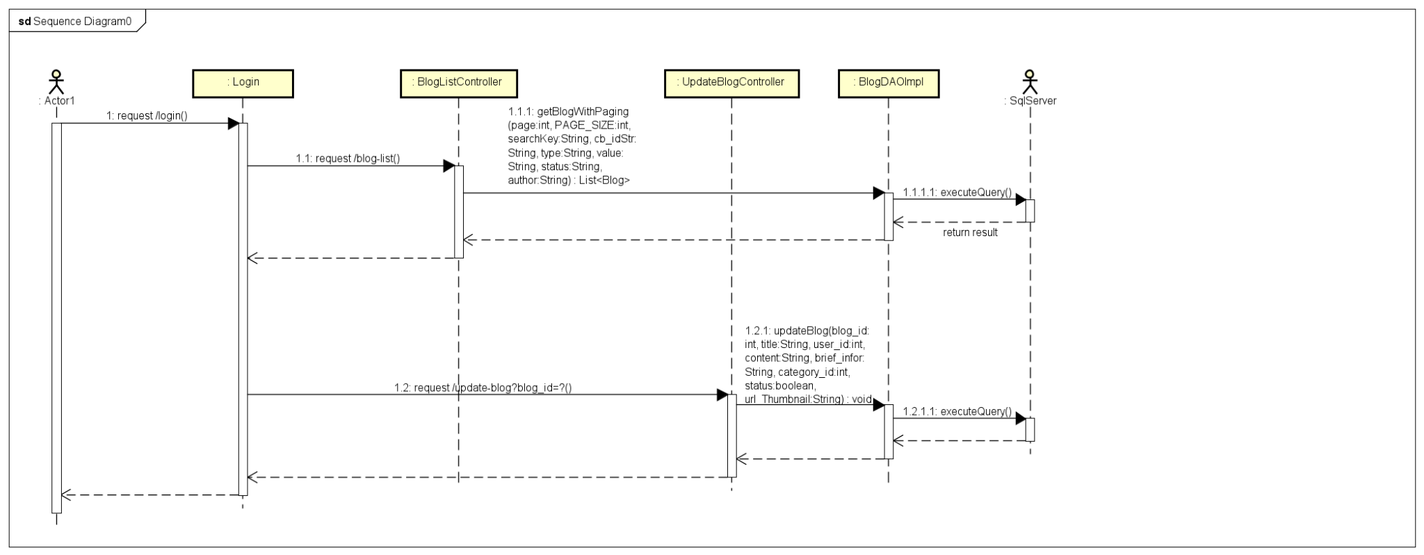

### e. Database queries

***- select * from Blog where blog_id = ?***

***- UPDATE [dbo].[Blog] SET [title] = ? ,[author_id] = ? ,[updated_date] = getdate() ,[content] = ? ,[thumbnail] = ? ,[brief_info] = ? ,[cb_id] = ? ,[status] = ? WHERE blog_id = ?***

## 24. Blog Management/Add Blog

## a. Screen Design

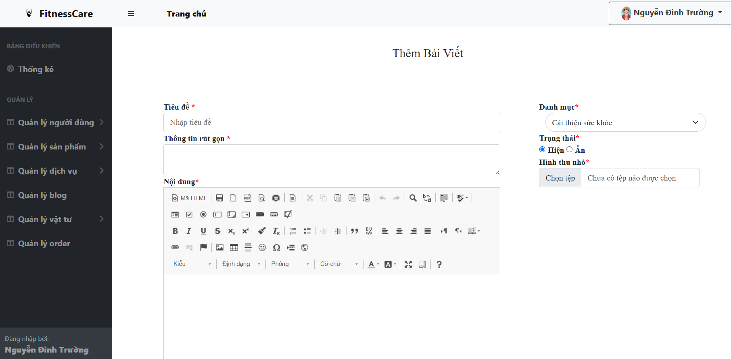

### b. Class Diagram

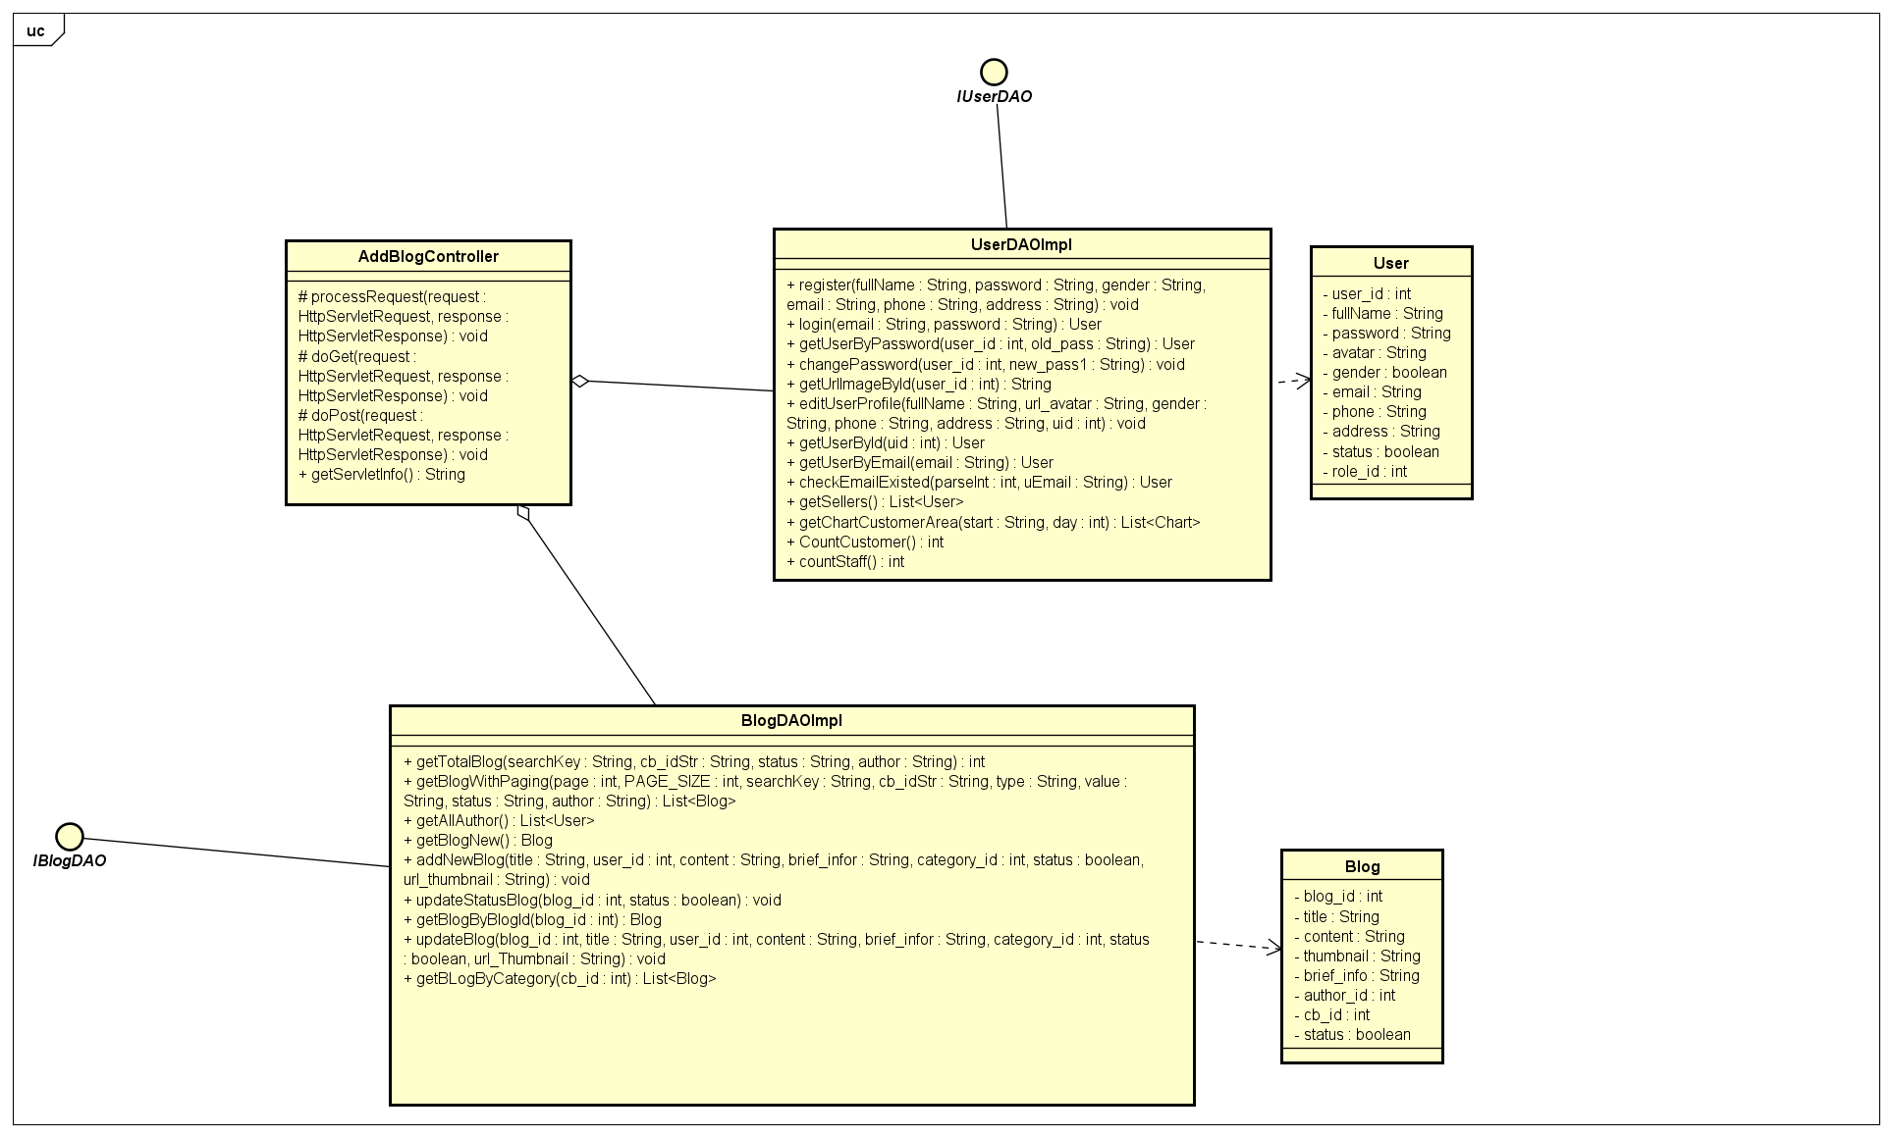

### c. Class Specifications

|  |  |  |
| --- | --- | --- |
| **No** | **Method** | **Description** |
| ***01*** | ***addNewBlog(title, user_id, content, brief_infor, category_id, status, url_Thumbnail);*** | ***add new blog*** |

### d. Sequence Diagram(s)

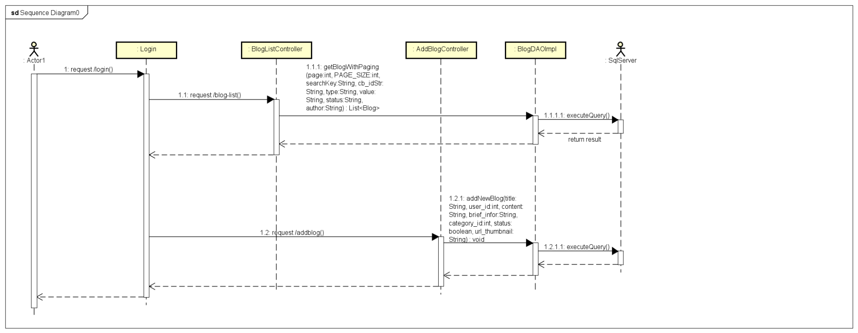

### e. Database queries

***- INSERT INTO [dbo].[Blog] ([title] ,[author_id] ,[content] ,[thumbnail] ,[brief_info] ,[cb_id] ,[status], [updated_date]) VALUES (?,?,?,?,?,?,?, getdate())***

## 25. Public/Blog List

## a. Screen Design

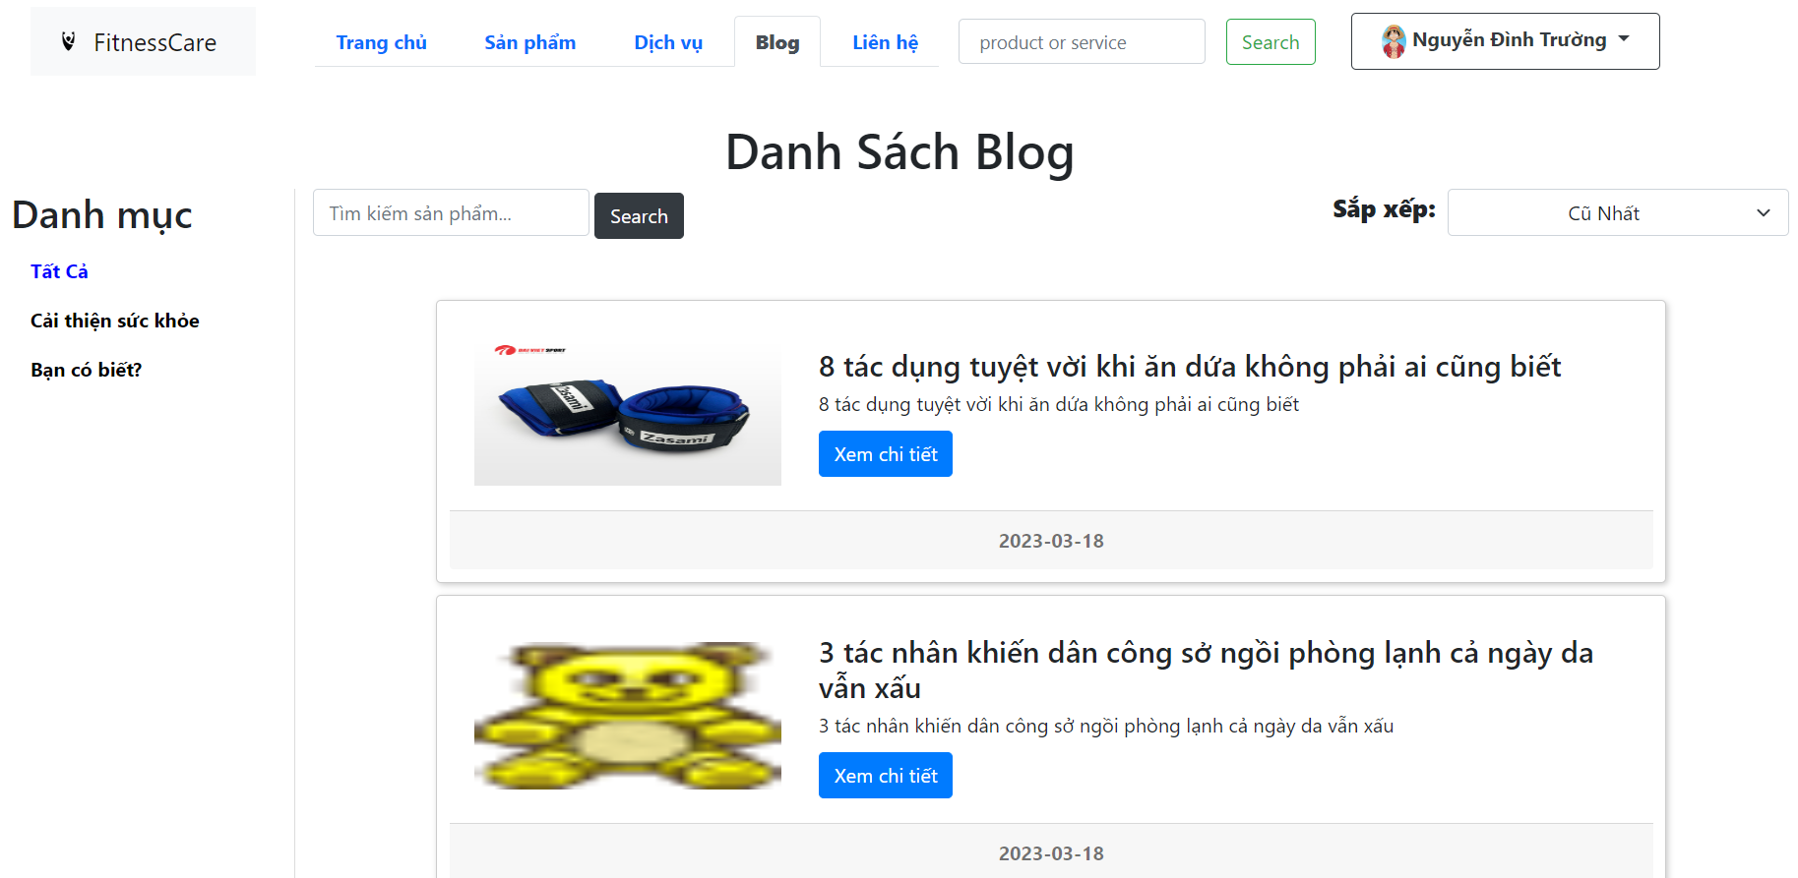

### b. Class Diagram

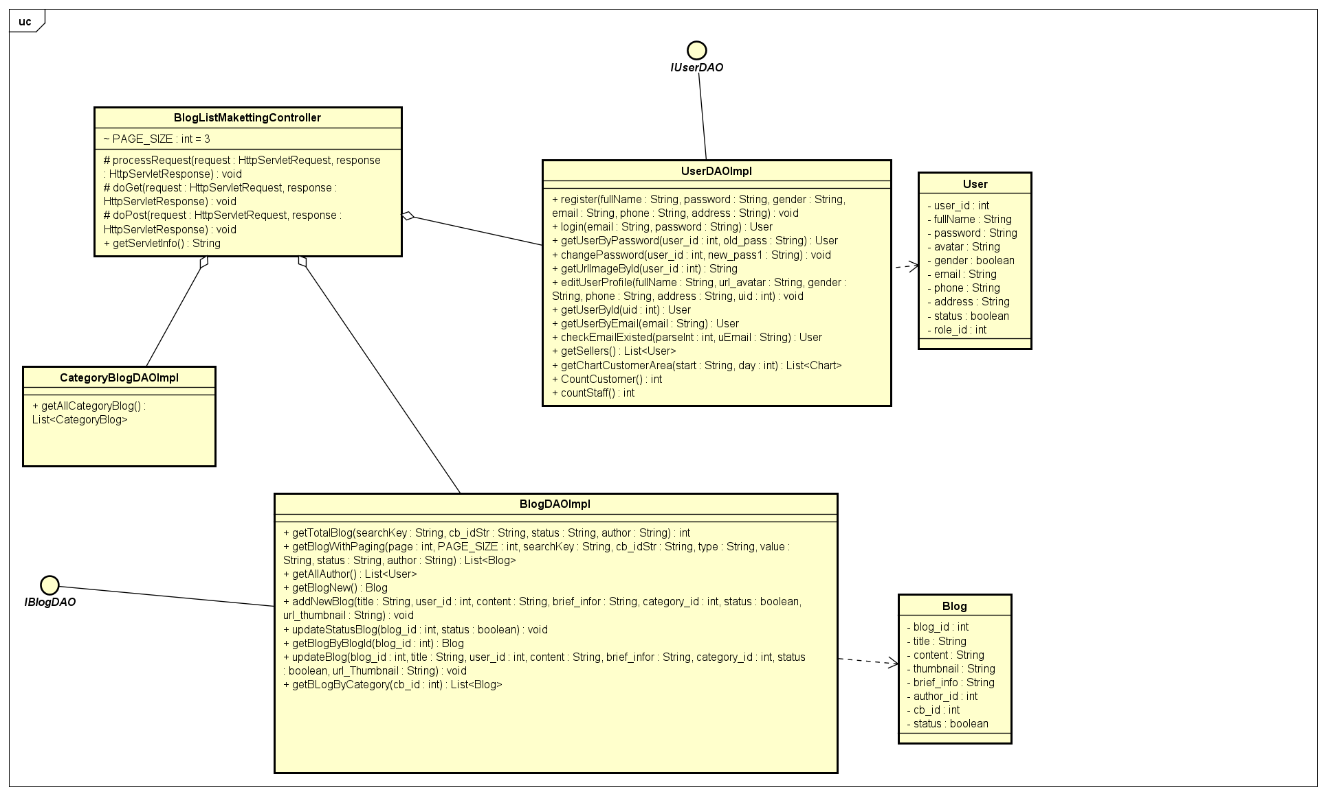

### c. Class Specifications

|  |  |  |
| --- | --- | --- |
| **No** | **Method** | **Description** |
| ***01*** | ***getTotalBlog(searchKey, cb_idStr, status, author)*** | ***get total blog by filter*** |
| ***02*** | ***getBlogWithPaging(page, PAGE_SIZE, searchKey, cb_idStr, type, value, status, author)*** | ***get Blogs by filter*** |
| ***03*** | ***getAllCategoryBlog()*** | ***get all category of blog*** |
| ***04*** | ***getAllAuthor();*** | ***get all user with role = 1 or role = 2*** |

### d. Sequence Diagram(s)

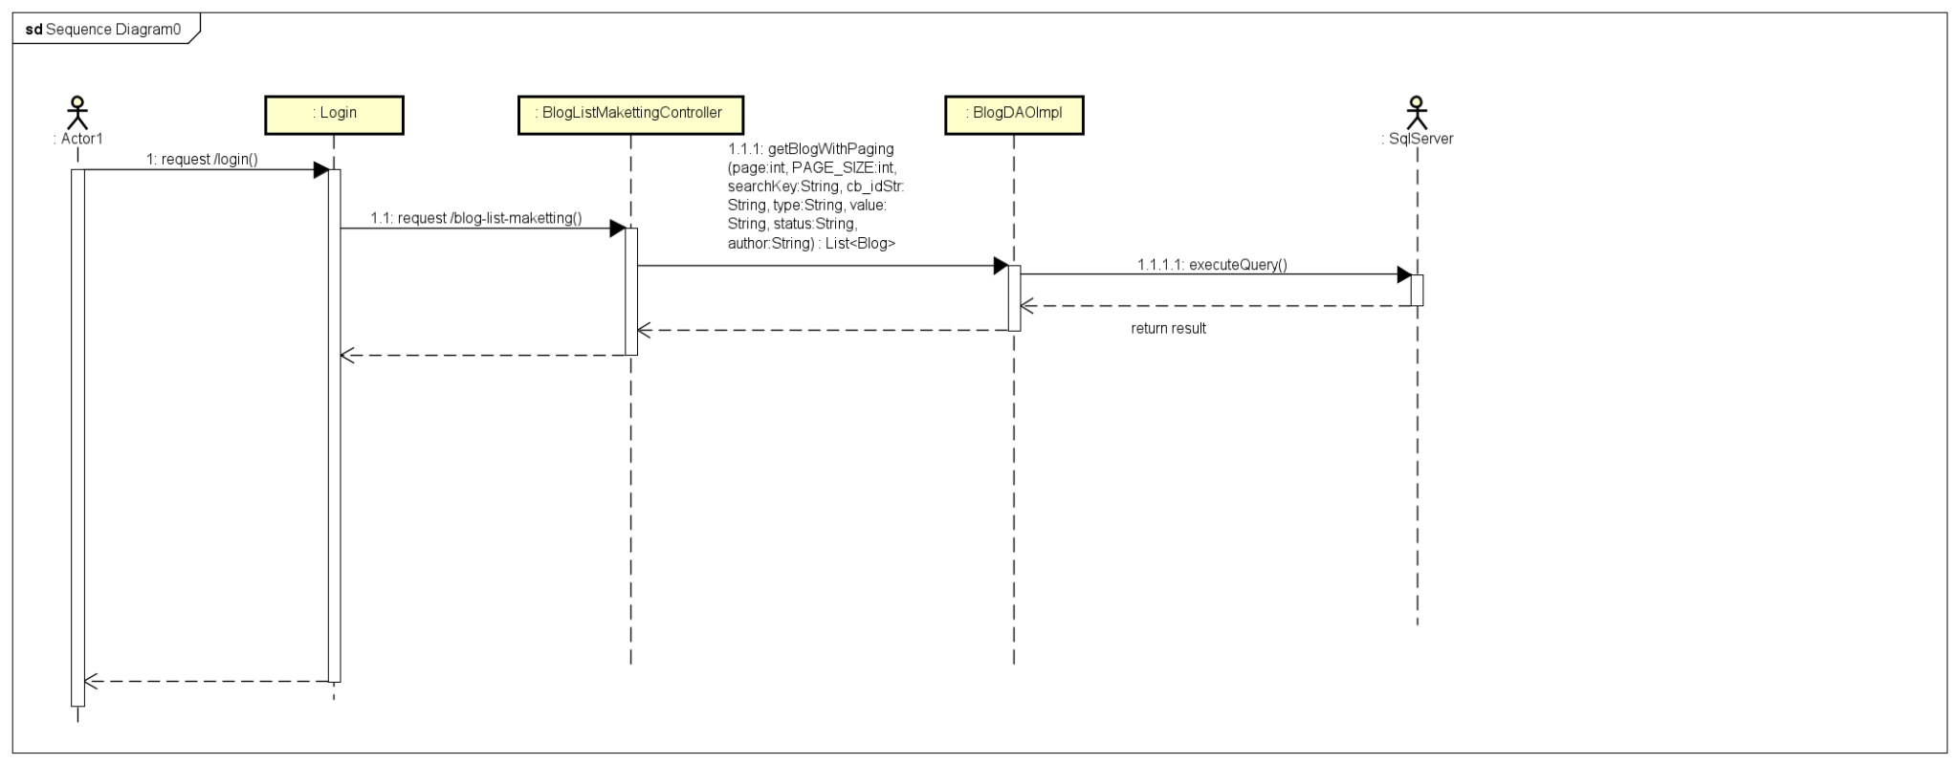

### e. Database queries

***- Select count(*) from Blog where cb_id " + cb_idStr + " and [status] " + status + " and author_id " + author + " and title like N'%" + searchKey + "%'\n***

***- select * from Blog where cb_id " + cb_idStr + " and [status] " + status + " and author_id " + author + " and [title] like N'%" + searchKey + "%' order by " + value + " " + type + " offset ? rows fetch next ? rows only;***

***- Select * from CategoryBlog where status = 1***

***- select * from [User] where role_id = 2 or role_id = 1***

## 26. Public/Blog Details

## a. Screen Design

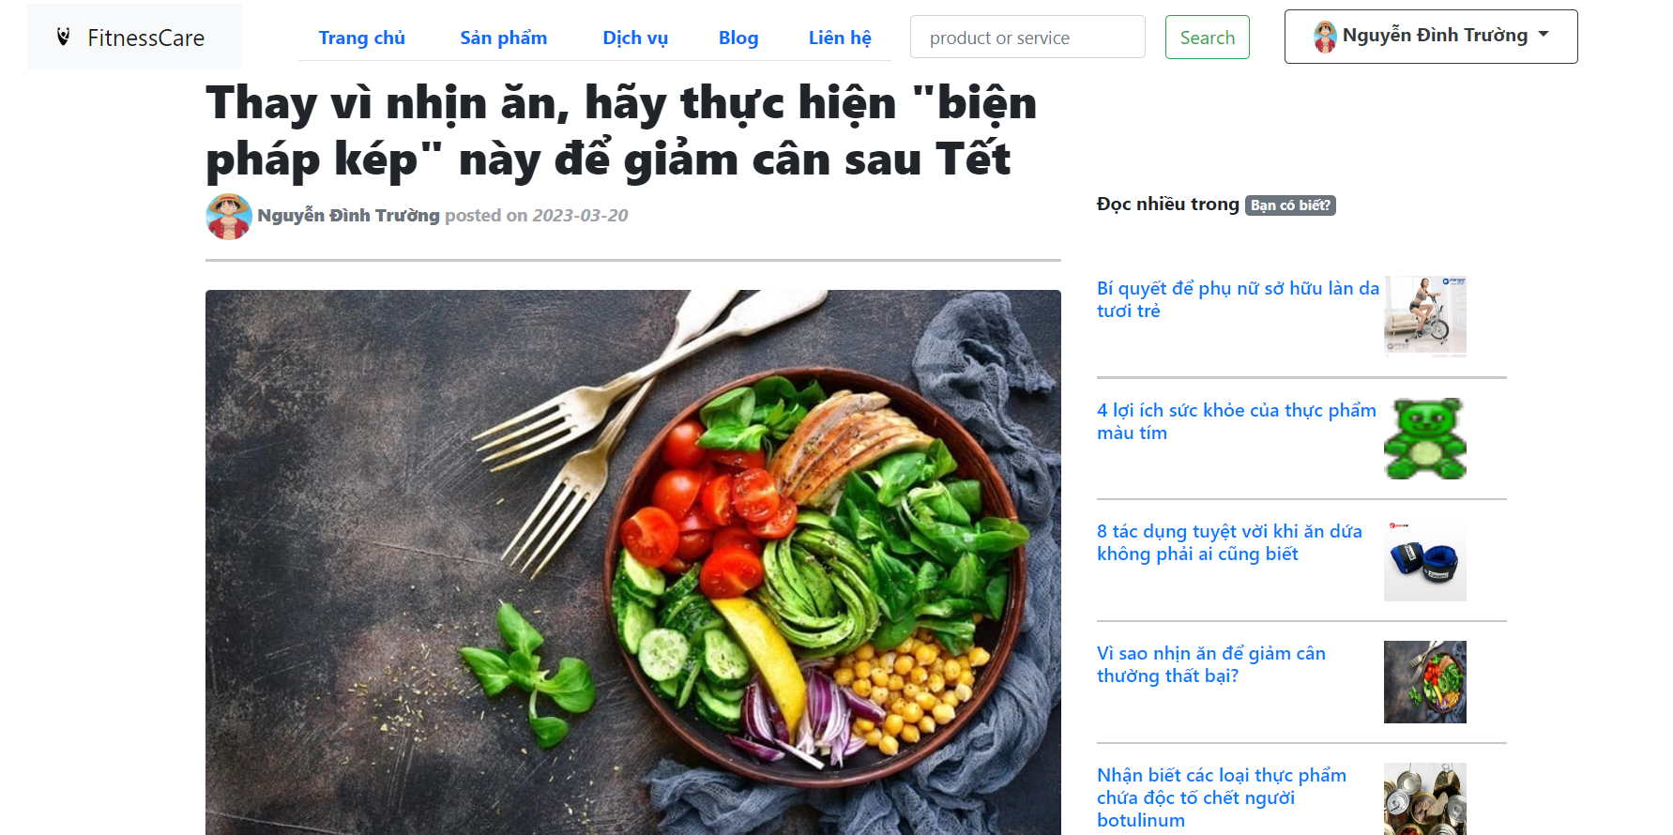

### b. Class Diagram

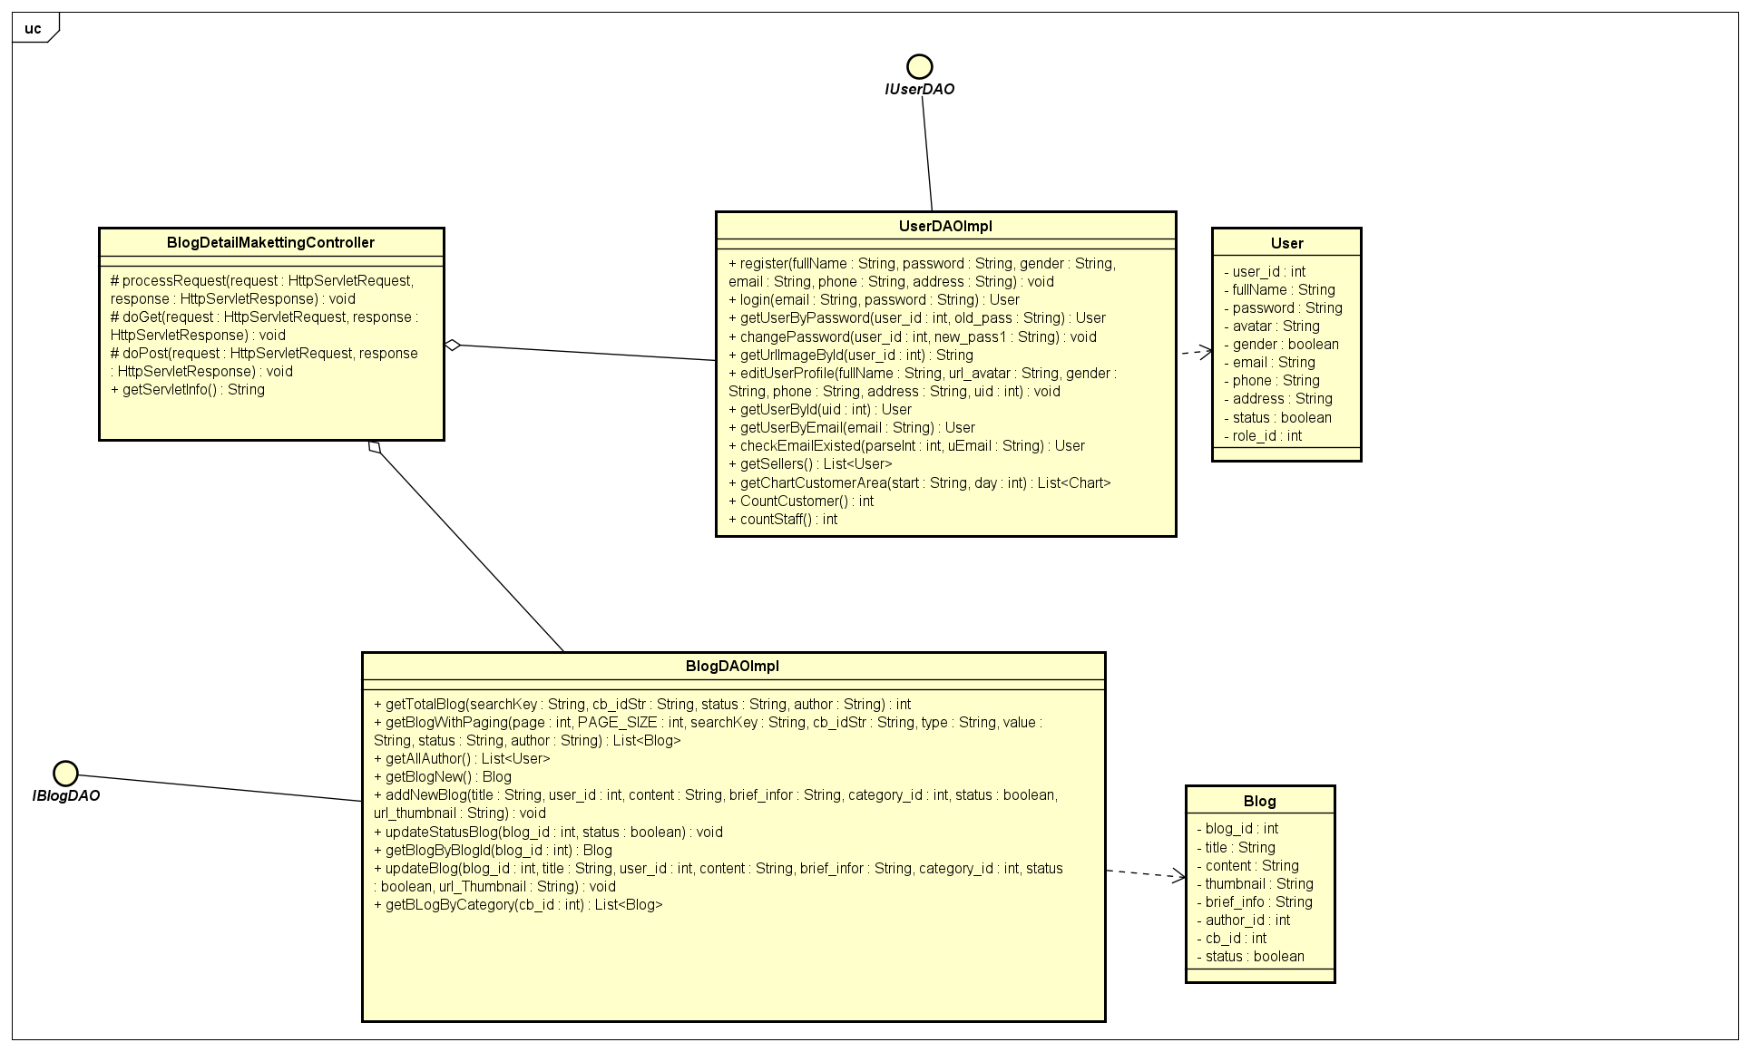

### c. Class Specifications

|  |  |  |
| --- | --- | --- |
| **No** | **Method** | **Description** |
| ***01*** | ***getBlogByBlogId(blog_id);*** | ***get Blog by blog_id*** |
| ***02*** | ***getUserById(blog.getAuthor_id())*** | ***get details of user by Author_id*** |
| ***03*** | ***getBLogByCategory(blog.getCb_id());*** | ***get related Blogs*** |

### d. Sequence Diagram(s)

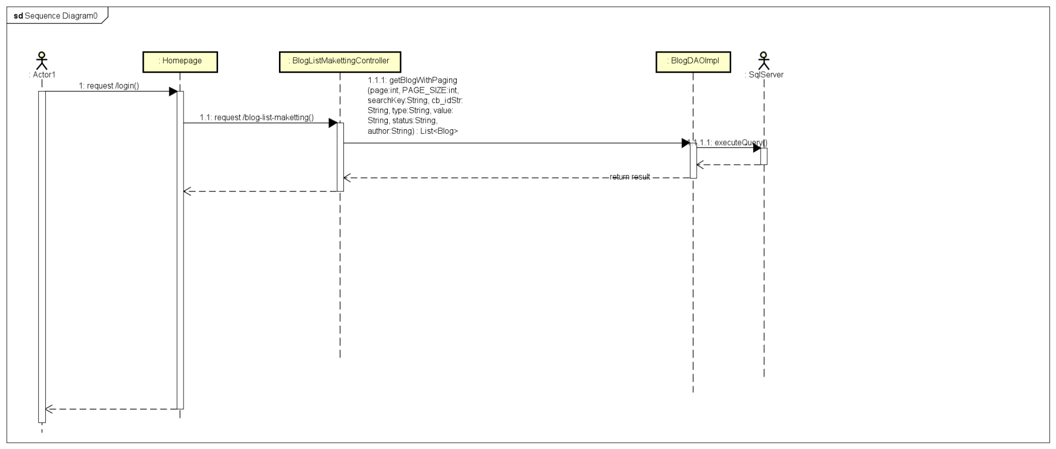

### e. Database queries

***- select * from Blog where blog_id = ?***

***- select * from [User] where user_id = ?***

***- select top 5 * from Blog where cb_id = ? and status = 1 order by updated_date***

## 27. Product Management/View Product list

## a. Screen Design

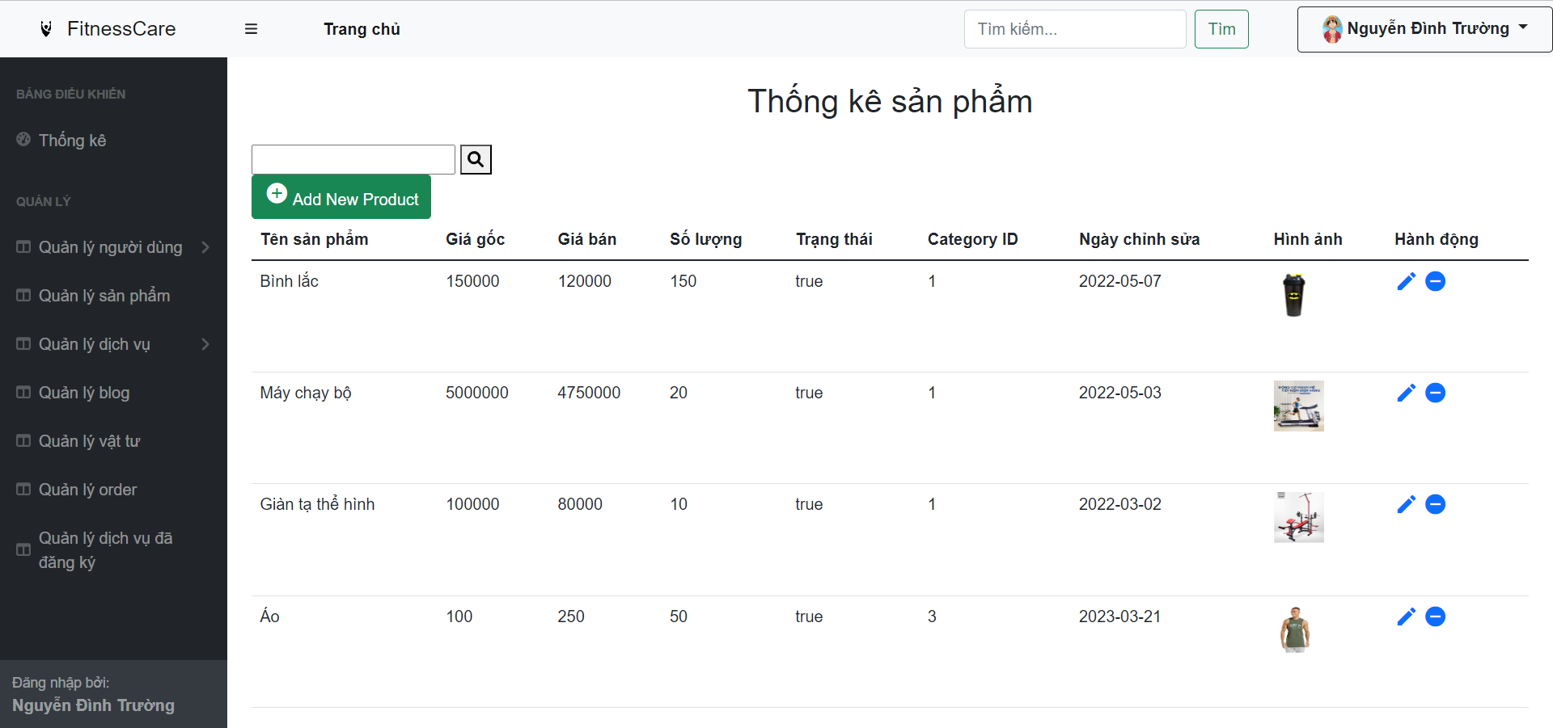

### b. Class Diagram

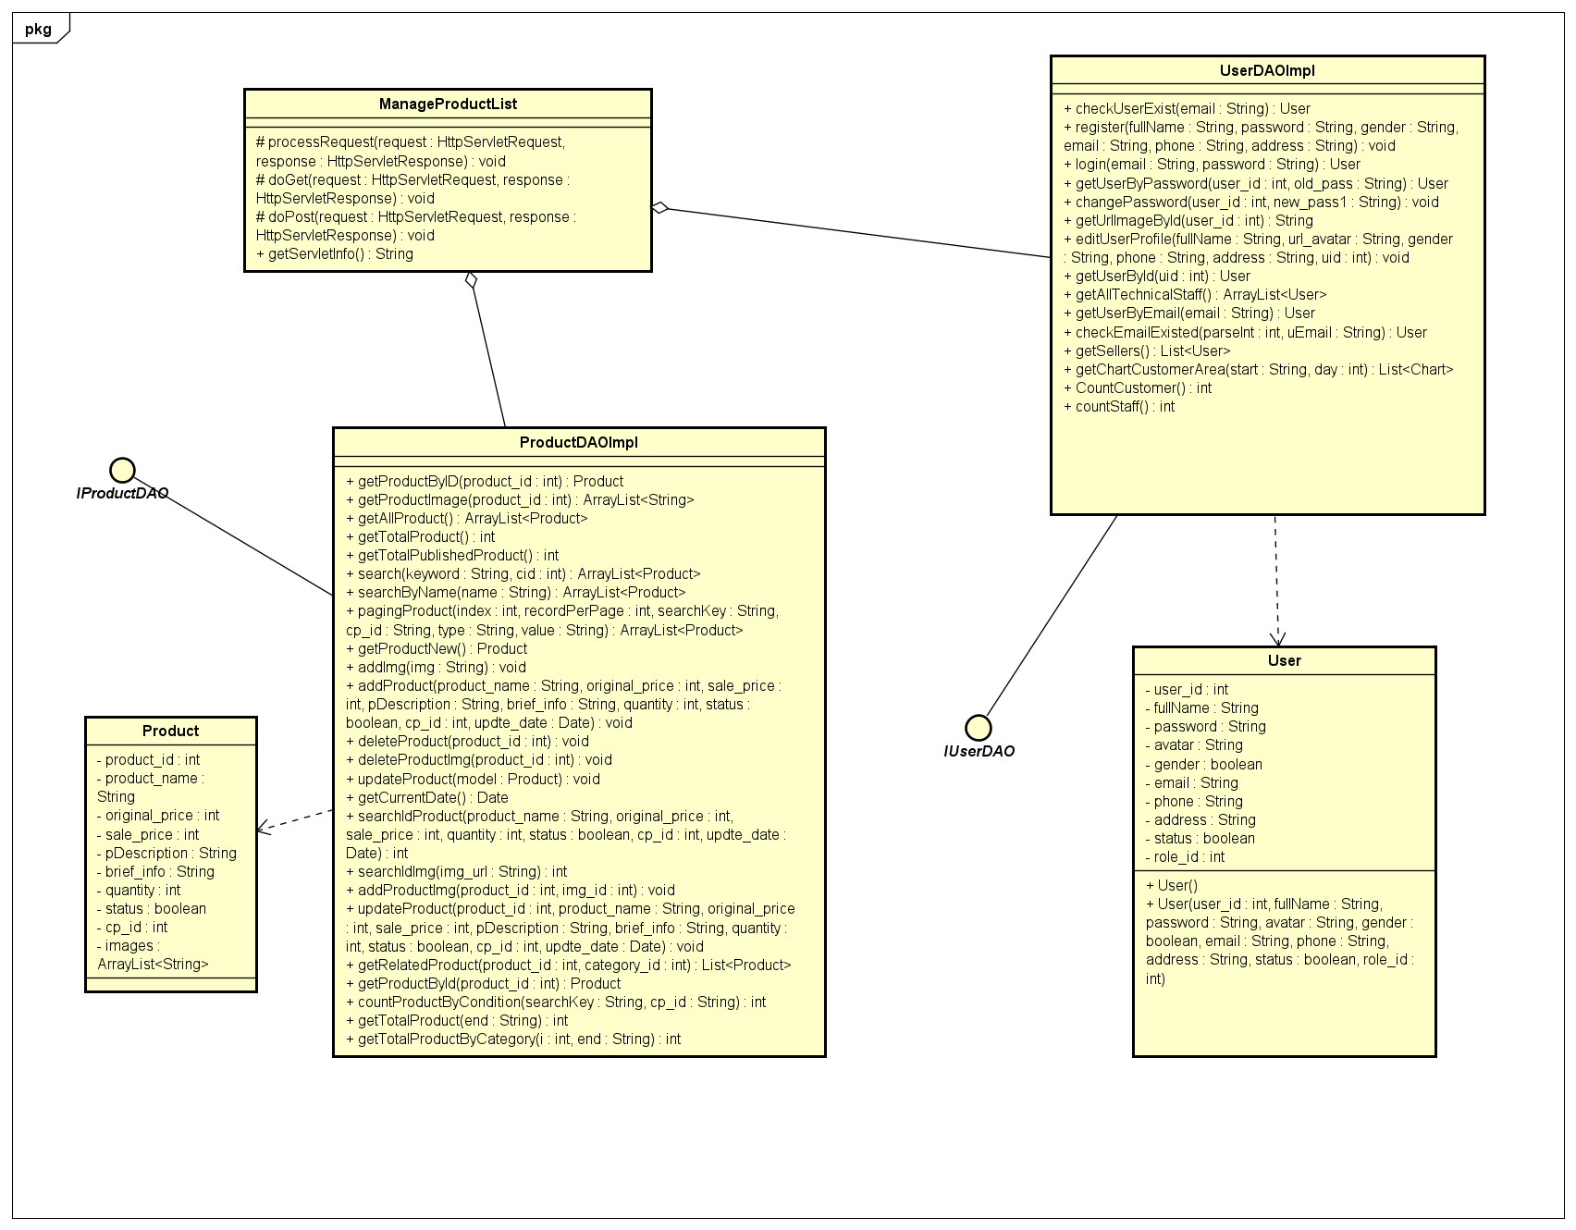

### c. Class Specifications

|  |  |  |
| --- | --- | --- |
| **No** | **Method** | **Description** |
| ***01*** | ***getAllProduct()*** | ***get all product in system*** |
| ***02*** | ***getAllCategory()*** | ***get all category of product in system*** |

### d. Sequence Diagram(s)

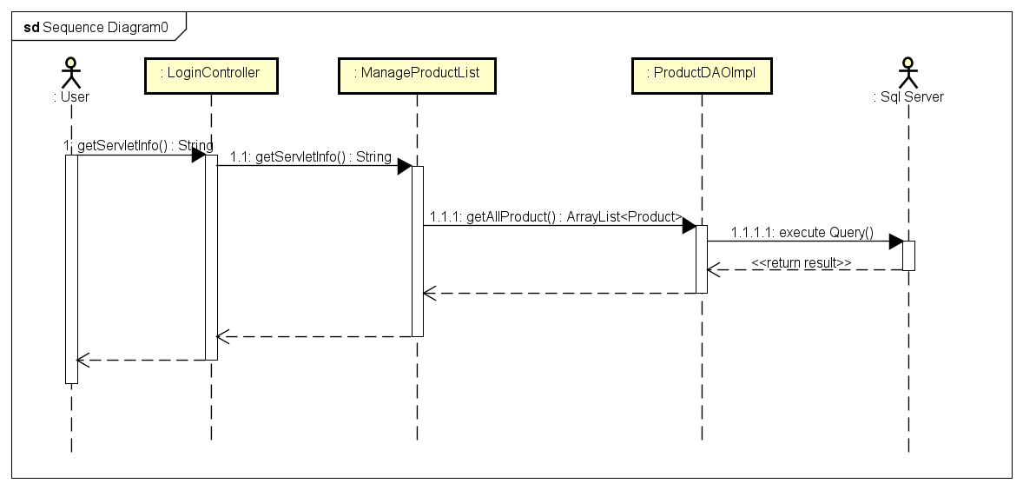

### e. Database queries

***- SELECT * FROM [dbo].[Product]***

***- Select * from CategoryProduct where status = 1***

## 28. Product Management/Add Product

## a. Screen Design

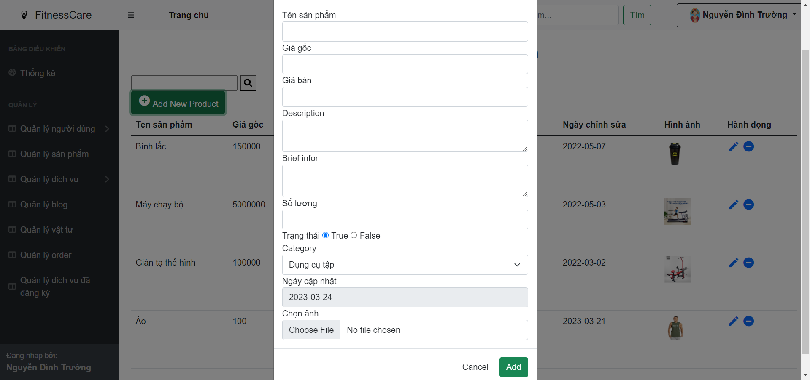

### b. Class Diagram

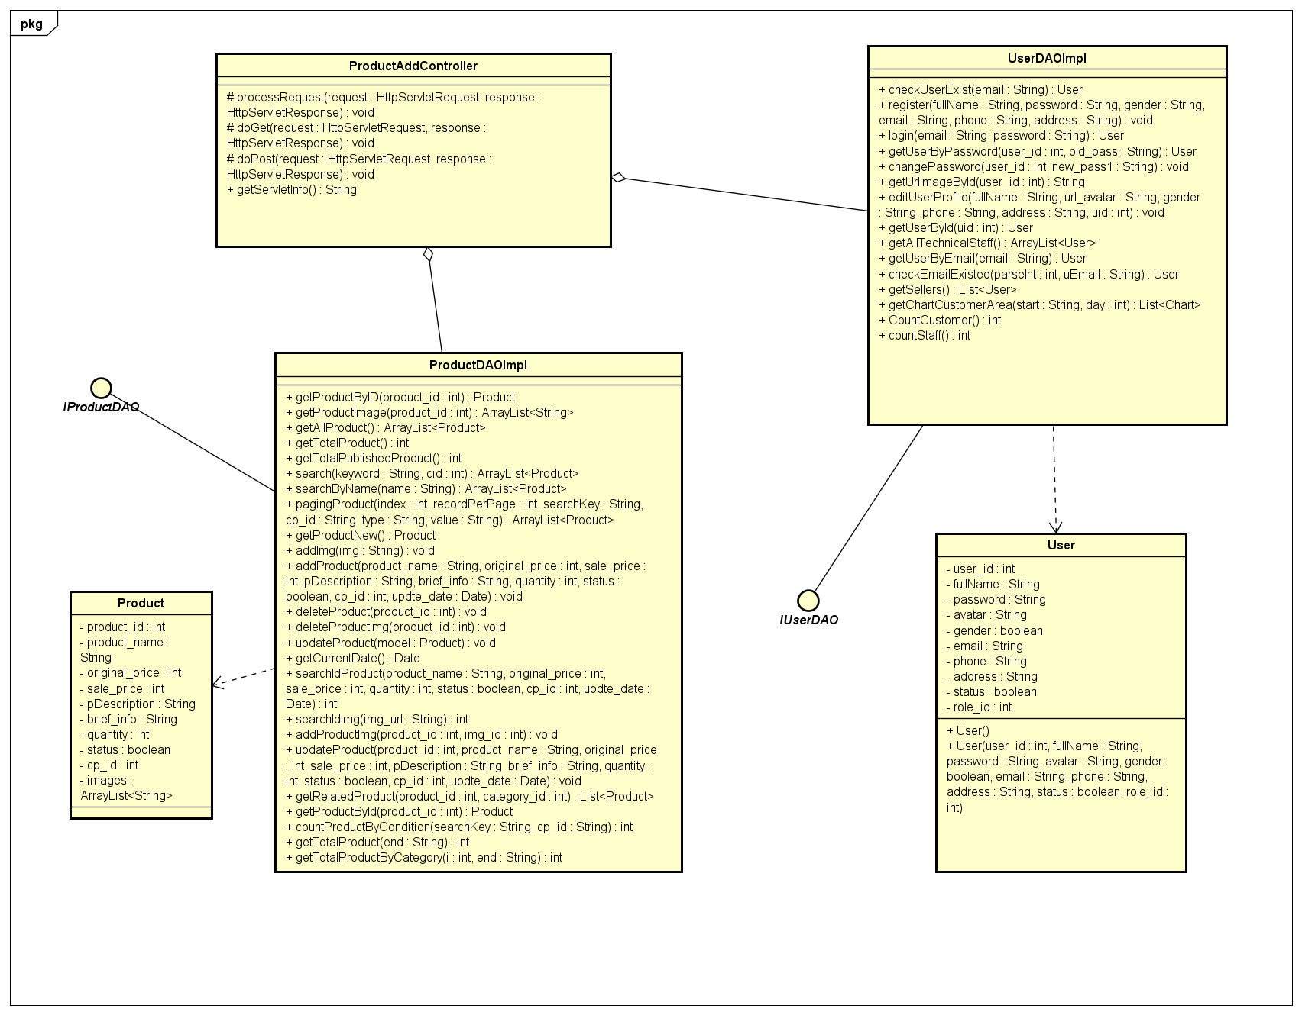

### c. Class Specifications

|  |  |  |
| --- | --- | --- |
| **No** | **Method** | **Description** |
| ***01*** | ***addProduct(pName, origin_price, price, pDes, pBrief, quantity, status, category, date)*** | ***add new product*** |

### d. Sequence Diagram(s)

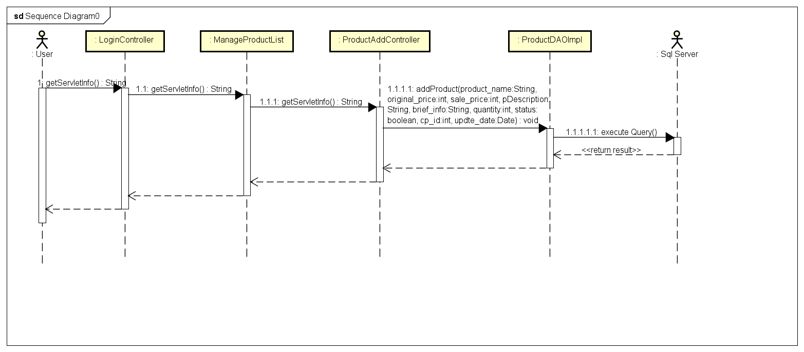

### e. Database queries

***- INSERT INTO [Product] VALUES (? ,? ,? ,? ,?, ?, ?, ?, ?)***

## 29. Product Management/Edit Product

## a. Screen Design

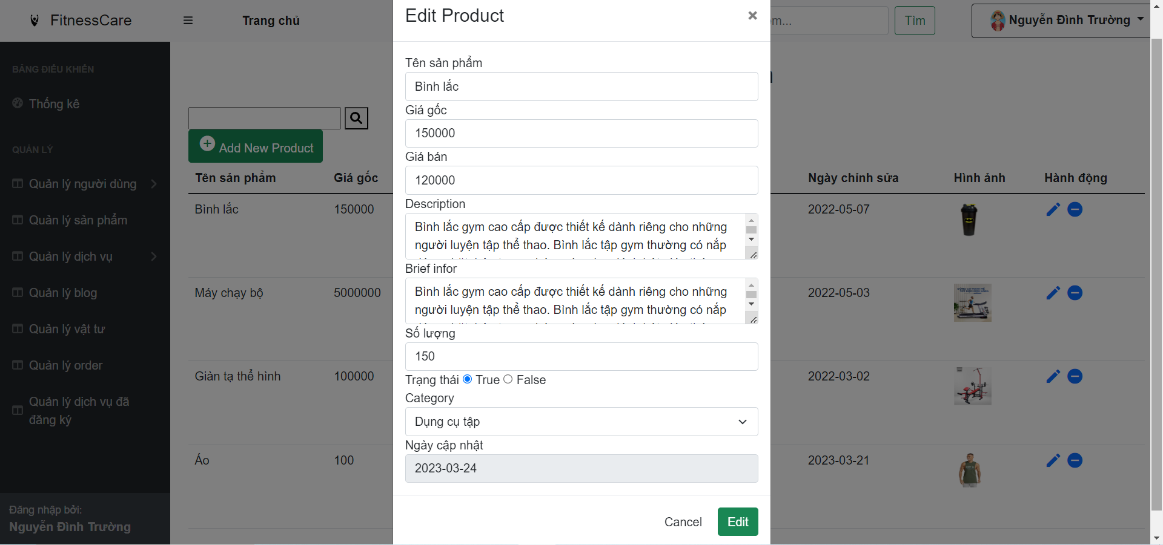

### b. Class Diagram

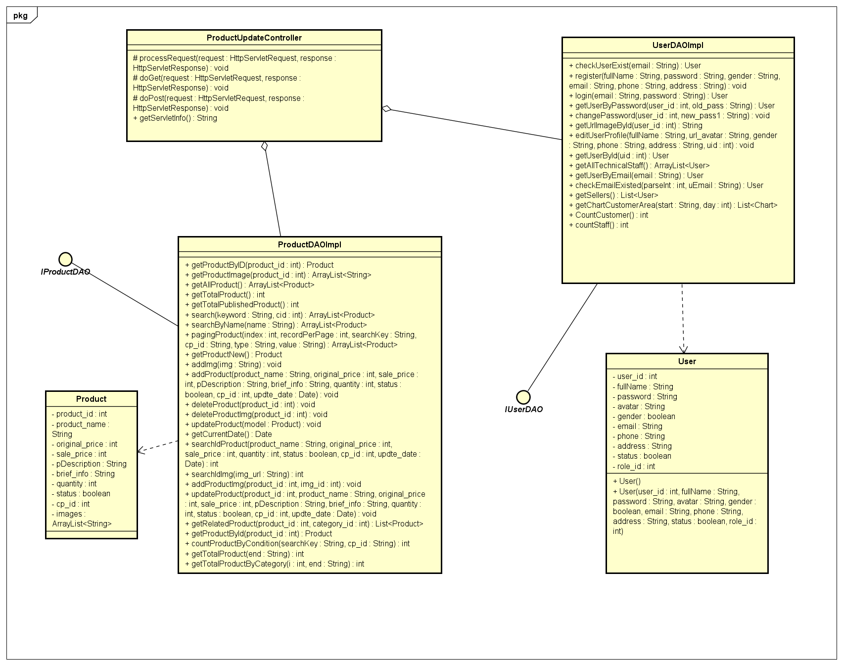

### c. Class Specifications

|  |  |  |
| --- | --- | --- |
| **No** | **Method** | **Description** |
| ***01*** | ***updateProduct(productId, pName, origin_price, price, pDes, pBrief, quantity, status, price, date)*** | ***Edit/update information of product*** |

### d. Sequence Diagram(s)

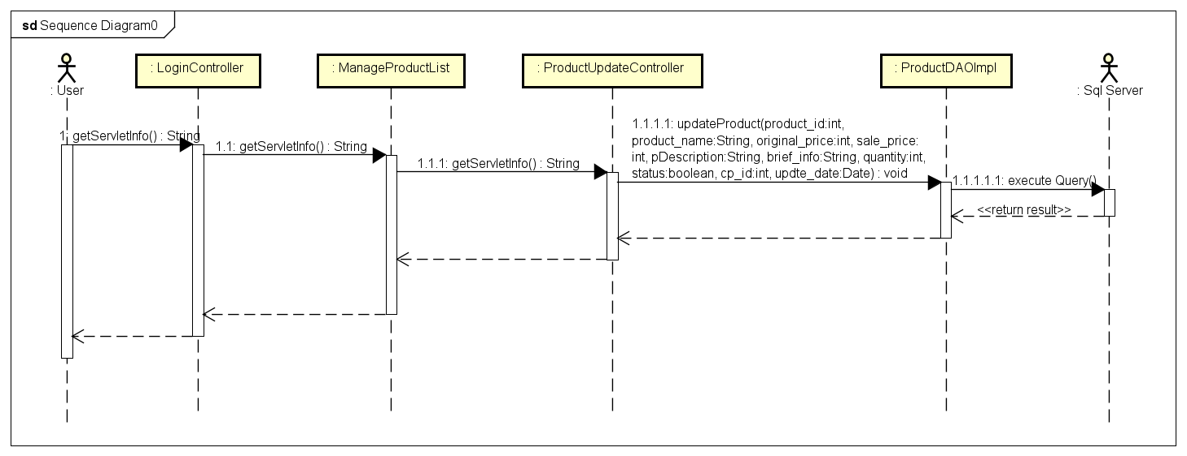

### e. Database queries

***- UPDATE [dbo].[Product] SET [product_name] = ?,[original_price] = ? ,[sale_price] = ? ,[pDescription] = ? ,[brief_info] = ? ,[quantity] = ? ,[status] = ? ,[cp_id] = ? ,[update_date] = ? WHERE product_id = ?***

## 30. Product Management/Delete Product

## a. Screen Design

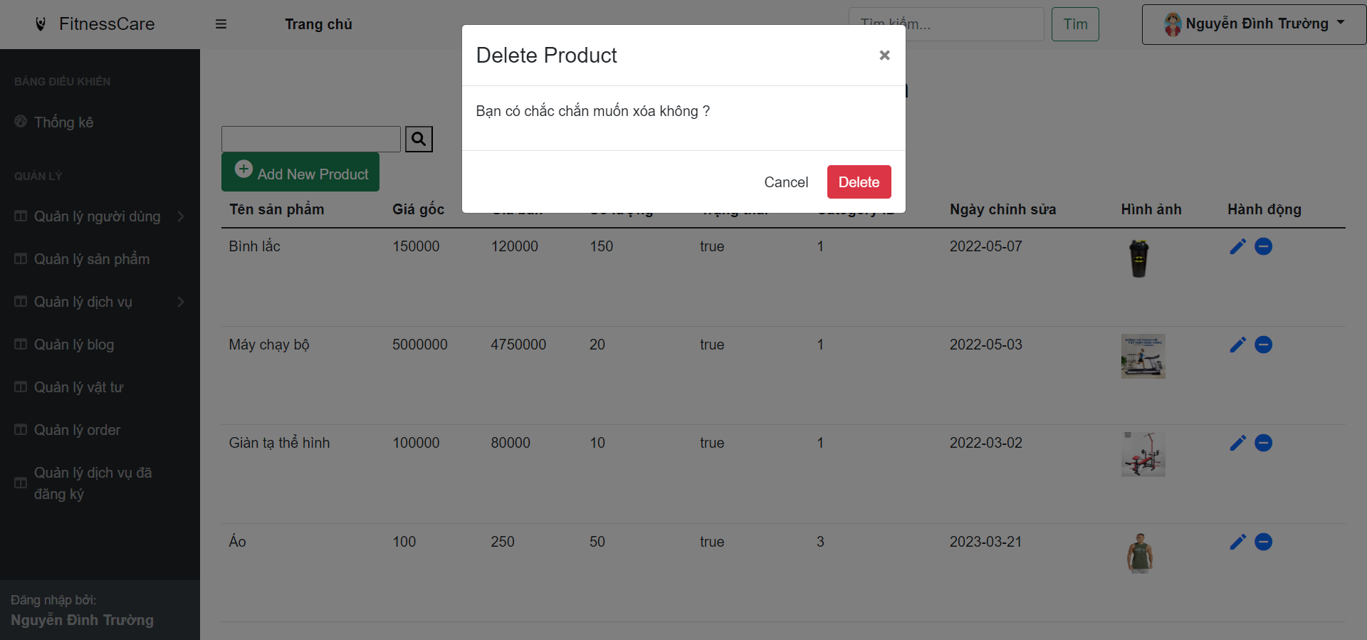

### b. Class Diagram

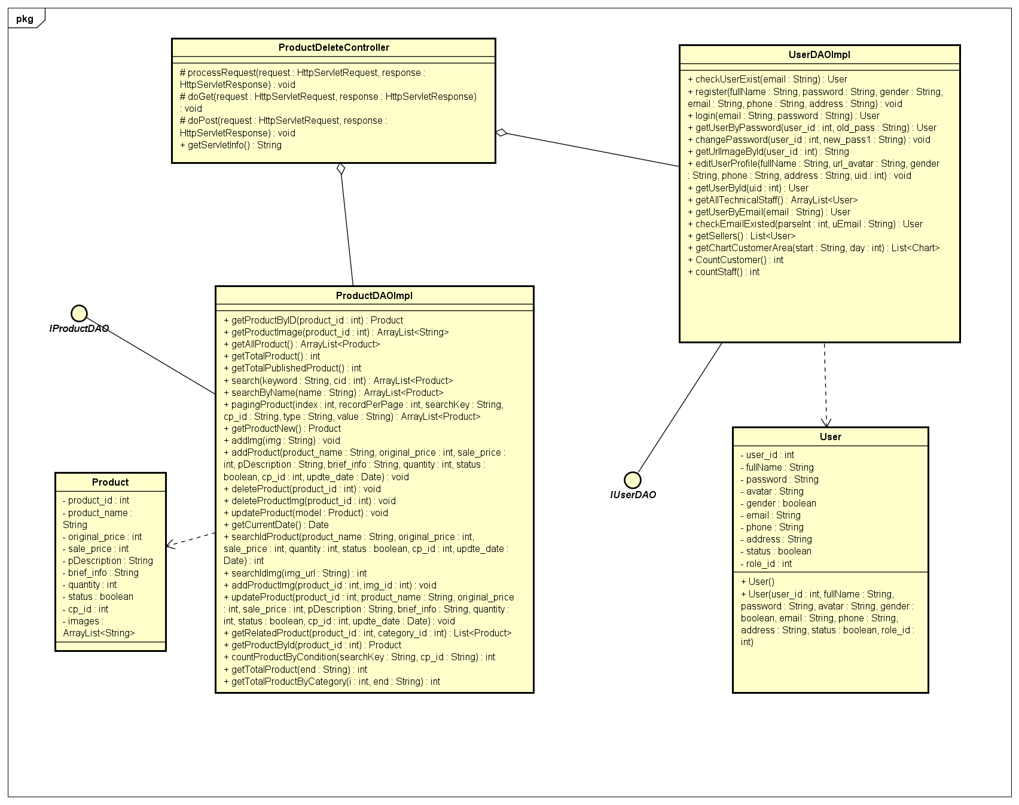

### c. Class Specifications

|  |  |  |
| --- | --- | --- |
| **No** | **Method** | **Description** |
| ***01*** | ***deleteProduct(id)*** | ***Delete product with id*** |

### d. Sequence Diagram(s)

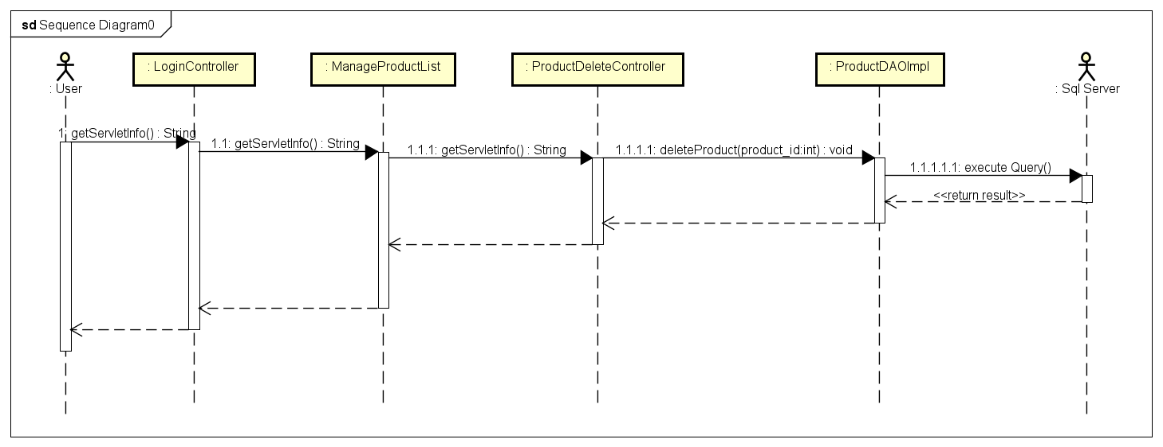

### e. Database queries

***- DELETE FROM Product WHERE product_id = ?***

## 31. Statistic

## a. Screen Design

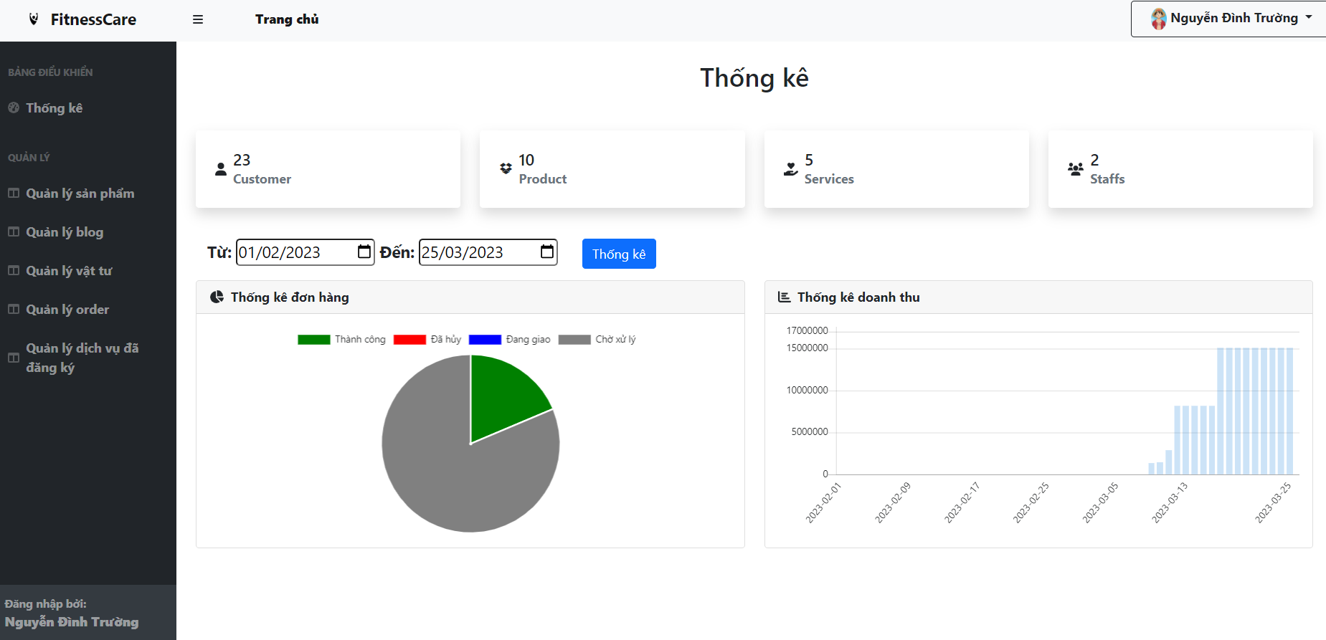

### b. Class Diagram

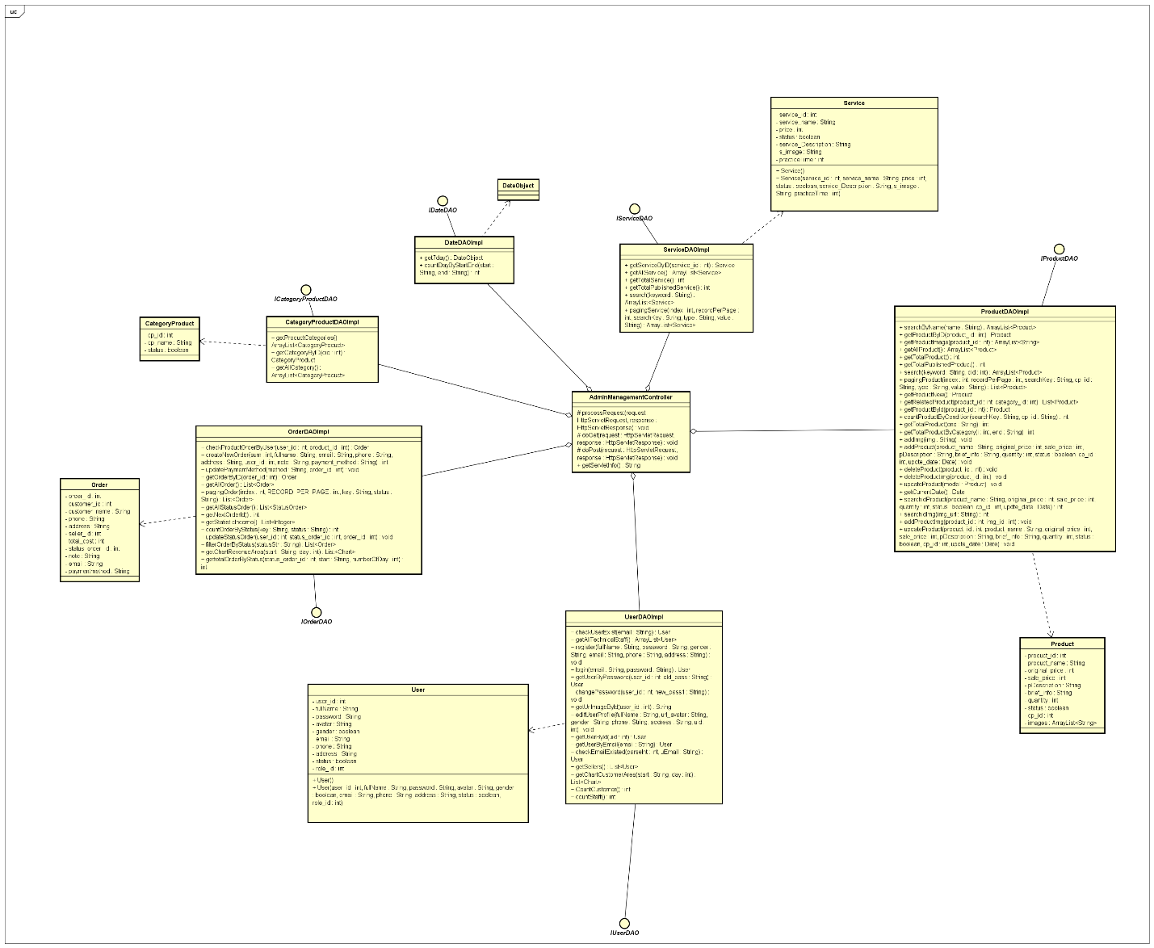

### c. Class Specifications

|  |  |  |
| --- | --- | --- |
| **No** | **Method** | **Description** |
| ***01*** | ***CountCustomer()*** | ***Count number of customer in db*** |
| ***02*** | ***getTotalProduct();*** | ***Count number of product in db*** |
| ***03*** | ***countStaff();*** | ***Count number of staff in db*** |
| ***04*** | ***getTotalService();*** | ***Count number of service in db*** |
| ***05*** | ***get7day();*** | ***Get 7 day from start date to end date*** |
| ***06*** | ***countDayByStartEnd(start, end);*** | ***Count number of day from start date to end date*** |
| ***07*** | ***getChartRevenueArea(start, numberOfDay);*** | ***Get chart about revenue from start date to numberOfday after*** |
| ***08*** | ***getAllStatusOrder();*** | ***Get All status Order (success, fail, in progress…)*** |
| ***09*** | ***gettotalOrderByStatus(1, start, numberOfDay);*** | ***Get number of order by status Order from startdate to numberOfday after*** |

### d. Sequence Diagram(s)

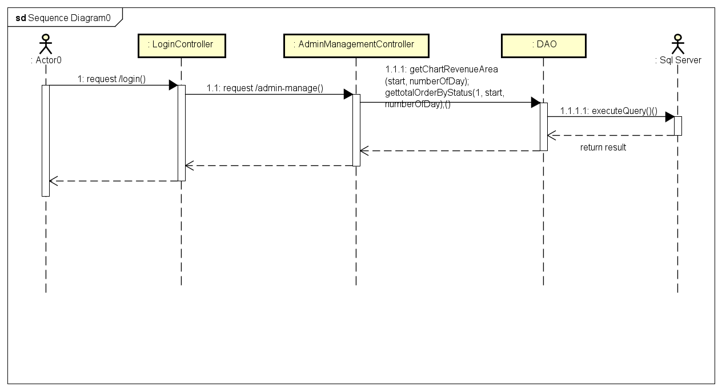

### e. Database queries

***select count(*) from [User] where role_id = 4***

***- select count(*) from [User] where role_id = 2 or role_id = 3***

***- select count(*) from [User] where role_id = 4 and updated_date <= DATEADD(DAY, ?, ?)***

***- select DATEADD(DAY, ?, ?)***

***- select COUNT(product_id) from Product***

***- select COUNT(service_id) from Service***

***- select GETDATE(), GETDATE()-6***

***- SELECT DATEDIFF(day, ?, ?)***

***- SELECT SUM(total_cost) FROM (SELECT FROM [Order] WHERE status_order_id = 1 ) AS orders_with_status WHERE order_Date BETWEEN ? AND DATEADD(DAY,?,?)***

***- select * from StatusOrder***

***- select count(order_id) from [Order] where status_order_id = ? and order_Date between ? and DATEADD(DAY, ?,?)***